Weighted Scale Activity
Solve the following equations by isolating x through illustration and algebraic proof.

1. $x+5=7$ 2. $x-6=-9$

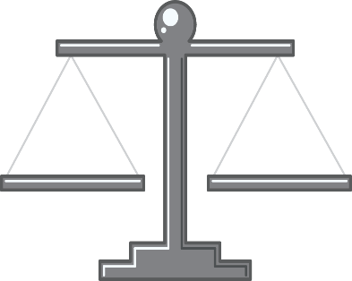

3. $-4x=8$ 4. $2x=10$

5. $2x-3=11$ 6. $-3x+1=13$

