Extend

Problem 1
- Identify the error in solving the absolute value equation.
- Correct the error. Show your steps.
- Explain how one might have made that error.
- Justify the correct answer and steps.

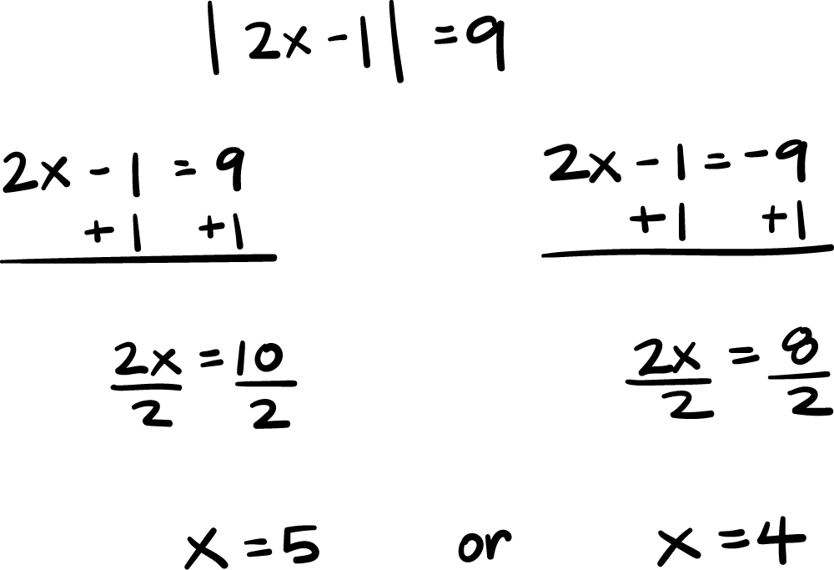

Problem 2
- Identify the error in solving the absolute value equation.
- Correct the error. Show your steps.
- Explain how one might have made that error.
- Justify the correct answer and steps.

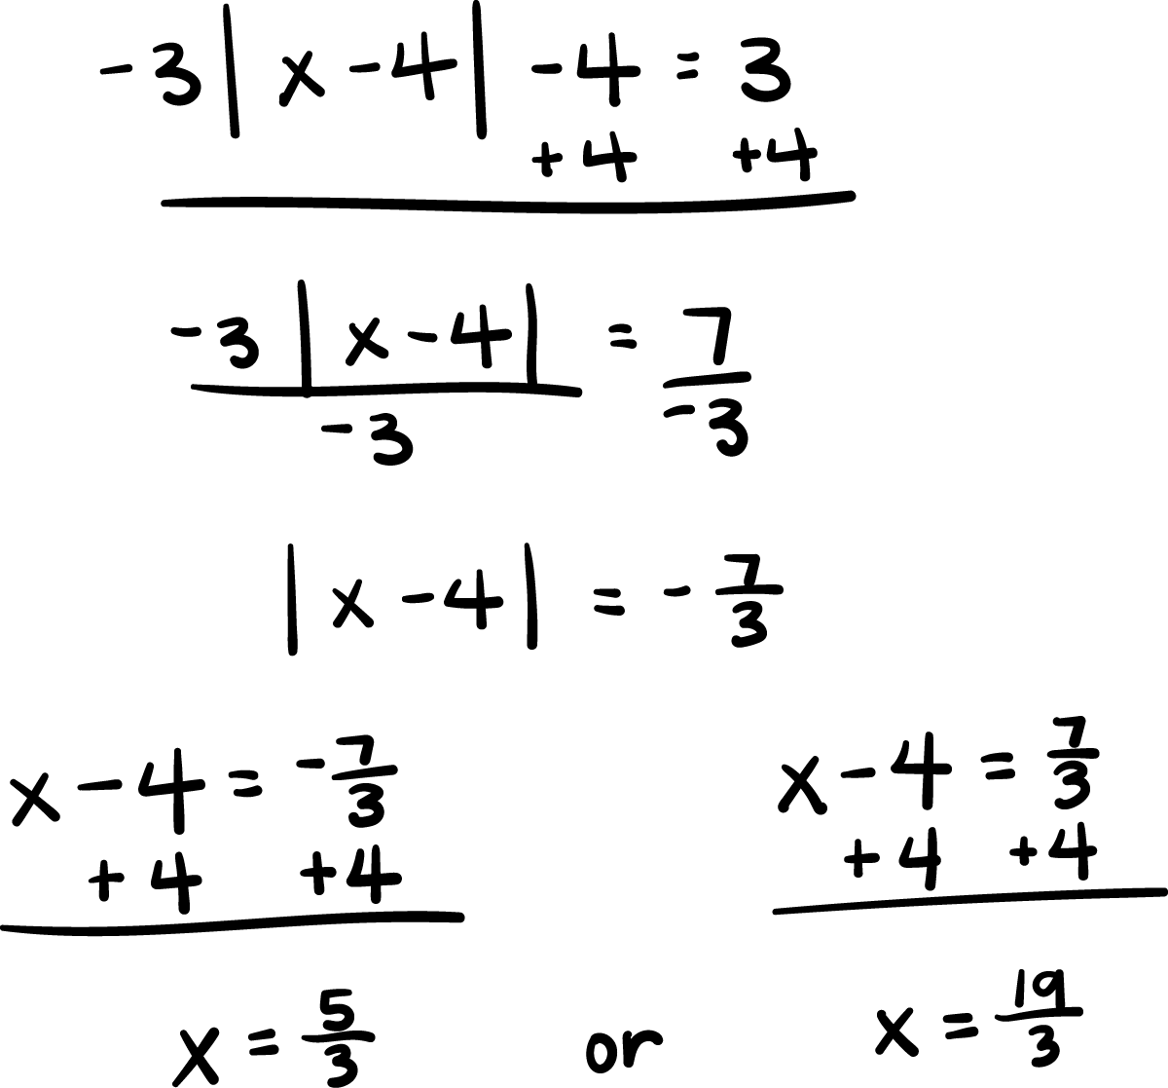

Problem 3
- Identify the error in solving the absolute value equation.
- Correct the error. Show your steps.
- Explain how one might have made that error.
- Justify the correct answer and steps.

