Hexomino Extension
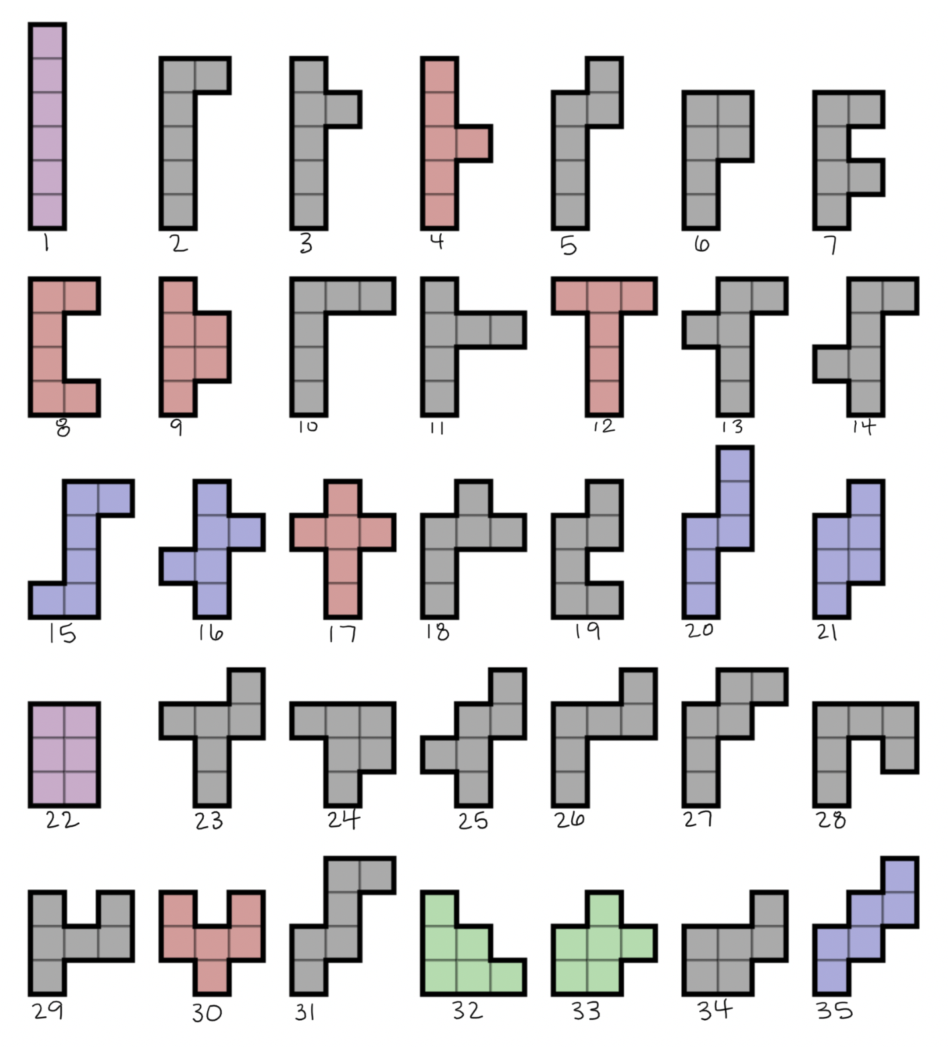
Source: Nonenmacher, R. A. (2008, September 12). All 35 free hexominoes [Image]. Wikimedia Commons. https://commons.wikimedia.org/wiki/File:All_35_free_hexominoes.svg

Use the hexominoes from the picture to fill in the table on the following pages. As you work, create a key at the end to explain your entries in the “Category for Perimeter” column.
Hexomino Number | Perimeter | Category for Perimeter | Area | Does it form a cube? (Y/N)
1
2
3
4
5
6
7
8
9
10
11
12
13
14
15
16
17
18
19
20
21
22
23
24
25
26
27
28
29
30
31
32
33
34
35

Perimeter Categories
Create a key to organize the perimeters of the hexominoes into categories. Use one symbol or color per category.

Explain why you categorized the hexominoes in this way. Why do hexominoes fall within these distinct categories?

Justification for Forming a Cube
Why do some of the hexominoes form cubes while others do not?

What are the key characteristics a hexomino needs to form a cube?

