Painting 1: Kiowa Buffalo Dancer

James Auchiah, 1930
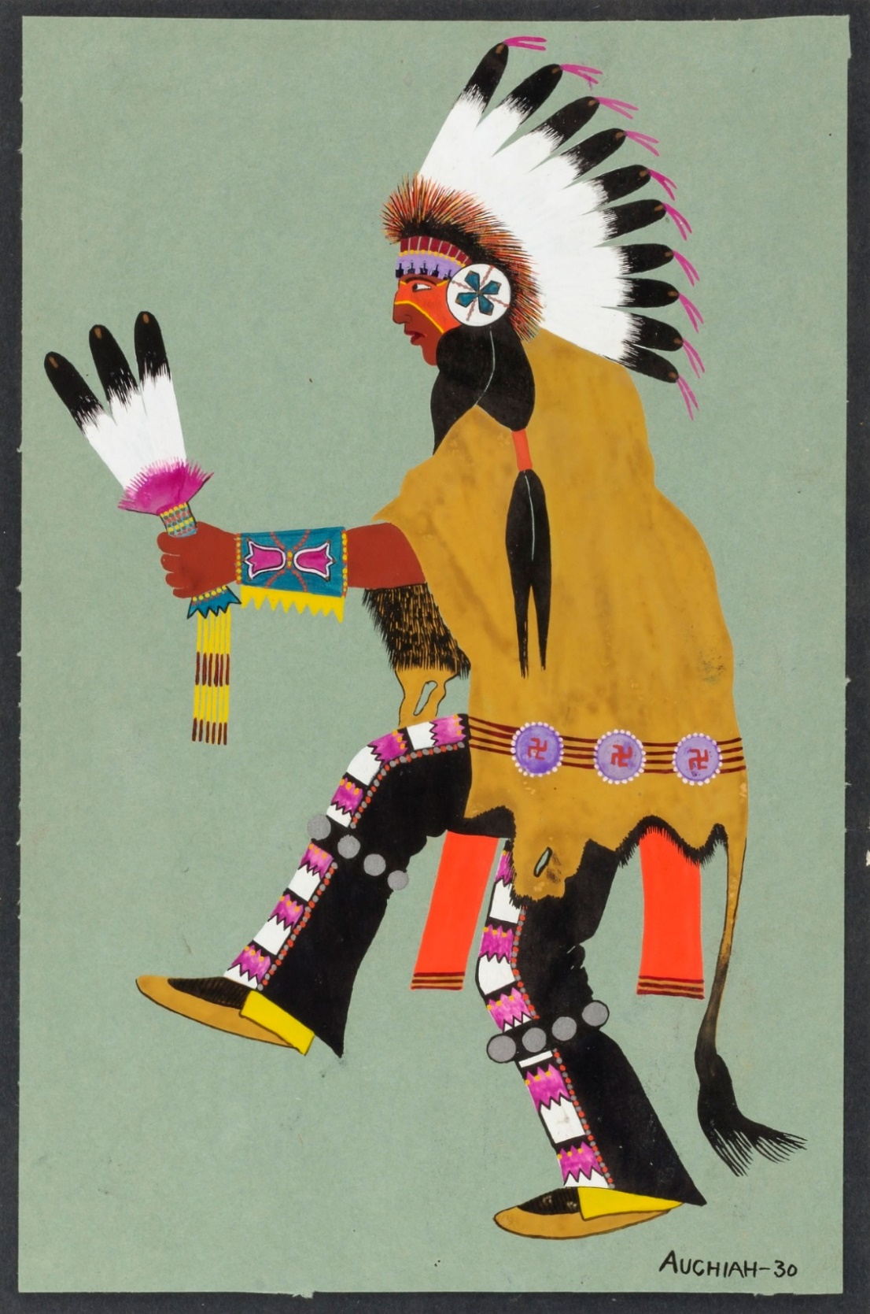
Auchiah, J. (1930). Kiowa buffalo dancer [Painting]. Smithsonian American Art Museum. Washington, D.C. https://americanart.si.edu/artwork/kiowa-buffalo-dancer-664

Painting 2: Belo Cozad

Monroe Tsatoke, date unknown
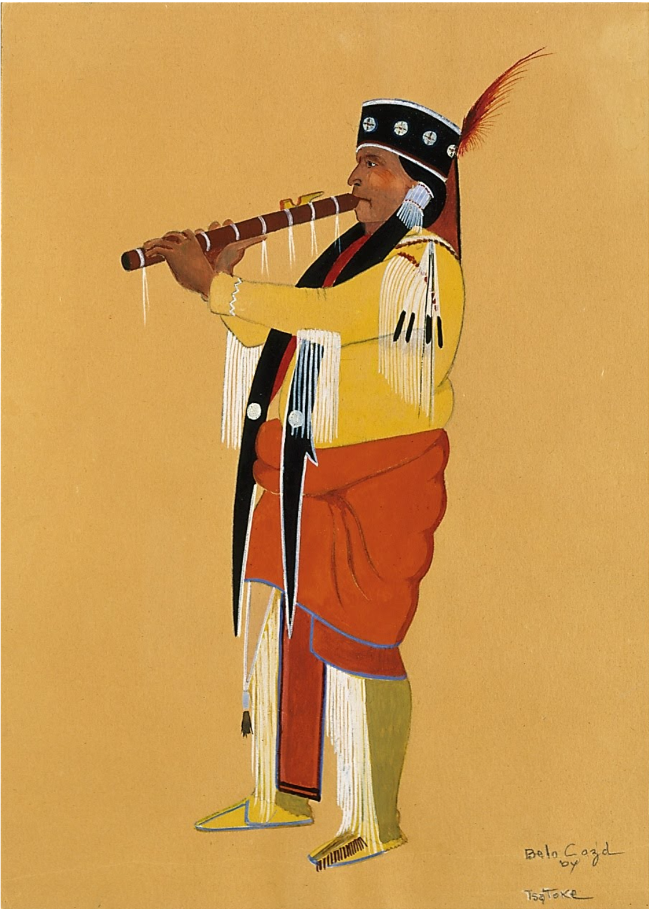
Tsatoke, M. (n.d.). Belo Cozad [Painting]. Google Arts and Culture. https://artsandculture.google.com/asset/belo-cozad-monroe-tsatoke-1904-1937/DwEbOCgxCdxfxQ?hl=en

Painting 3: Apache Ben

Stephen Mopope, 1928
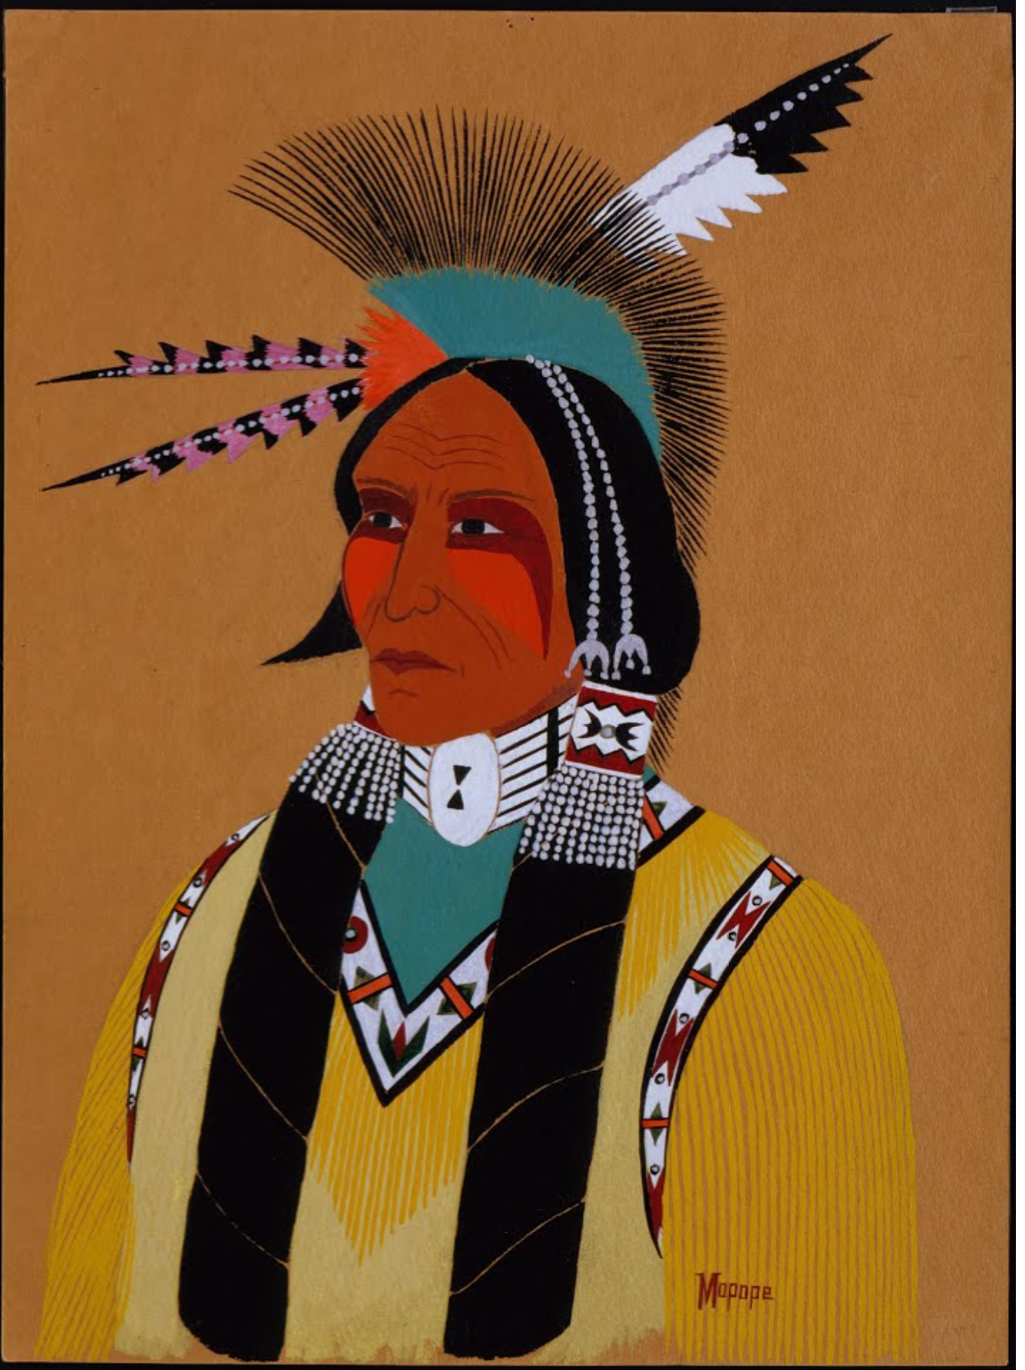
Mopope, S. (1928). Apache Ben [Painting]. Google Arts and Culture. https://artsandculture.google.com/asset/apache-ben-stephen-mopope-1898-1974/rAFm8MuHScByhg

Painting 4: Feathered Man on Brown Horse

Spencer Asah, date unknown
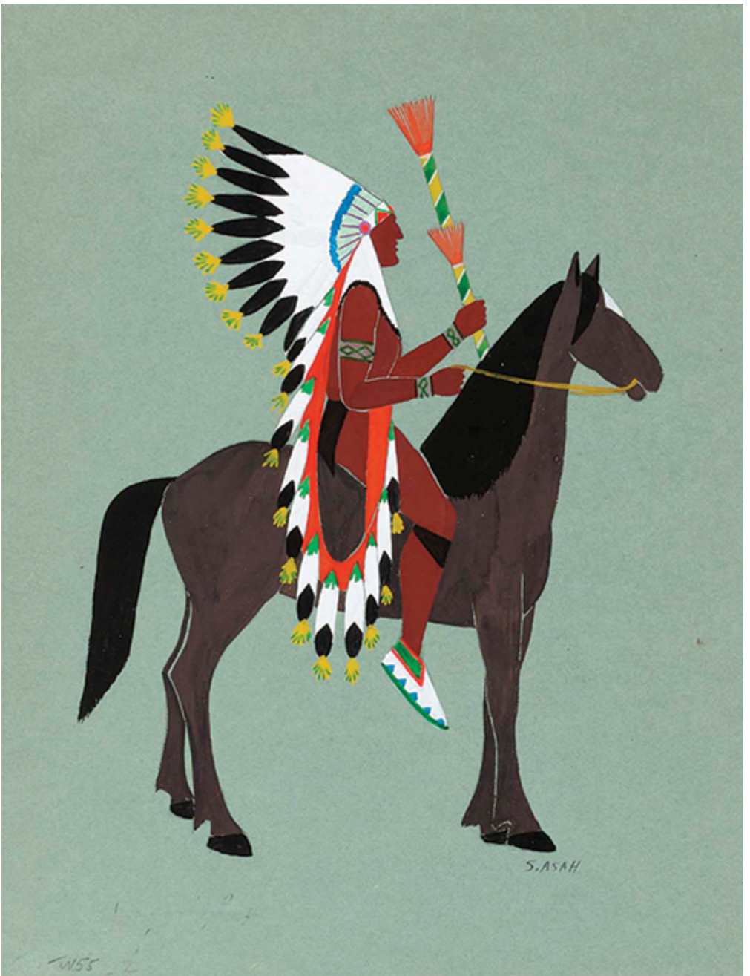
Asah, S. (n.d.). Feathered man on brown horse [Painting]. Smithsonian Modern Art Museum. Washington, D.C. https://americanart.si.edu/artwork/costumed-horseman-feathered-man-brown-horse-635

Painting 5: Greeting of The Moon God

Jack Hokeah, 1929
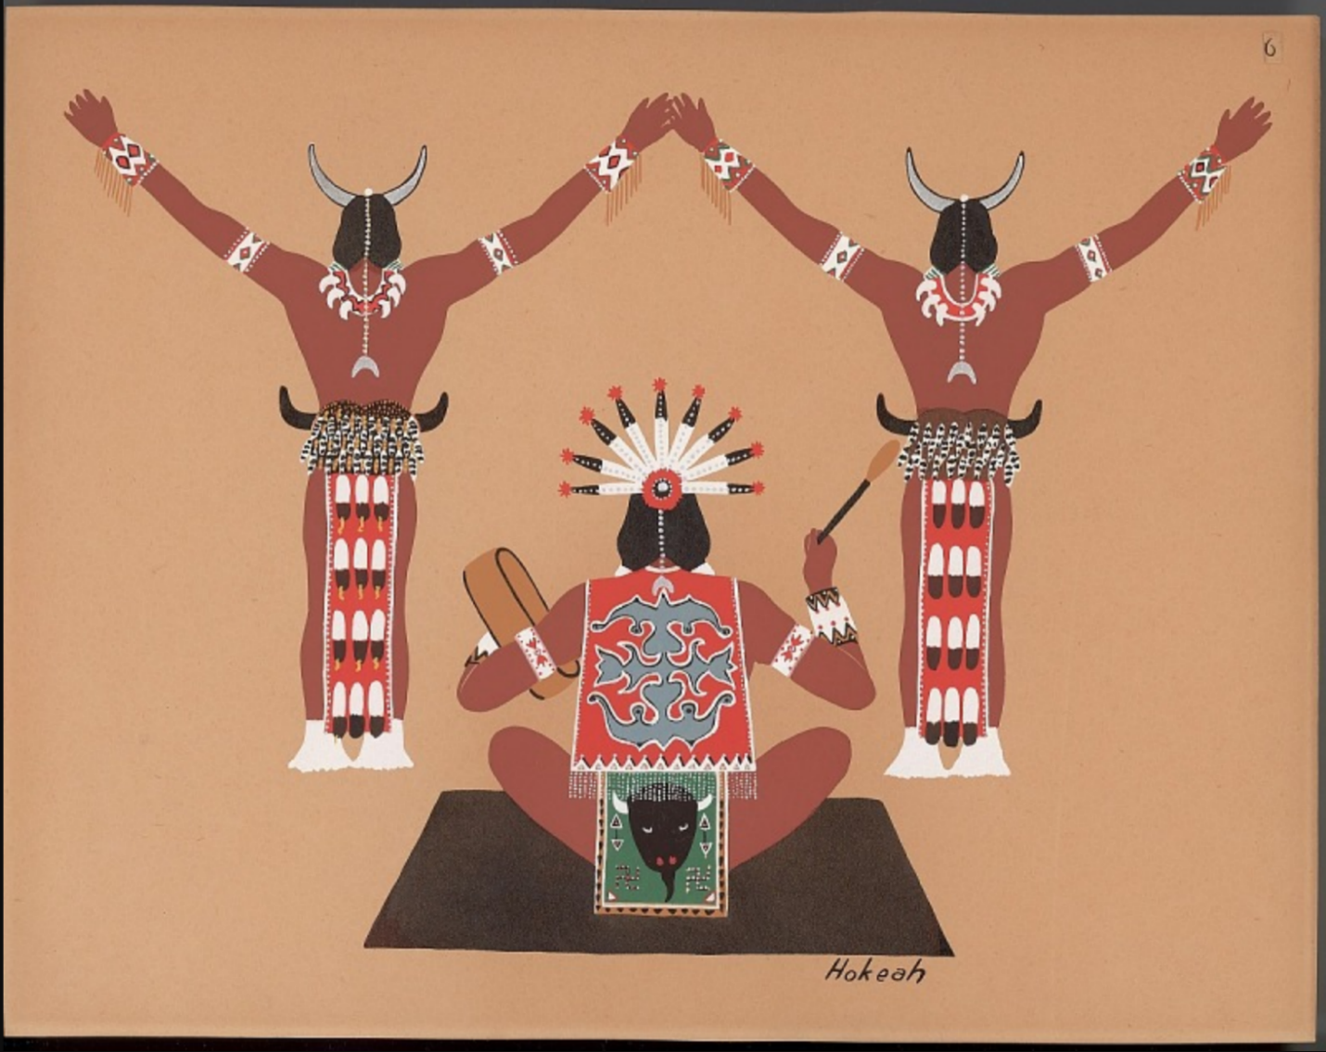
Hokeah, J. (1929). Greeting of the moon god [Painting]. Smithsonian American Art Museum. Washington, D.C. https://collections.si.edu/search/detail/ead_component:sova-naa-ms7536-ref4?q=Jack+Hokeah&record=20&hlterm=Jack%2BHokeah&inline=true

Painting 6: Kiowa Family

Lois Smoky, 1929
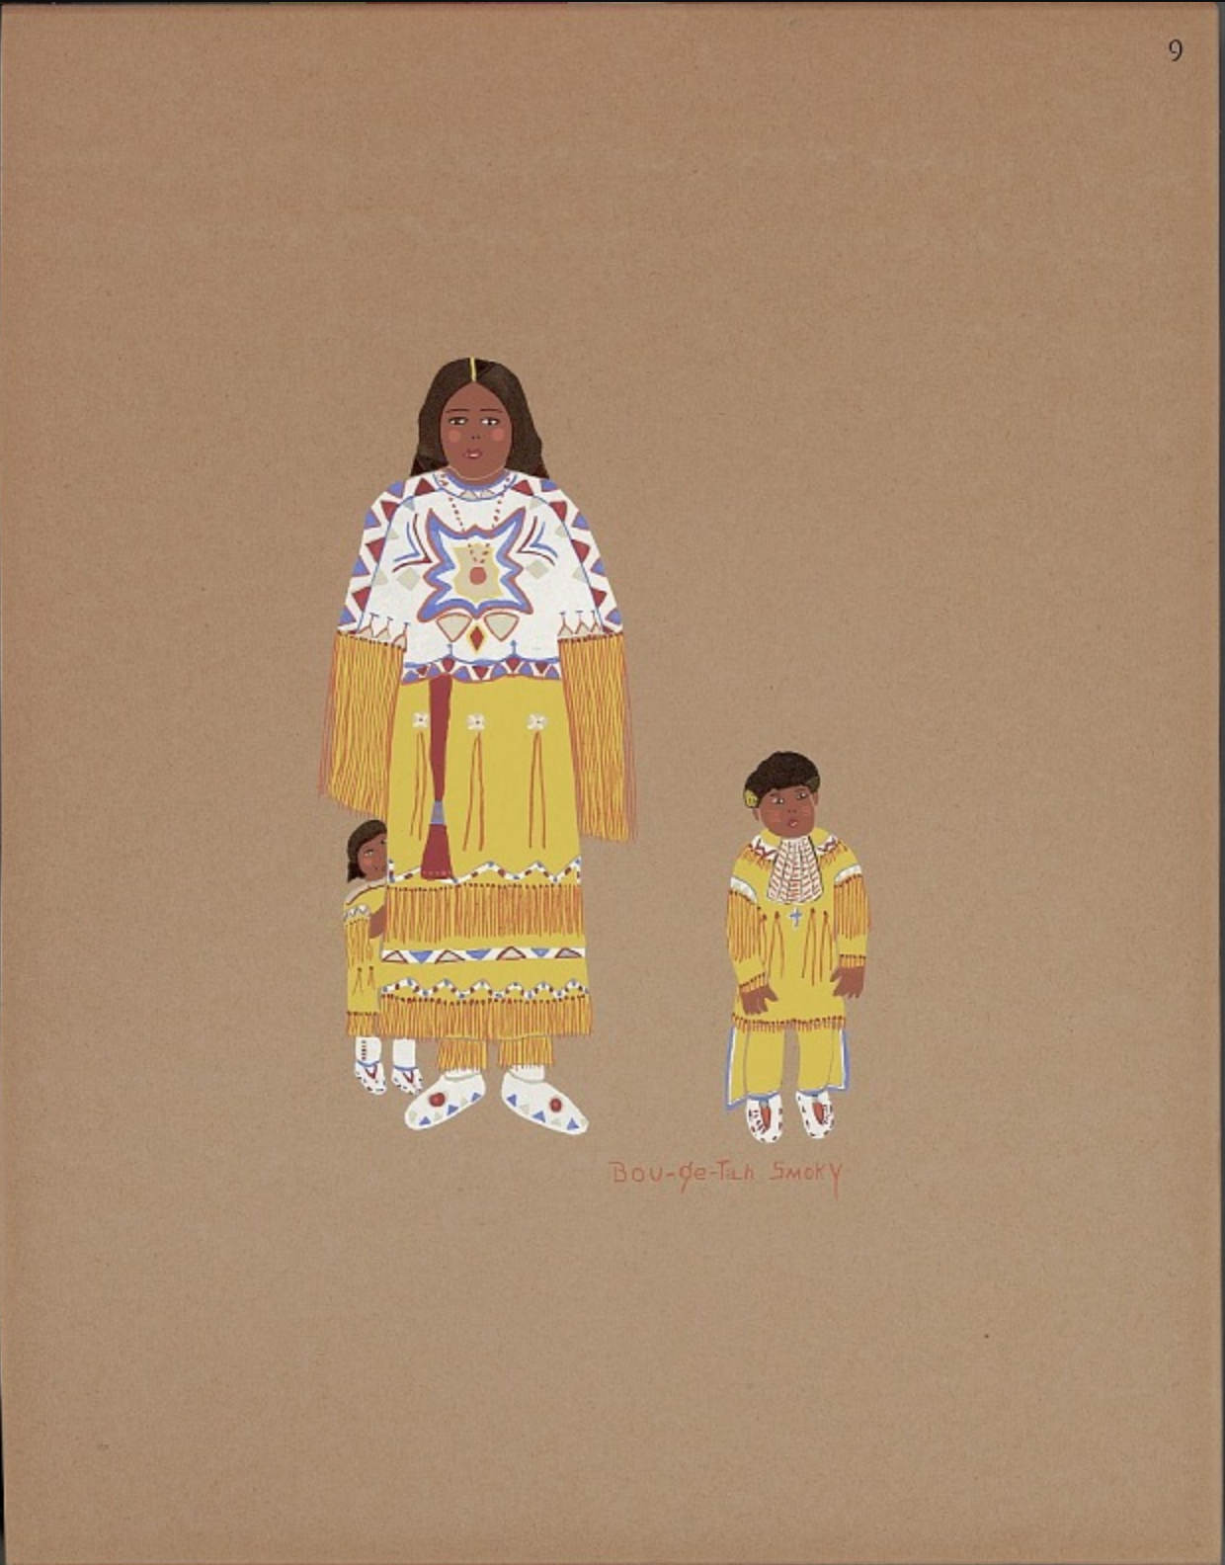
Smoky, L. (1929). Kiowa family [Pochoir print]. Smithsonian American Art Museum. Washington, D.C. https://collections.si.edu/search/detail/ead_component:sova-naa-ms7536-ref6

