CARD SORT PHOTOGRAPHS – NATURE AND MAN-MADE

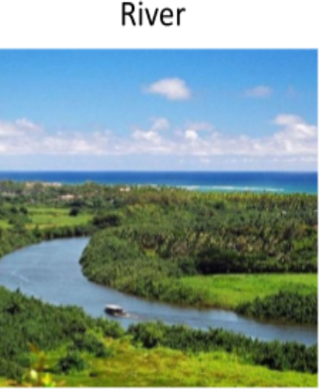 | 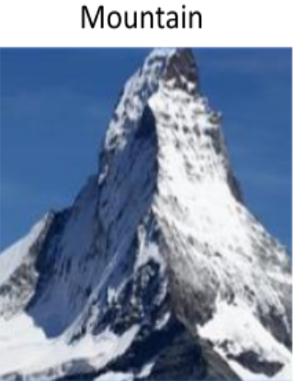 | 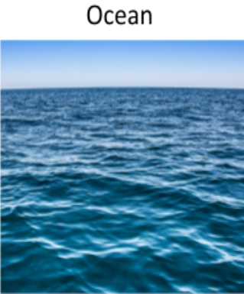
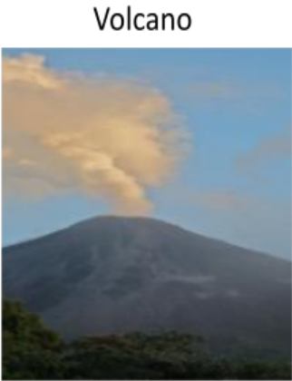
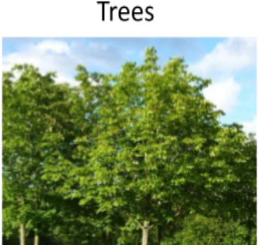 | 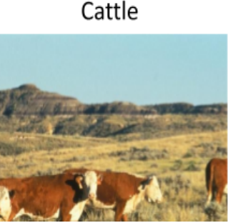 | 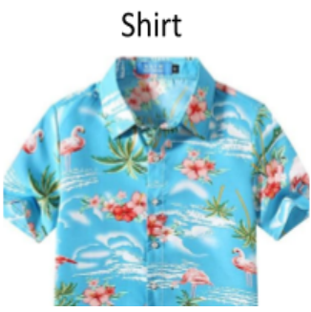
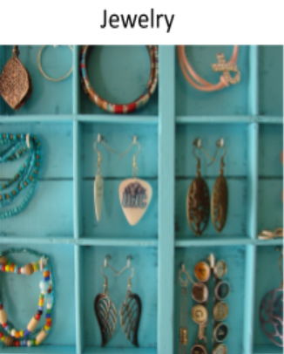 | 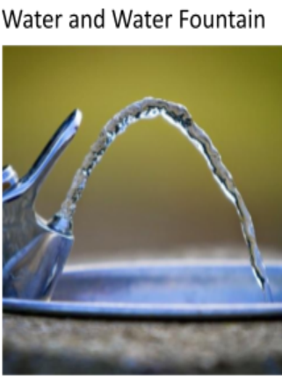 | 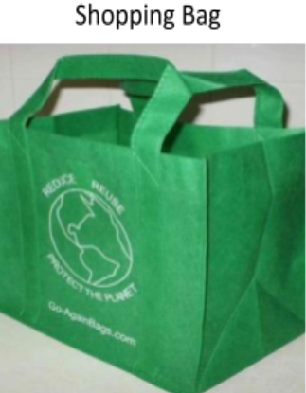
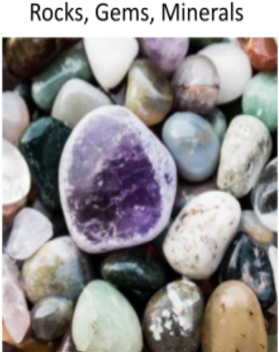 | 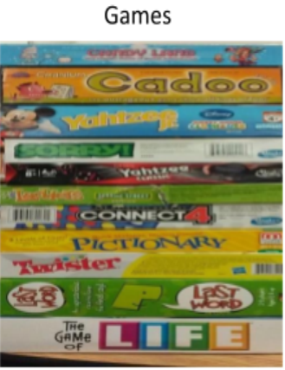 | 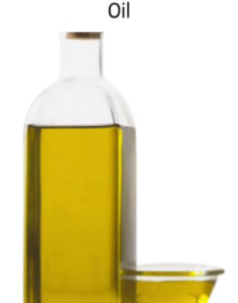
 | 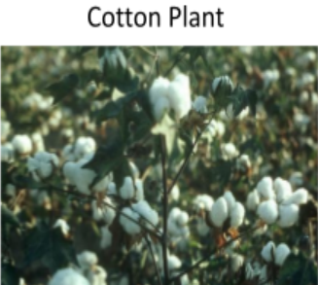 | 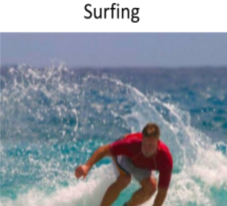

SOURCES FOR CARD SORT PHOTOGRAPHS

River
https://upload.wikimedia.org/wikipedia/commons/thumb/e/ee/Wailua_River%2C_Kauai%2C_Hawaii.jpeg/1280px-Wailua_River%2C_Kauai%2C_Hawaii.jpeg
Mountain
https://images.pexels.com/photos/52710/matterhorn-zermatt-switzerland-snow-52710.jpeg?auto=compress&cs=tinysrgb&fit=crop&h=627&w=1200
Ocean
https://live.staticflickr.com/3822/32972768576_2d822d6509_b.jpg
Volcano
http://res.freestockphotos.biz/pictures/17/17711-active-volcano-pv.jpg
Computer
https://images.pexels.com/photos/6354/desk-laptop-working-technology.jpg?w=1200&h=627&fit=crop&auto=compress&cs=tinysrgb
Books
https://blogsmedia.lse.ac.uk/blogs.dir/30/files/2016/02/Books-for-Survey.jpg
Trees
https://www.htxt.co.za/wp-content/uploads/2013/07/trees.jpeg
Cattle
https://pixnio.com/free-images/fauna-animals/cows-and-calves/hereford-cattle.jpg
Shirt
https://images-na.ssl-images-amazon.com/images/I/91nUzWX2gsL._AC_UX679_.jpg
Jewelry
https://3.bp.blogspot.com/-r4dwst0DXmo/UN8fxzSvEeI/AAAAAAAABok/fh0ej8-G6jQ/s640/printertray2.jpg
Water and Water Fountain
http://1.bp.blogspot.com/-FfJjj5EsTg8/VLm8sx_RqoI/AAAAAAAAMA8/UMwnGNHj8x0/s1600/drinking-fountain-water.jpg
Shopping Bag
http://c-pol.com/Fun/Blog/reusable_bag.jpg
Rocks, Gems, Minerals
https://get.pxhere.com/photo/rock-purple-color-pebble-colorful-material-jewellery-background-violet-bright-amethyst-minerals-shimmer-gemstone-mineral-polished-gems-semi-precious-stones-fashion-accessory-913668.jpg
Games
http://3.bp.blogspot.com/-Q_KZ-rjxcLc/VUz9MesM89I/AAAAAAAAD_I/dmYPZkc-PNM/s1600/games_stack.jpg
Oil
http://www.pngall.com/wp-content/uploads/2017/03/Olive-Oil-Free-PNG-Image.png

Football
https://get.pxhere.com/photo/grass-structure-lawn-football-stadium-baseball-field-sports-equipment-american-football-sports-ball-sport-venue-492687.jpg
Cotton Plant
https://www.google.com/imgres?imgurl=https%3A%2F%2Fupload.wikimedia.org%2Fwikipedia%2Fcommons%2F2%2F24%2FCotton_Plant.png&imgrefurl=https%3A%2F%2Fcommons.wikimedia.org%2Fwiki%2FFile%3ACotton_Plant.png&tbnid=h2nKi_JP8FJO_M&vet=12ahUKEwiq0Zv7iJLwAhWjna0KHRqrBWcQMygAegUIARC2AQ..i&docid=8AavBsZzA0abNM&w=512&h=668&q=cotton%20plant%20creative%20commons&ved=2ahUKEwiq0Zv7iJLwAhWjna0KHRqrBWcQMygAegUIARC2AQ
Surfer
https://c.pxhere.com/photos/07/6d/surfer_surfboard_surfing_wave_water_surf_ocean_hawaii-763735.jpg!s

