PHOTO SLIDES OF GEOGRAPHIC FEATURES

PHOTO SLIDES
Photo Slide #1: Grand Canyon National Park
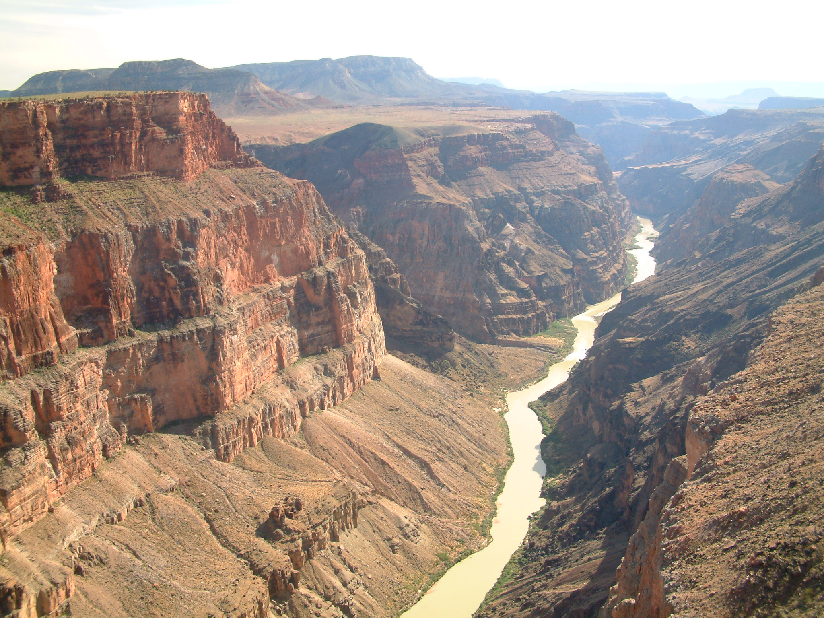
Photo Slide #2: Baja California Peninsula
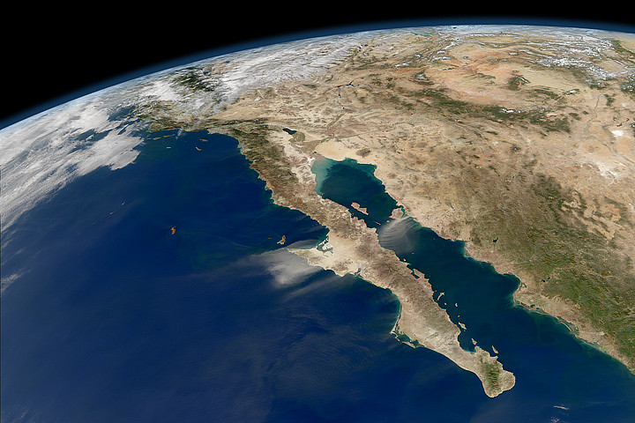
Photo Slide #3: Sakurajima, Japan
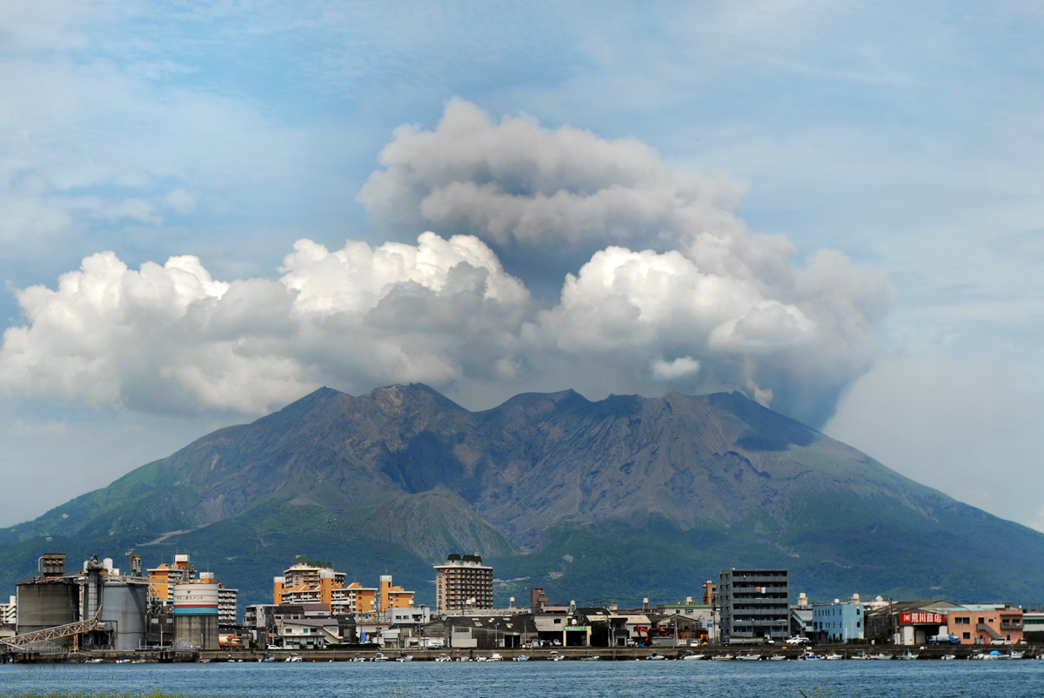
Photo Slide #4: Wood Valley, Hawaii
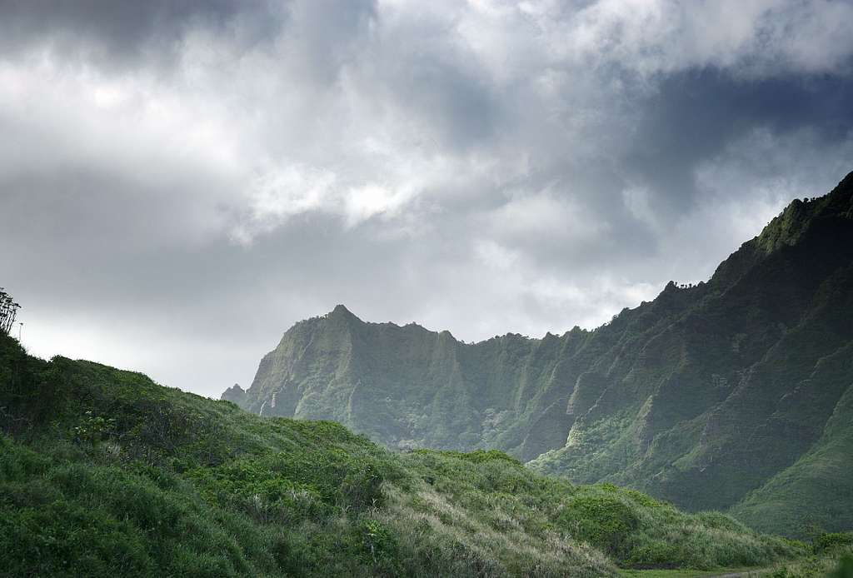
Photo Slide #5: The Narrows, Utah
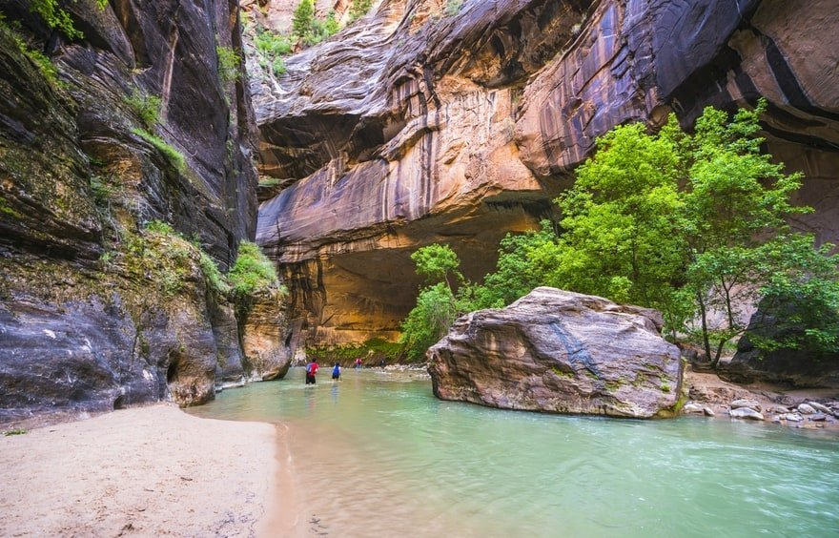
Photo Slide #6: Lake George, New York
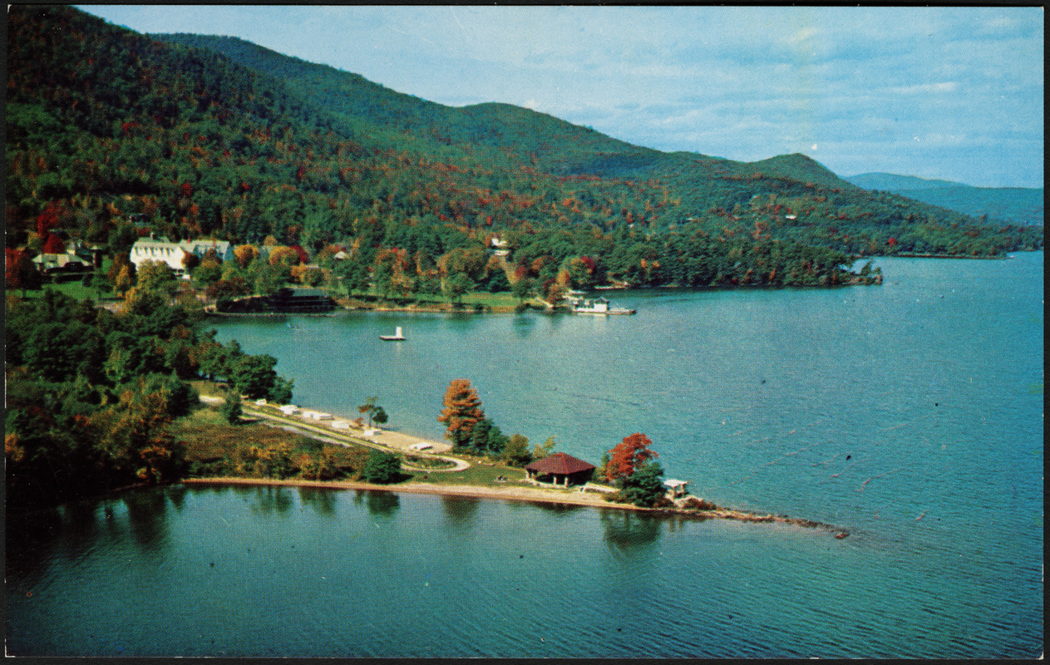
Photo Slide #7: Nile River Basin
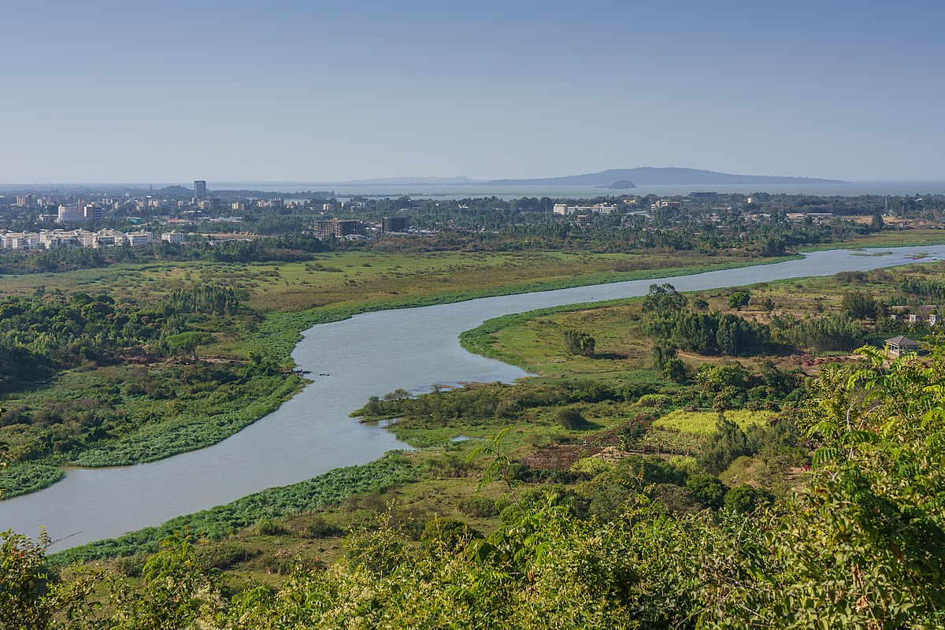
Photo Slide #8: The Red Sea
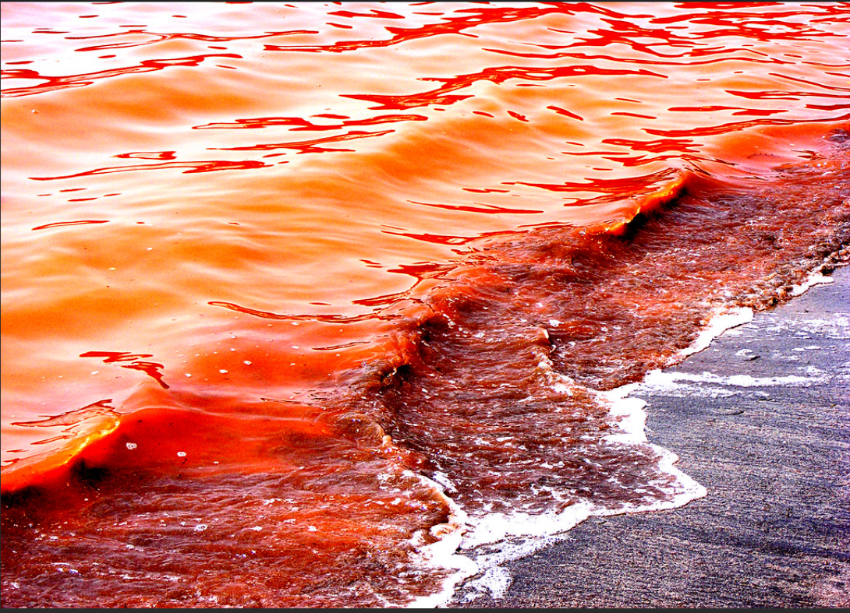

Photo Slide #9: Sahara Desert
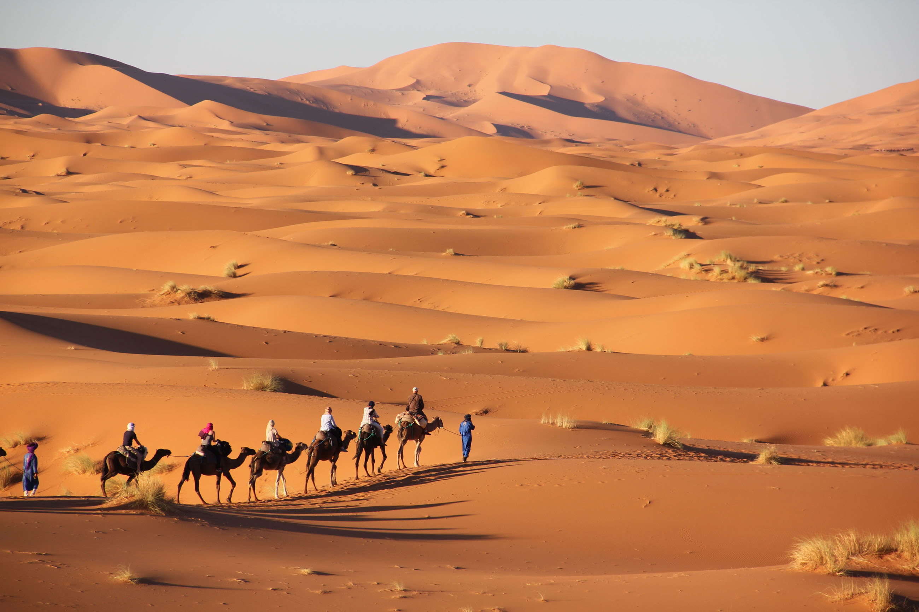
Photo Slide #10: Redwood National Park
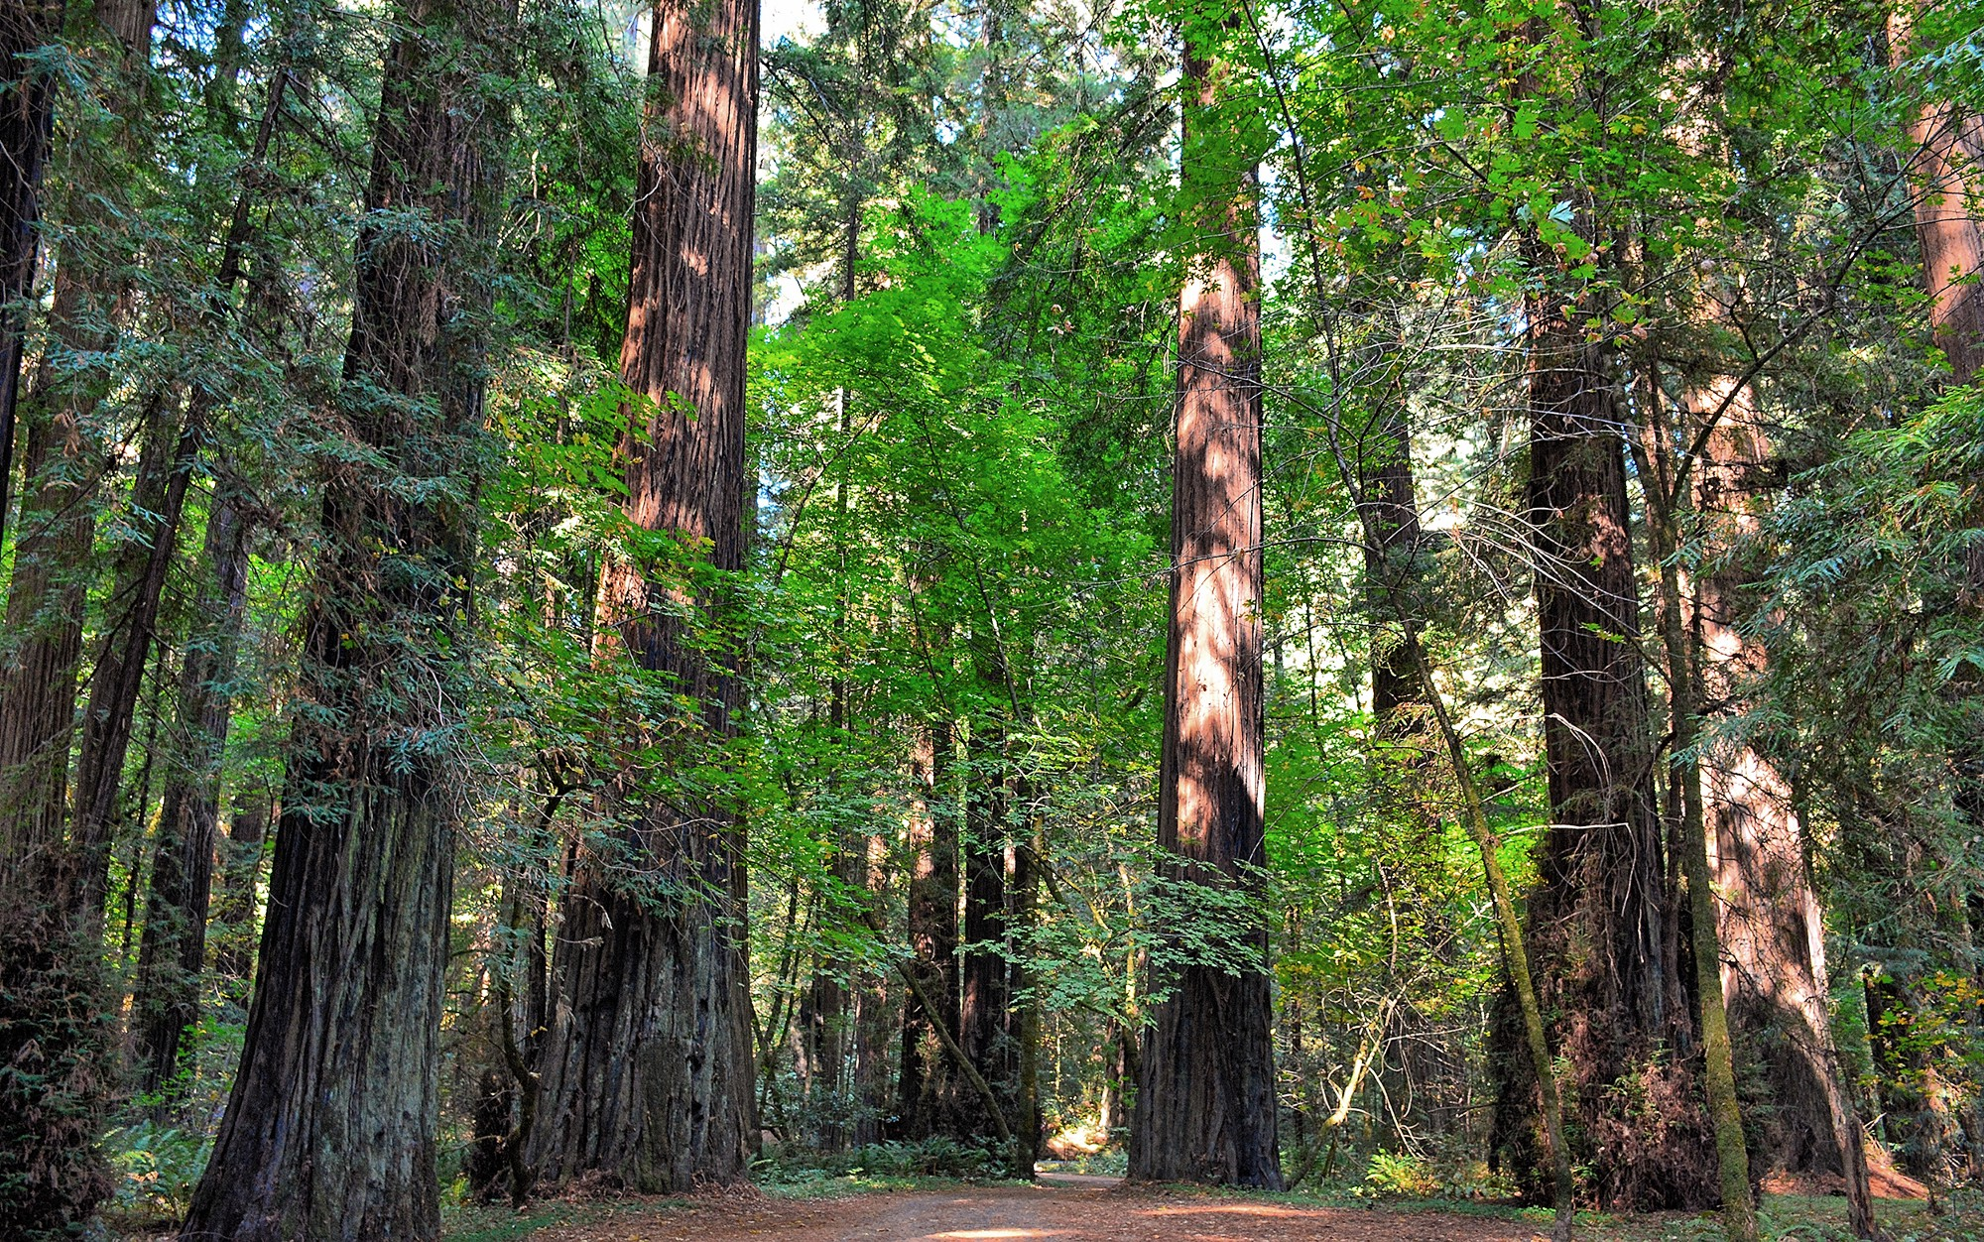

Photo Slide #11: Ceremonial South Pole
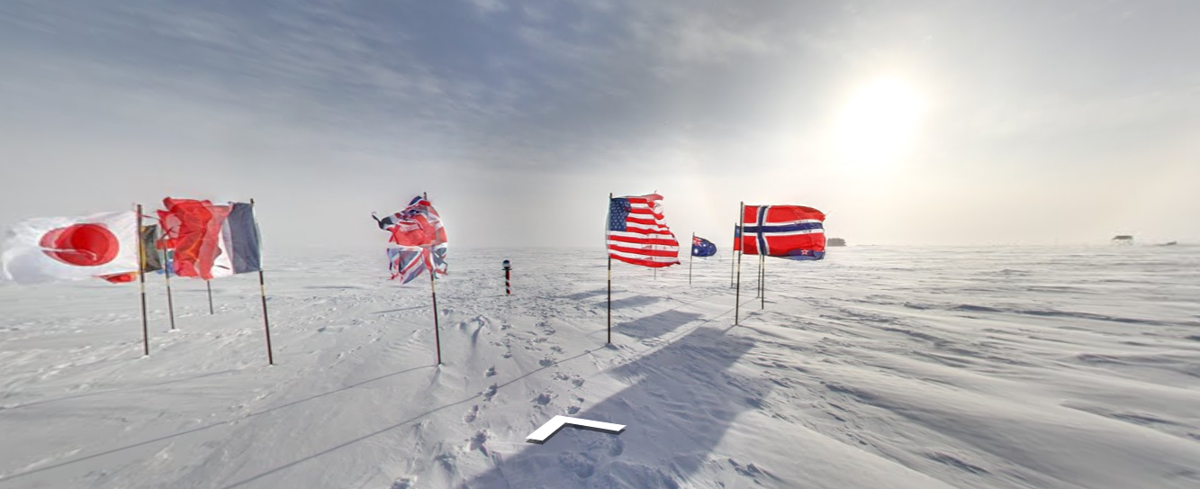

Sources
- Wikimedia. (n.d.). Grand Canyon National Park. [Digital image]. https://upload.wikimedia.org/wikipedia/commons/0/04/-conservationlands15_Social_Media_Takeover%2C_Feb_15th%2C_BLM_Winter_Bucket_List%2C_Grand_Canyon-Parashant_National_Monument_in_Arizona_for_Its_Dark_Sky_Park_Status_(16353386300).jpg
- Flickr.com. (n.d.). Baja California Peninsula. [Aerial Photo]. https://live.staticflickr.com/7155/6660030421_4d5cb5cd2f_b.jpg https://learn.k20center.ou.edu/lesson/1292
- Wikimedia. (n.d.). Sakurajima, Japan. [Digital image]. https://upload.wikimedia.org/wikipedia/commons/0/02/Kagoshima_cityscape_against_the_background_of_Sakurajima_volcano._Japan%2C_East_Asia.jpg
- Picryl.com (n.d.) Wood Valley, Hawaii. [Digital image]. https://cdn4.picryl.com/photo/2019/09/23/storm-in-the-mountains-hawaii-fae0dd-1024.jpg
- Travel in USA. (n.d.). The Narrows, Utah. [Digital image]. https://www.travelinusa.us/wp-content/uploads/sites/3/2019/12/shutterstock_474048757.jpg
- Digital Commonwealth. (n.d.). Lake George, New York. [Postcard/Digital image]. Cliff Smith YMCA Postcard Collection. https://ark.digitalcommonwealth.org/ark:/50959/vm416w818
- Wikimedia. (n.d.). Nile River. Bahir Dar. [Digital image]. https://upload.wikimedia.org/wikipedia/commons/thumb/0/0b/ET_Bahir_Dar_asv2018-02_img32_view_from_Bezawit.jpg/1200px-ET_Bahir_Dar_asv2018-02_img32_view_from_Bezawit.jpg
- Flicker. [2008]. The Red Sea. [Digital Image]. https://flickr.com/photos/st-stev/2432121049/
- Wikimedia. (n.d.). Sahara. Merzouga. [Digital image]. https://upload.wikimedia.org/wikipedia/commons/a/a9/Merzouga_sahara.jpg
- CDN Images. (n.d.). Redwood National Park. [Digital image]. https://cdn-images-1.medium.com/max/2000/1*18Zts411Eit_dm7CyqLurA.jpeg
- Virtual Globe Trotting. (n.d.). Ceremonial South Pole. Antarctica. [Aerial image]. Google Maps. https://virtualglobetrotting.com/map/ceremonial-south-pole/view/google/

