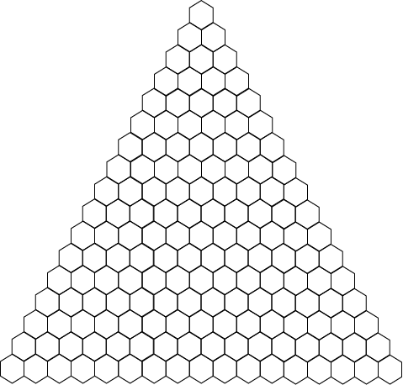
Fill out the triangle based on the pattern.

