H-Chart

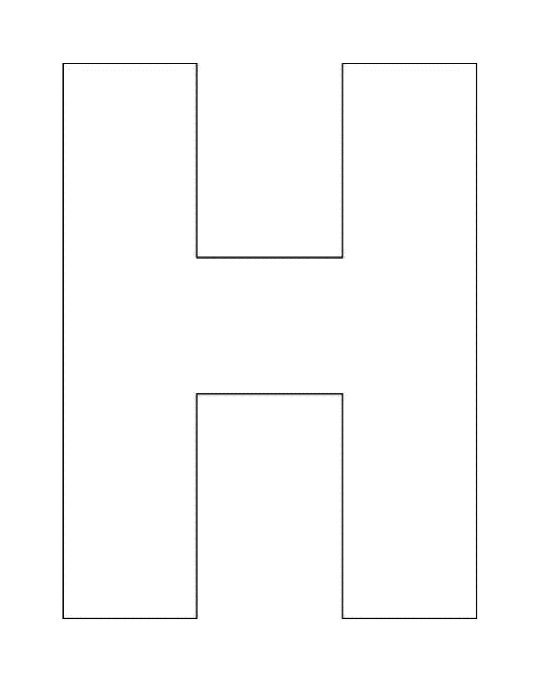

Denote or Connote?

Connotation

Both Videos