WRITING A PROFESSIONAL EMAIL
A necessary skill for most 21st-century digital citizens is professional email communication. A professional, cordial email is not only a sign of respectful communication, but also clearly relays an intention or request that honors the recipient’s time and encourages a desired action, response, or feeling.

Assignment:
Write a professional, cordial email to your teacher that accomplishes a certain task.

Tasks to Consider:
- Question about homework
- Idea to share that was not shared in class
- Thanks for help
- Notification about absence or a problem
- Scheduling time to meet after class

Timing and Length:
When is the best time to send an email? Remember to respect the recipient’s time and to have realistic expectations. Of course, there are always special circumstances (perhaps you only have access to email at a specific time), but try to send an email close to the time of an issue. Additionally, it is best not to expect a response to an email sent late at night. Keep an email short, around four sentences. If it needs to be much longer, have a conversation with the recipient instead.

Format:
- Fonts: Black, 12 pt. Times New Roman, Arial, Calibri

Elements to Consider:
Subject line
Keep the subject line simple, clear, and to the point. Include your name and enough detail to make it immediately clear what the email will be about. Refrain from vague subject lines like “Class Question.”
- Chris Mears - Current Events, Unit 1 Quiz Grade Question

Formal Greeting
Greet the recipient using a salutation, their prefix, and last name.
- Dear Mr. Jones,
- Hello Ms. Abrams,
- Good morning Coach,

Personal context about yourself
If your teacher does not yet know your name (beginning of the year), provide context of who you are.
- This is Chris Mears from your 2nd Hour Current Events class.

Context about request/sentiment/action
Provide context about what the point of the email is.
- I have a question about the graded quiz that was passed back today.

State request/sentiment/action
Clearly state what the issue or topic is.
- The quiz I received in class has a 92% on it, but my online grade is an 82%. When you are able, would you please check my online grade?

Statement of gratitude
- Thank you for your time.
- I appreciate your help.
Formal Closing
Close your email cordially. After a closing salutation, include your full name.
- Thank you,
- Sincerely,

SAMPLE EMAIL
TEMPLATE: Introductory Letter
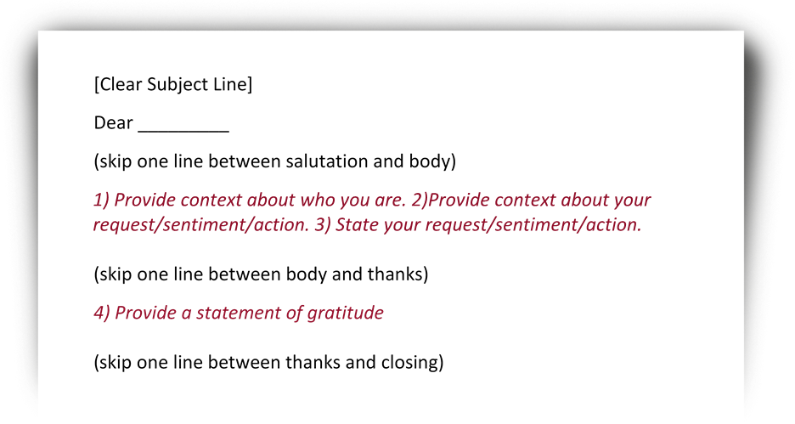

SAMPLE EMAIL: Student to Instructor
