Spend a Buck
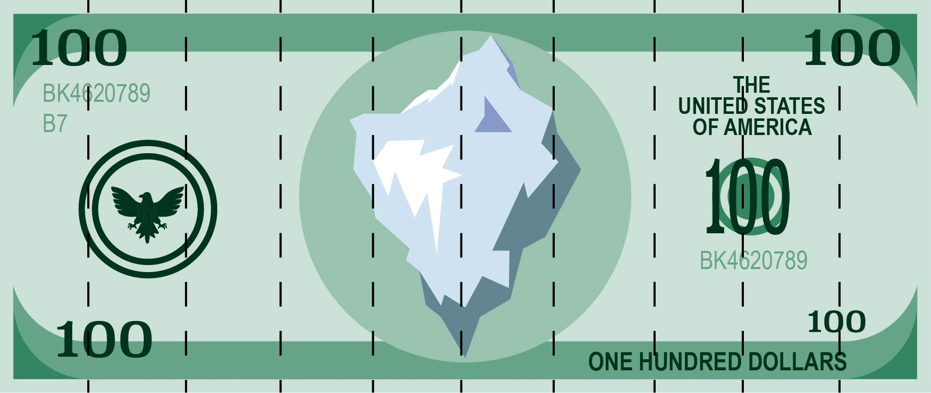
Print one $100 bill per student. Each student will donate their money to a fund of their choice, or they may choose to split their money among funds. Each strip on the bill represents $10.

