SPECTRA OF 14 REMOTE STARS FROM THE SLOANE DIGITAL SKY SURVEY DATABASE
Source: SDSS. (n.d.) Classifying stars. SDSS Voyages. http://voyages.sdss.org/expeditions/expedition-to-the-milky-way/spectral-types/classifying-stars/

Plate: 266/1630 Fiber: 346
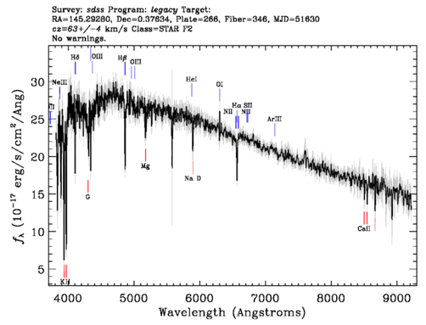

Plate: 266/1630 Fiber: 275
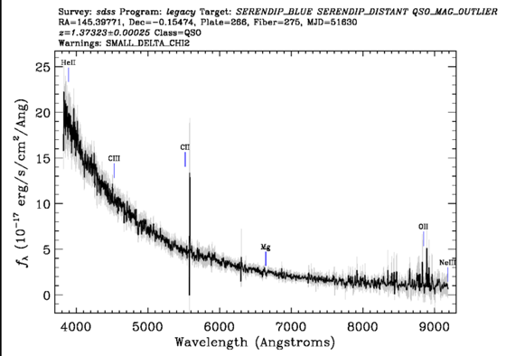

Plate: 266/1630 Fiber: 365
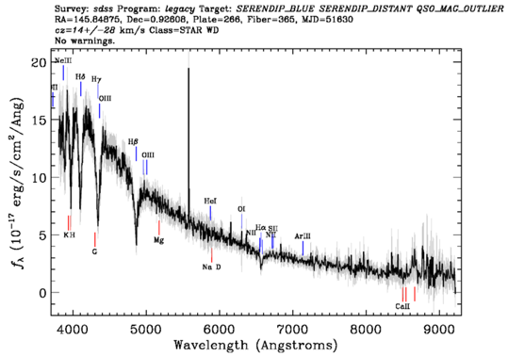

Plate: 273/51597 Fiber: 2
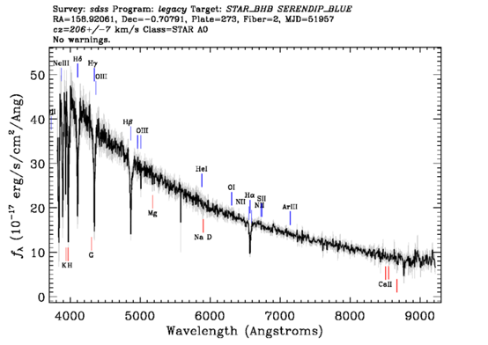

Plate: 273/51597 Fiber: 157
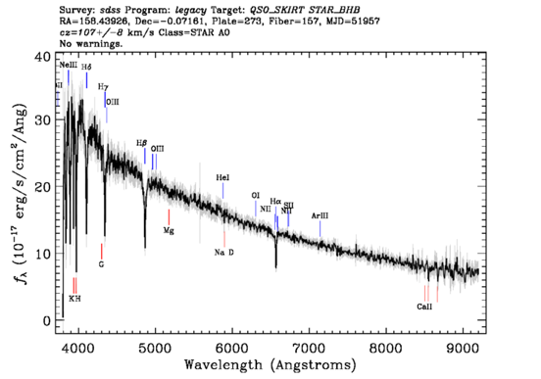

Plate: 273/51597 Fiber: 589
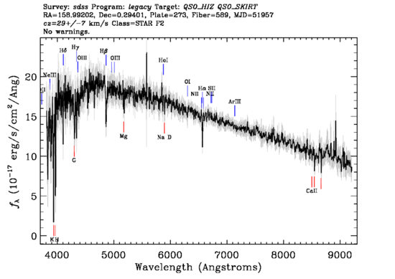

Plate: 281/51614 Fiber: 4
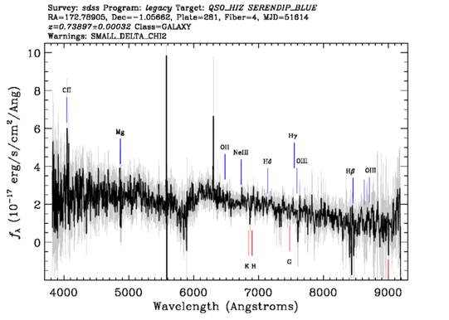

Plate: 266/51630 Fiber: 173
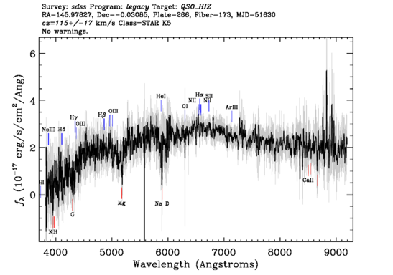

Plate: 266/51630 Fiber: 314
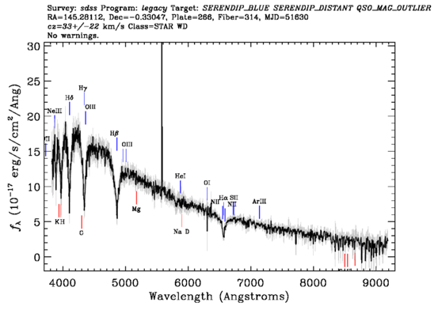

Plate: 266/51630 Fiber: 513
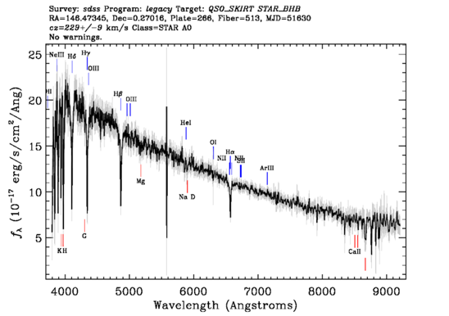

Plate: 498/51984 Fiber: 538
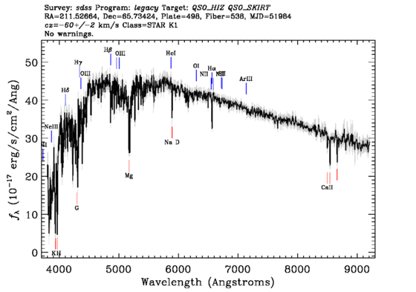

Plate: 273/51597 Fiber: 245
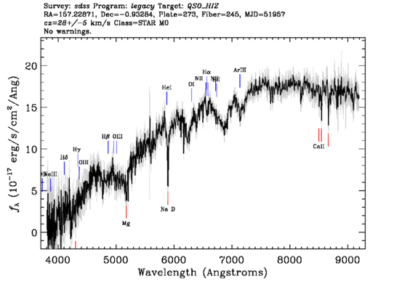

Plate: 281/51614 Fiber: 3
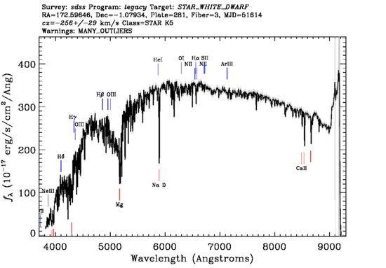

Plate: 281/51614 Fiber: 133

