How to Classify Stars with Spectra (SAMPLE RESPONSES and TEACHER CLARIFICATIONS)

ENGAGE
1. What physical characteristics make stars more likely to harbor an orbiting planet with complex life on it?
Expect and encourage a wide range of answers. Looking for "Sun-like" planets is a typical suggestion and an approach that scientists are using. Students may also suggest that stars should have moderate properties (e.g., give off enough light, but not too much light). Students may also suggest stars need to avoid giving off dangerous radiation, avoid being in binary star systems, or have other properties. The key is to build enthusiasm for the idea that we can narrow our search for stars that could support life by considering the properties stars should have. The list of properties that are most important is only a secondary issue. During the Evaluate, students will read a NASA article that returns to this topic.
2. How do we look for stars with these life-supporting characteristics?
The point of this question is to realize that there are too many stars that are too far away to investigate at close range. Indirect observation with telescopes is the main way we study stars.
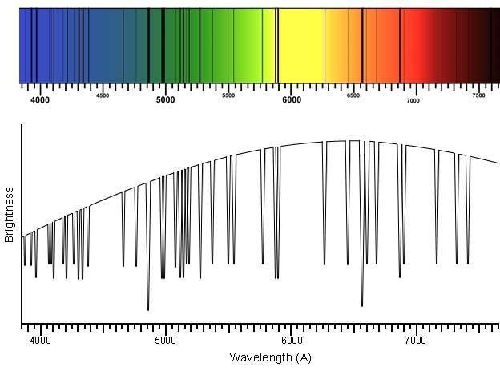
3. Define the terms star spectra and spectral absorption lines. What can we learn about star characteristics by studying them? Try to guess!
A key way to learn about a star from a distance is to study the star's emitted light. As shown in the figure (also used in slide 6), starlight can be separated into a rainbow-like spectrum that reveals details that provide information about the star using a diffraction grating (like a prism, spectroscope, spectrometer, etc.). For example, spectral absorption lines (black lines in the spectra or dips in a brightness vs. wavelength graph) reveal the presence and chemical status of elements in a star. In the connected K20 lesson “Emission Spectra of Excited Gasses,” (https://learn.k20center.ou.edu/lesson/986) students view the Sun's spectrum and learn about absorption lines. The figure shown here is the Sun spectrum that was studied in that activity. The time you will spend explaining this will depend on your students’ background. You either engage previous knowledge or teach fundamental background so students understand the data used in the Explore phase.

EXPLORATION
Part A: Compare Star Spectra to Classify 14 Stars
1. Form a team as directed.
2. Open the following database of star spectra that has been curated by the Sloane Digital Sky Survey: http://voyages.sdss.org/expeditions/expedition-to-the-milky-way/spectral-types/classifying-stars/. You can access this link on a device or use a handout instead.
3. Scroll down the webpage to find a table with 14 stars (in two columns of seven) in it. This is what the top of the table looks like:
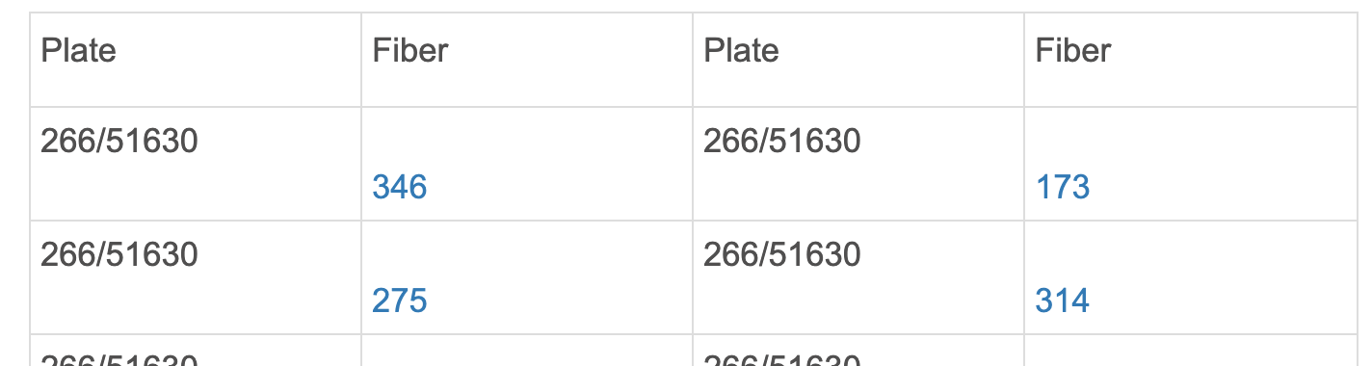
4. Each blue hyperlink (a “fiber” number) opens an information page for a given star. Scroll down the star’s page to find its spectrum. Your goal is to sort the 14 stars into star groups using features of the spectra. What features in the spectra will you use for sorting? Brainstorm with your partner(s) as you look at the first stars in the database.
5. As you study the spectra, sort them into groups. Develop a process (consider taking notes or drawing pictures) to organize your team’s work. Create as many star groups as you need. Different groups can have a different number of stars in them. For a very unusual spectrum, it is okay to make a one-star group, but it is better to carefully look for shared features in other spectra and group it. Use a table like the one on the next page to record your classification. There is no correct number of groups, so you might not use every row in the table. Give each group of stars a name.

CLASSIFICATION OF 14 STARS BY THEIR SPECTRA: OUR TEAM
Stars in Group | Characteristics of Stars in this Group | Name for the Star Group

6. In a paragraph, summarize the process you used to classify the stars into groups.
There is not a single correct classification scheme, but the schemes developed should be founded on systematic logic and data. Many students are likely to use the overall spectrum shape (including the wavelength of maximum brightness) and the dips (absorption lines) in the spectra for sorting. These are the two major features astronomers used to build their initial classification schemes.

Part B: Compare Star Classifications
As directed, partner with another team to compare your classification systems. First, spend a few minutes comparing your classifications with your partnered team’s classifications.
Next, take notes while you discuss the following questions with your partnered team.
- Which team created fewer star groups? Is it better to have more groups or fewer groups?
The ideal number of star groups is somewhat arbitrary—commonalities and differences are both informative. Groups with only one star are best avoided.

- List the stars that are grouped together in both classification schemes.
Answers will vary. There is not a single correct classification scheme.

- What feature(s) of the spectra did the other team focus on to sort the stars?
Answers will vary. There is not a single correct classification scheme.

NOTE: As teams complete questions 10–14, prepare to facilitate a discussion of when and how scientists should cooperate. This discussion should act as a segue to the classification scheme explored in the Explain activity. For further explanation, see the note after question 14.
Next, work with your partnered team to create a consensus classification that both teams are willing to accept. Make a table or a diagram to document this classification. Try to make a figure explains your grouping process to other groups without you explaining it.
- Was it difficult for both teams to agree on this consensus classification? Why or why not?

- What strategies did your combined group use to discuss differences and build consensus?

- Would it be easier to classify stars into groups if you had additional information about the stars? If so, what else do you want to know about the stars?

- Do you think teams of scientists that first classified stars compared results with other teams before reaching their final classification scheme?

- In general, when and how should scientists compare their results with those from other scientists?

Based on the above questions, facilitate a class discussion about when and how scientists should cooperate. If needed, guide the discussion toward the idea that independence is needed for the development of new ideas. Additionally, cooperation is needed for synergistic breakthroughs and to confirm (or refute) ideas from another group.
Use this discussion to segue to the classification scheme explored in the Explain activity. In brief, the OBAFGKM classification used in the Explain phase is a middle step in classification systems. It was built by substantially modifying (and improving the usability) of an alphabetical scheme developed by Draper. It was subsequently elaborated to include more complexity and some new data as the Morgan-Keenan scheme. For a fuller explanation of this history, see the COSMOS page on the Harvard Spectral Classification (https://astronomy.swin.edu.au/cosmos/h/harvard+spectral+classification).
EXPLAIN
Part A: How do Astronomers Classify Stars?

Like your classification, the OBAFGKM classification system sorts stars using star spectra. Each letter (O, B, A, F, G, K, and M) is a label for a different group of stars. Key spectral lines and the specific elements responsible for making them are shown in Tables A1 and A2. The correlation of these star groups with star temperatures is also shown in Table A2.

Element Creating Spectral Line | Wavelength of Spectral Line (Angstroms)
Helium, Ionized | 4400
Helium, Neutral | 4200
Hydrogen Atom (H_{α}, H_{β}, H_{γ}) | 6600, 4800, 4350
Ionized Calcium (Ca) | 3800-4000
Sodium  (Na) | 5800
Titanium Oxide (O) | Lots of lines 4900 - 5200, 5400 - 5700, 6200 - 6300, 6700 - 6900

Table A1. Absorption lines in star spectra

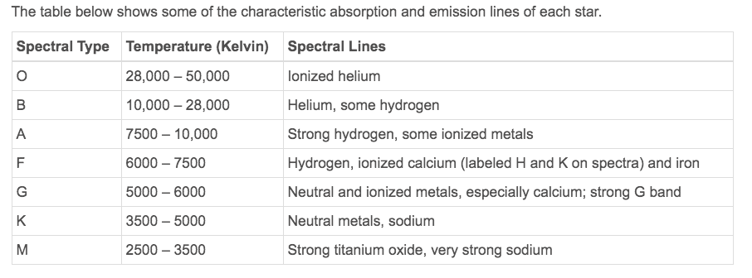

Table A2. Characteristics of OBAFGKM stars

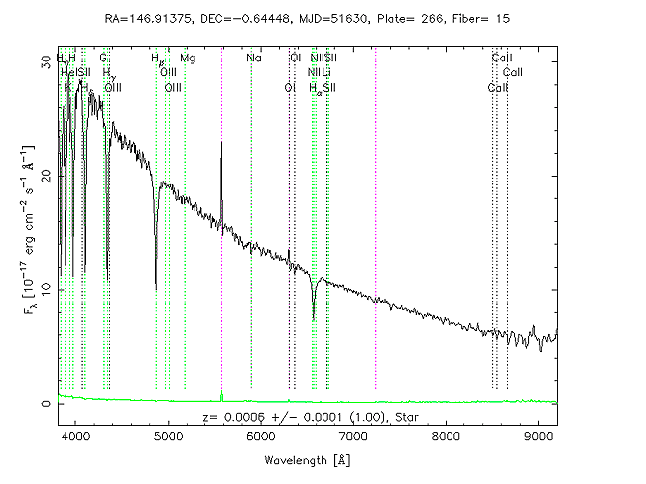

Figure A3. Spectrum of a star (not the Sun)

Our Sun is classified as “G” type. Use the data shown in Figures A1–A3 to answer the following questions about the Sun.
- Look at Table A2. What range of surface temperature is expected for the G-type Sun?
According to Table A2, we expect the G-type Sun to have a temperature between 5,000 and 6,000 K. Students may want or need to be told about the Kelvin temperature scale.
- Look at Table A2. What spectral lines are characteristic of absorption in G-type spectra?
Table A2 indicates that the Sun should show spectral lines associated with metal elements (like Ca and Na in table A1).
- According to Table A1, ionized calcium absorbs 3800-4000 Angstrom light. Is ionized calcium absorption expected in the G-type Sun spectrum? Why or why not?
Ionized calcium is an ionized metal, so its absorption at 3800–4000 Angstroms is expected in the G-type Sun spectrum.
- According to Table A1, what wavelengths of light are absorbed by helium?
According to Table A1, neutral helium atoms absorb at 4200 Angstroms and helium ions at 4400 Angstroms. Ideally, students will question helium's ability to make an ion. It is a noble gas, and the dogma is that noble gases do not ionize. In short, helium will only ionize at very high temperatures, which gives electrons the high energy needed to escape the nucleus. Part B addresses this phenomenon in detail.
- Based on Table A2, are spectral lines from helium absorption expected in the G-type Sun spectrum? Why or why not?
G-type stars are not characterized by helium absorption. This could prompt questions because some students may know that helium is one of the two main elements in stars. The lack of absorption does not mean there is no helium in the star. It just means the electrons are not poised to absorb visible light wavelengths. Part B addresses this issue in detail.

Figure A3 shows a spectrum for another star (not the Sun). Refer to this spectrum, as well as Table A1 and A2, to answer the following questions:
- List the wavelengths of the seven strongest absorption lines (dips) in the Figure A3 spectrum.
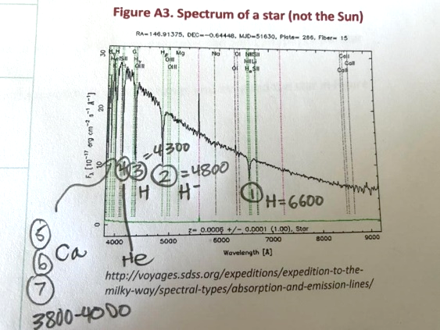
See the below answer.
- Referring to Table A1, identify the elements that cause the strong absorption lines you noted in the previous question.
To the right is an annotated picture of Figure A3 (also used in slide 13) identifying lines at 4300, 4800, and 6600 Angstroms in the spectrum as being the result of hydrogen absorption. There are also lines from 3800 to 4100 Angstroms that match Ca and neutral helium absorption.
- Based on the elements you identified in the previous question, assign this star an “OBAFGKM” type.
Take a student vote before discussing this. Remember, students should be encouraged to defend any answer with logic and data. The strong hydrogen lines indicate a type B, A, or F star. The calcium lines below 4000 Angstroms are most consistent with F-type stars.
- Based on the assigned “OBAFGKM” type, predict a range of surface temperatures for this star.
The temperature should match the star type identified. For example, the surface temperatures of F-type stars are 6000–7500 Kelvin.
- Which star is expected to have a higher surface temperature, the Sun (G-type) or the star shown in Figure A3? Explain briefly.
Most students will probably match the spectra to a star-type that is hotter than the G-type Sun.
- How confident are you of the class and temperature range you assigned the star in Figure A3? Explain.
As in all science, certainty at less than 100% is natural and part of the process of analyzing data. Ask students if the class vote was helpful. Ask if having additional measurements or information would help. In the Extend phase, students learn about a second equation that is an alternative for measuring star temperature.
- Is star temperature an important characteristic for finding stars that can support life? Why or why not?
This question serves to focus in on temperature as a subject for the rest of the lesson. Optionally, preview the reading in the next phase of the lesson by pointing out that temperature is a key feature astronomers use to find stars with planets that could support complex life.
EXPLAIN (continued)
Part B: Why Do Different Elements Absorb Better at Different Temperatures?
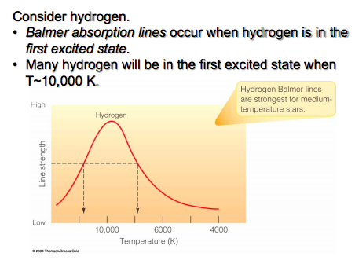
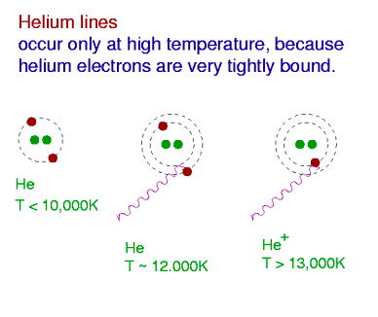
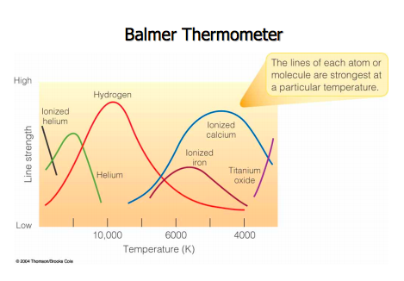
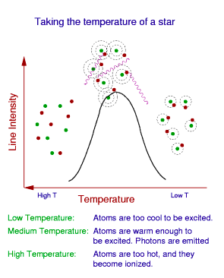

B1
B2
B3
B4
Images courtesy of Dr. Karen Leighly, University of Oklahoma

Refer to the figures above to help you answer the questions on the next page.
Note: You may need to lay some groundwork to review or introduce the Bohr models and excited state electrons. Slide 14 is provided for this purpose. For in-depth background, refer back to the connected lesson “Emission Spectra of Excited Gasses” (https://learn.k20center.ou.edu/lesson/986). Use slide 15 to go over the answers.

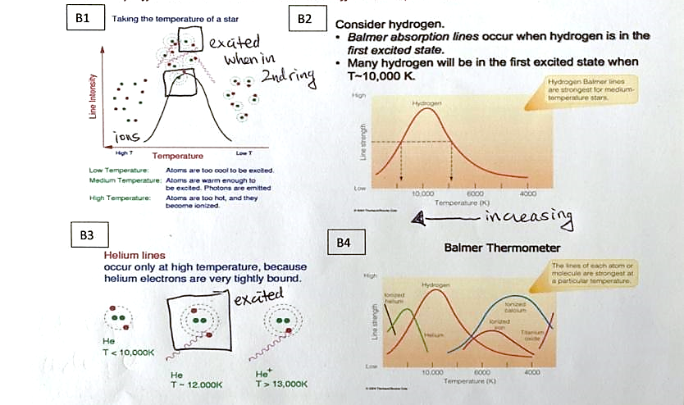
- To absorb light, electrons in atoms must become “excited”. In Figures B1 and B3, atoms (green dots) are shown with electrons (red dots) occupying different energy levels in a BOHR diagram (dotted rings). In Figures B1 and B3, draw squares around atoms with excited electrons.
In the annotated picture of Figures B1 and B3 (see the picture to the right and slide 15), squares have been drawn around atoms with excited electrons. They are atoms with electrons promoted to outer energy levels (rings) that are physically farther from a nucleus and a higher energy state.
- According to Figure B2, at what star temperature does hydrogen best absorb light?
According to Figure B2, hydrogen best absorbs light at a temperature just below 10,000 K. Notice the temperatures are increasing from right to left in the figure (the opposite of what most expect).
- True or false? According to Figure B4 and compared with hydrogen, helium best absorbs light in relatively hot stars. Justify your answer.
True, helium best absorbs light in relatively hot stars. This is shown in figure B4. Remember temperatures are decreasing left to right, so helium absorbs best at a hotter temperature as shown by the peak displaced to the left of hydrogen's peak.
- True or false? Table A2 also indicates that helium absorbs better in relatively hot stars.
True, Table A2 also indicates that helium absorbs better in relatively hot stars. Helium absorption typifies type O and type B stars: the hottest star types. Hydrogen absorption occurs in relatively cooler type B, A, and F stars.
- Compared with hydrogen, why does helium absorb better at higher temperatures? (Two hints: this is shown in the figures, and helium is a noble gas.)
Use slides 16–17 to teach this difficult point. To absorb energy in the visible light range, electrons start in the 2nd energy level and then can absorb visible light to move to higher energy levels (slide 16; this is the "Balmer series"). Helium is a noble gas with relatively high nuclear charge density and little shielding, so relatively large electrostatic forces between helium electrons and the nucleus cause the electrons to remain close to the nucleus in a ground state. Therefore, relatively high temperatures are needed to excite electrons to the 2nd level excited state where they can absorb visible light (show slide 17). Hydrogen is a larger and more reactive atom than helium because there is only one proton in the nucleus and the electron is held less tightly by electrostatic interactions. It takes less energy (temperature) to excite the hydrogen electron to the 2nd level, where it absorbs incoming visible light radiation (slide 16).

EXTEND

Research questions 1–4 and record your findings.
- O-type stars are rarely observed in the universe.
  - First, make a guess: Given the relative temperature of O-type stars (expressed in the data above), why are there relatively few O-type stars?
  - Next, research: What OBAFGKM type(s) of stars are the most abundant in the universe?
Type-O stars are the hottest stars. This is the result of high rates of fusion in the core of the stars. The rapid fusion releases large amounts of energy and increases the temperatures of the stars. It also means that the stars run out of material for fusion sooner and have a shorter lifetime. The shorter lifetime causes the abundance of these stars to be relatively low.
- What was Annie Jump Cannon’s role in developing the OBAFGKM classification scheme?
Annie Jump Cannon was the driving force behind the Harvard-based efforts to make the OBAFGKM system in the early 20th century. Like many women scientists in this historical era, her pathway to contribution and recognition was impeded by barriers to female entry and participation in science. For more information, see Scientific Women’s “History of Scientific Women: Annie Jump Cannon” (https://scientificwomen.net/women/cannon-annie-24) or show the short video “Annie Jump Cannon: Unsung Heroes of Science 2020” (https://www.youtube.com/watch?v=T8r8Pw4RQ_k).
- Why are letters are missing in the OBAFGKM system? Why are the letters in the system not in alphabetical order?
The use of letters was introduced in an earlier star classification system. Originally, the order of star groups was alphabetical. When the Harvard group improved the classification, they reduced the number of star groups (eliminating letters) and found that the classification worked better when the order of some groups was rearranged, breaking alphabetical order. These changes were accepted because they were driven by improved technology (better telescopes) that allowed more data to be collected for the classification.
- Music students, in order to memorize the notes on the treble clef (EGBDF), often memorize the mnemonic “Every Good Boy Does Fine.” Create a mnemonic to memorize the order of letters in OBAFGKM. (Be creative! Don’t use a mnemonic you find on the web.)
Many mnemonics for this star classification order can be found in a quick online search, including the somewhat dated "Oh Be A Fine Girl, Kiss Me" and the sarcastic "Only Boring Astronomers Find Gratitude Knowing Mnemonics." Encourage your students to bring their own personality and creativity into this process to devise their own mnemonic.

Read the following information. Then answer questions 5–8.
Stars (and other radiating “blackbody” objects) emit light at a peak wavelength that depends on their temperature. A second way to measure star temperatures is to measure the peak wavelength of light emission in a star spectrum and then apply this equation:

T = 2.897 x 10⁻³ m K / λ_{peak}.
The equation has two variables: T is the temperature in Kelvin, λ_{peak} is the wavelength in meters. The m and K stand for meters and Kelvin and are units for the constant, not variables.
- According to this equation, as star temperature increases, does peak wavelength increase or decrease? Explain.
The relationship is inverse. As T increases, wavelength decreases and vice versa.

- Which star should have a higher temperature: Star A with a peak wavelength of 400 nanometers, or Star B with a peak wavelength of 720 nanometers? Explain or show your work.
The lower wavelength (400 nm, Star A) is emitted by the higher temperature star. Students may be aware that blue (400 nm) fire is hotter than red fire (720 nm), and the relationship is analogous with star colors.

- Which star should have a higher peak wavelength of emission: Star X with a surface temperature of 3000 K or Star Y with a surface temperature of 10,000 K? Explain or show work.
With a lower temperature, Star X will emit light with a higher peak wavelength.

T = 2.897 x 10⁻³ m K / λ_{peak}.
- Let’s use the equation to study the Sun. The peak wavelength for the Sun is 5100 Angstroms.
  - Convert the wavelength to meters (1 m = 1x10⁻¹⁰ Angstroms) for use in the equation.

  - Calculate the predicted surface temperature of the Sun in Kelvin.

  - Compare the temperature you calculated with the equation to the expected surface temperature of G-type stars shown in Figure A2. Do the two measures agree?

  - The human eye can detect wavelengths from 380 to 700 nanometers. Is it a coincidence that the peak wavelength for the Sun (640 nm, 6400 Angstroms) is in this range?
Life on Earth evolved in an environment illuminated by the Sun's electromagnetic radiation. So, there would have been a selective advantage to organisms capable of improving their fitness by detecting these frequencies. They would outcompete organisms that did not have the biological capability to detect sunlight. In other words, it is likely that the range of visible light for life on a planet is dictated by the light made by its star. In another star system where a star emits a different range of wavelengths, the hypothesis is that organisms would evolve to "see" a different range of "visible" electromagnetic wavelengths (such as IR or UV light). Of course, we do not yet have evidence for this hypothesis because life has not been discovered on any other planet.
EVALUATE
First, read the following NASA article on the connection between star types and habitable planets: “Goldilocks Stars are the Best Places to Look for Life” (https://www.nasa.gov/feature/goddard/2020/goldilocks-stars-are-best-places-to-look-for-life).
Then, use the 4-2-1 strategy to identify and discuss the most important ideas.
- On your own, identify and write down the four most important ideas from the reading.

- In pairs, share your ideas, and decide on the two most important ideas from the reading.
- In groups of four, share your ideas, and decide on the most important idea from the reading.

Finally, write individually for 3-5 minutes to explain what you have learned from this activity and reading. Try to explain the reading to someone who isn’t familiar with classifying stars.

Answers will vary. A few points to emphasize or look for in student work:
- Planets of moderate temperatures are currently considered more likely to harbor life. This is the “Goldilocks hypothesis.” Stars that are too hot burn out before complex life can develop. Stars that are too cold make zones of habitation that are too narrow and reduce the probability of a suitably located planet in the solar system (as shown in the figures in the reading).
- The M, K, and G types have the best balance between lifetime and zones of habitation. Our sun, a larger “G-type” is almost too hot (so shorter lifetime) to be a good candidate star. K-type stars are considered to have the most optimal temperatures by the authors of this reading.
- Remind students that we need to collect and understand spectra to categorize planets by star temperatures and find candidate stars.

Sources
Garner, R. (Ed.). (January 2020). Goldilocks stars are best places to look for life. NASA. https://www.nasa.gov/feature/goddard/2020/goldilocks-stars-are-best-places-to-look-for-life
Germany, L., Proctor, R., Gaztelu, A., Mackie, G., Maddison, S., Lagos, A., Kilborn, V., Bailes, M., Graham, A., Bains, I., Waugh, M., Murphy, N., Ford, A., Knebe, A., & Musgrave, R. (n.d.). Harvard spectral classifications. Swinburne University. https://astronomy.swin.edu.au/cosmos/h/harvard+spectral+classification
Investigating Astronomy. (n.d.). Solar spectrum. TERC. https://ia.terc.edu/spectral_solar_spectrum.html
K20 Center. (n.d.). Emission spectra of excited gasses. 5E lessons. https://learn.k20center.ou.edu/lesson/986
Hertford College, Oxford. (2020, May 11). Annie Jump Cannon: Unsung Heroes of Science 2020 [Video]. YouTube. https://www.youtube.com/watch?v=T8r8Pw4RQ_k
Scientific Women. (n.d.). History of scientific women: Annie Jump Cannon. Scientificwomen.net. https://scientificwomen.net/women/cannon-annie-24
SDSS. (n.d.) Absorption and emission lines. SDSS Voyages. http://voyages.sdss.org/expeditions/expedition-to-the-milky-way/spectral-types/absorption-and-emission-lines/

