Solar Spectrum and Light Absorption – Representative Data
Images shown in Figures 1–6 were gathered using a “Project STAR” spectrophotometer and an iPhone 6 camera.

Full input light
Figures 1–3 show representative data obtained without blocking any input light.

1. Light off white paper 2. Light off red paper 3. Light off green paper
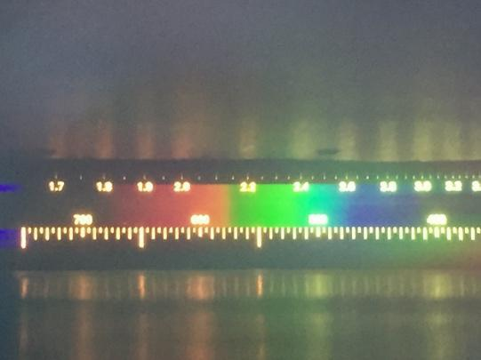
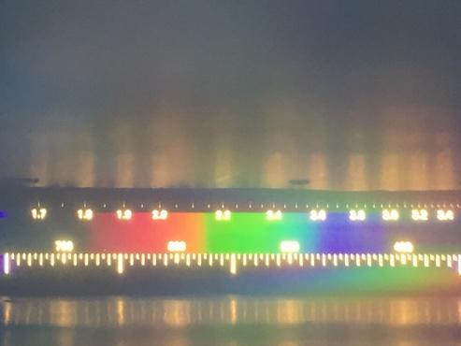
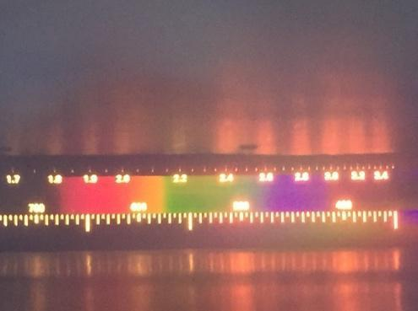

If students have trouble seeing the spectrum with the diffuse extraneous light that appears above and below the spectrum, then show them that they can hold their hand over the large panel (as shown in Figure 4) to limit input light to the narrow slit. You lose the wavelength numbers, but the spectra are easier to view qualitatively (Figures 5 and 6).

Blocked input light
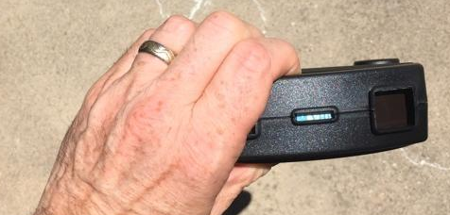
4. Blocking input light 5. Off red paper, held as D 6. Off green paper, held as D
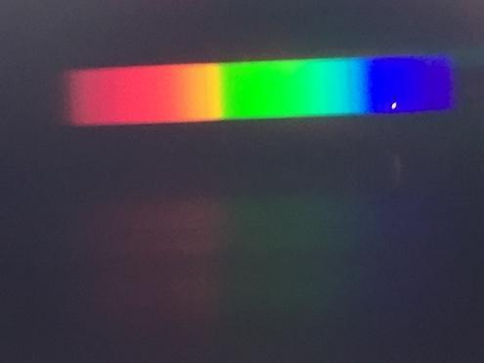
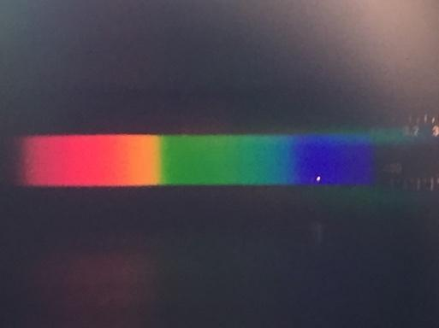

Though the absorption lines in the solar spectrum do not readily pop out in these iPhone photos, rest assured that a good spectroscope, like the project star spectrophotometer, allows viewing of the absorption lines.

Allow enough time for all of your students to verify the spectrum with their own eyes and record some primary data. You could make it a class challenge to capture the best photo to share with others. Encourage students to think about how they could block light that is not going through the spectroscope to make a better image. That is the subject of an extend question in the handout.

