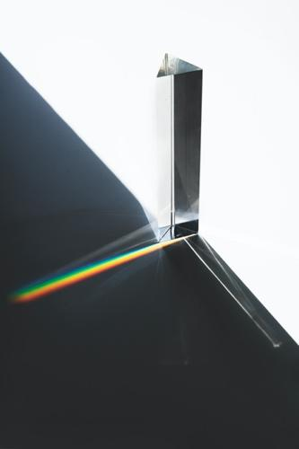
Light Absorption and Solar Spectra – Sample Responses
https://www.freepik.com/photos/background

ENGAGE:
1. What clothing colors stay cooler on bright, sunny days? What role does light absorption and reflection play in this phenomenon?
White clothing reflects light better than colored clothing. This is because white clothing lacks pigments needed to absorb photons of incoming light. Use slide 5 to helps students distinguish absorption from reflection. Black clothing absorbs the fullest spectrum of visible light, and the energy content of absorbed light is converted into heat. Other colors reflect wavelengths that combine to make the color seen. For example, red clothing reflects light colors that blend to red while absorbing other complementary colors, with the absorbed light energy converted into heat.
2. Draw or describe an example of a light spectrum. How do spectroscopes help scientists observe them?
The image on slide 6 shows a spectrum. Rainbows are the best known example of spectra. A spectrometer contains a diffraction grating that separates mixed incoming light into its constituent rainbow colors (like a prism or spectroscope).
3. How do stars make light? What star properties make stars better suited to support life on an orbiting planet? What can we learn about star properties by looking at the light spectra they emit? It is good to guess or research!
This is a broad question and students will likely offer a wide range of answers. It is okay to encourage students to get excited about this question and not worry about delivering specific content. Let students know that the lab activity will result in a tool that is used by astronomers to analyze stars and search for solar systems that could sustain life. The next box offers an optional reading that you could use to engage this question more fully.
4. Staring at the Sun can cause blindness. How does sunlight cause blindness?
Slide 7 helps address question 4 and the lab's SAFETY concern—that students should not look directly at the sun with or without the spectrometer. Sunlight can cause short-term eye damage similar to a sunburn called solar keratitis, and UV frequencies can burn through tissues to cause solar retinopathy. The eye does not contain any pain receptors, so we don't feel the damage being inflicted. This website provides more information: https://www.science.org.au/curious/people-medicine/will-looking-sun-really-make-you-blind

EXPLORE:

Part A: Observe the Light Spectrum of the Sun
***Safety Reminder: DO NOT look directly at the sun by eye or through a spectroscope. Instead, look at the light reflected off of the papers.***
1. Form groups as directed. Gather three pieces of paper, one white and two different colors, and a spectroscope/spectrometer.
2. Place the pieces of paper on a flat surface in direct sunlight.
3. View the light reflected off of the WHITE paper with a spectrometer/spectroscope. Adjust your eye positioning to observe the rainbow-like spectrum. Ask for help if you are not seeing it.
4. Record answers to the following questions:
A) Are all of the colors of the rainbow equally bright in the spectrum?
B) How many thin, black lines can you see in the rainbow spectrum? (HINT: If available, it can help to take a picture of your spectrum to observe the black lines.)
5. Discuss your observations with a neighbor. Did they see any black lines? How many? Did they get a good picture of the spectrum?
6. In the data table provided (next page), draw the spectrum you see reflected off of white paper. Draw in color and mark the location of black lines (MISSING colors) in the spectrum. Label the wavelength or frequency of black lines if your spectroscope has that capability.
7. Now observe the light reflecting off of at least two different colors of paper. Draw the spectrum for light reflecting off of one color in the data table.
8. Feel the different papers in the sun with your hands. RECORD a description of the relative temperatures of the different colors of paper.

Drawings of Spectra for Sunlight Reflected Off of Different Colors of Paper

White Paper

(nm) 700 600 500 400 300

Colored Paper = ______________ (put color of paper in the blank)

(nm) 700 600 500 400 300

Part B: Analyze the Spectrum of the Sun
The figure below shows a detailed spectrum for light from the Sun. During PART A, you might have seen something similar to this when you viewed sunlight reflected off of white paper. The graph below the spectrum quantifies the brightness of different wavelengths of light in the Sun spectrum.
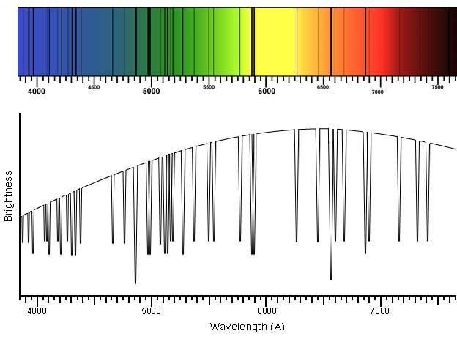
IMAGE CREDIT: https://ia.terc.edu/spectral_solar_spectrum.html

Students are expected to find matches noted on the figure shown in the image below. Students are likely to find matches for SOME or ALL lines for H, He, C, N, O, and Mg. They are not expected to find matches for Ne or Si. It can be helpful to collect class votes about each element make sure students understood the matching activity.
1. According to the brightness graph, what color(s) are the brightest colors in sunlight? What is approximate wavelength (in Angstroms) of the brightest color?

DID YOU KNOW?
Scientists have concluded that star spectra result from a blackbody emission of color at the center of a star minus the colors (black lines) absorbed by specific elements in the star. “Absorbed” means light has been captured by the element.

2. Open this webpage, (https://ia.terc.edu/spectral_catalog.html) to view a spectral catalog of element absorption. As you click on different elements, you can see the wavelengths of light that are absorbed by each element.
3. Do elements tend to absorb many lines of color or just a handful of specific wavelengths?
4. Do each of the elements absorb the same colors or different colors of light?

DID YOU KNOW?

To identify elements that absorb light in the Sun, scientists match black absorption lines for a specific element (measured in experiments on Earth) to black absorption lines observed in the Sun’s spectrum. When an absorption line for an element is also an absorption line in the Sun, scientists conclude that the Sun includes that element as part of its makeup. So, let’s use the catalog to find out if any of these eight elements are absorbing light in the Sun!

5. One-by-one, look at each element in the catalog. Write the element’s symbol next to any absorption lines in the Sun spectrum (above) that match an absorption line for the element in the catalog. It is okay if some elements do not have a match in the Sun’s spectrum.
6. In the table below, summarize how well each element’s absorption lines match absorption lines in the Sun’s spectrum by writing the element’s name or symbol in the table.

DATA TABLE: Comparing Element Absorption Lines to Absorption Lines in the Sun Spectrum
How well do lines match? | Elements from database

ALL element lines are in the Sun’s spectrum

SOME element lines are in the Sun’s spectrum

NO element lines are in the Sun’s spectrum

EXPLAIN:

Part A.
A1. When placed in sunlight, do colored pieces of paper have a higher or lower temperature than white paper?
Colored pieces of paper change temperature faster than white paper.
A2. Compare the color of maximum brightness in the Sun’s spectrum to the color kids use to draw Sun pictures in elementary school.
The color of maximum brightness in the Sun spectrum is in the yellow-orange region and many use the same colors to draw the Sun in pictures.
A3. In one or two sentences, describe differences between the spectrum reflected off white paper and the spectrum reflected off of colored paper. Be specific.
The spectrum reflected off of colored paper is brighter for colors that are similar to the paper color and dimmer in other colors (see sample data handout). If different groups observed different colors of paper, canvas them to see if their observations confirm this principle.
A4. Are the brightest parts of colored paper spectra the opposite or same color as the paper? When they hit the paper, what happens to light colors that appear brightest in the spectra?
(A4–A6 go together and slide 10 will help you discuss them.) The brightest parts of colored paper spectra are the same color as the paper. Though students should be encouraged to share different ideas, the pigments in the paper absorb the colors you don't see and the remaining colors we do see are reflected off the paper. Slide 10 gives you a visual to go over this point.
A5. What happened to the light that is reduced or missing in the colored paper spectra?
A6. Why do many people prefer to wear white clothing in the heat of the summer?
White clothing is feels cooler because white reflects light, reducing the light that is absorbed and converted to heat.
A7. Scientists explain the difference in reflected spectra for different colors using the term “absorbed”. For example, atoms in red paper absorb different colors than atoms in blue papers. What happens to the light’s energy when it is absorbed by an atom? Good to guess or research.
(A7–A9) These questions address atomic-level mechanics and energetics during absorption. Slides 11 and 12 use BOHR diagrams to show energetic and physical changes for electrons in an atom. In another K20 activity, similar diagrams are used to explain light emission (click to see K20 activity on this topic) . When a light photon is absorbed, the energy content of the photon is used to excite an electron and change its position to a higher energy level (as shown in the BOHR models in the slides). Electrons only exist in specific, limited energy levels, so only specific, limited light frequencies have the correct amount of energy to be absorbed and promote the changes. Atoms emit specific colors when excited electrons (e.g. energized by flames in a flame test or by electricity in a gas tube) return to ground state. Thus, elements often absorb and emit the same colors because electrons are moving between the same energy levels in both phenomena. (That being said, other phenomenon, such as fluorescence, bend this simplified explanation.)
A8. What changes occur inside of an atom that has absorbed light? Good to guess or research.
A9. Elements emit specific colors when energized (e.g. by flames in a flame test or by electricity in a gas tube). Are the colors an element absorbs the same or different from the colors it emits? Research or explain your hypothesis.

Part B.
B1. Did absorption lines (black lines) for hydrogen match absorption lines in the Sun’s spectrum?
(B1–B3) Typically, students match absorption lines (black lines) for hydrogen and carbon to absorption lines in the Sun’s spectrum. In contrast, absorption lines (black lines) for neon are NOT seen as absorption lines in the Sun’s spectrum. You can use slides 8 and 9 to review the matching process.
B2. Did absorption lines (black lines) for carbon match absorption lines in the Sun’s spectrum?
B3. Did absorption lines (black lines) for neon match absorption lines in the Sun’s spectrum?
B4. To absorb light in a star, the element must be in that star. Based on your previous three answers, do you conclude that the composition of the Sun includes hydrogen atoms? Carbon atoms? Neon atoms?
This leading question might help students realize that elements have to be present within the sun to absorb light leaving the sun. Use slide 13 to introduce or reinforce this logic. Typically, once the logic is introduced, students then assume that hydrogen and carbon, but not neon, are in the sun based on the matching absorbance lines.
B5. Are you surprised by the presence or absence of any of these elements? Explain your answer.
(B5–B6) Here is a chance to talk about the elements that are in the sun. Some students may know H and He are the main elements in stars and will not be surprised absorb light in the Sun. Fewer students would already know that other elements are also in the Sun at a lower abundance and are thus able to contribute absorption lines, as carbon does. However, as B6 introduces, the story is not this simple. B6 is a good chance to think creatively and critically about a complicated science situation. Students might suggest a variety of reasons for the lack of absorption lines. The following is a list of some scientifically supported reasons in the order that students are likely to suggest them in discussion: (1) not every element is in every star, (2) some elements are present but at too low of an abundance to absorb enough light to create absorption lines, (3) some elements may not absorb electromagnetic radiation in visible light range (but could absorb UV, IR, etc.), and (4) the temperature and other properties of stars can change element absorption from the patterns we see at standard temperature and pressure on Earth. The effect of temperature on element absorption is addressed in another OU Physics RET activity in the K20 curriculum.
B6. Absorption lines for 67 elements have been matched to absorption lines in the Sun’s spectrum. Why haven’t absorption lines for all 92 of the Earth’s naturally occurring elements been matched to absorption lines in the Sun spectrum? Be creative and hypothesize at least two specific explanations for this.
EXTEND:
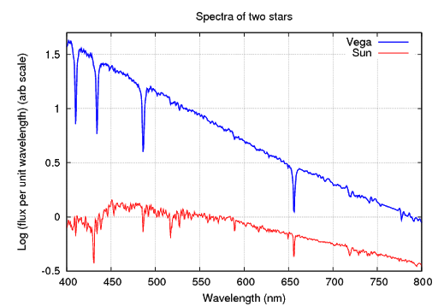
VEGA
SUN
Image Source: http://spiff.rit.edu/classes/phys301/lectures/spec_lines/spec_lines.html

The figure above shows the visible light spectra for two stars: Vega (top line) and the Sun (bottom line). Use this figure to answer the following questions.
1. Compare and contrast the wavelengths of dips (absorption lines) and maximum brightness in these spectra. Be as detailed and specific as possible.
Students should note some of the dips match and others don't. They will also probably notice the gradual decrease in brightness as wavelength increases in Vega's spectrum, which contrasts the mounded shape in the Sun spectrum.
2. Given the pattern of absorption (dips in the spectra shown), are the elements that absorb light in these stars best described as the same, similar, or different? Justify your answer.
The pattern of partially matching absorption (dips) in these stars is best described as similar and suggests similar but not identical elements are in these stars. (However, as raised in Explain #B6, other properties of the stars can affect which elements absorb outgoing light.)
3. When observed WITHOUT a spectroscope, do you predict the stars would appear to be the same color a different color? If different, what color is Vega? Justify your answers.
Students know the Sun is yellow-orange (as discussed in Explain). A quick online search will reveal that Vega is blue-white. If you look at slide 14, you can see that the brightest wavelengths are the relatively short wavelengths of blue and violet light.
4. Hypothesize. Do you think spectra for other stars would be similar, the same, or different from these two spectra? Explain your choice.
Star spectra widely vary, but contain features that allows stars to be grouped according to shared features in those spectra. This is the subject of another activity in the K20 curriculum.
5. Gathering the light to view spectra for distant stars (such as Vega) can be tricky. Propose (guessing is good) at least two reasons why measuring the spectra of Vega and other distant stars is more challenging than measuring the Sun’s spectrum.
(5 and 6 go together) Encourage student creativity over coverage of specific answers. Viewing spectra for far away stars can be tricky because (1) stars are dim and don't emit a substantial amount of light (2) their light can be absorbed in transit by aspects of the universe and our own atmosphere, and (3) their light has to compete with light from other stars (especially the Sun!) to be viewed. Orbiting satellites (like the Hubble telescope) are one example of technology used to collect light from these distant stars. They can be directed away from incoming sunlight and orbit at an altitude that avoids interference from our atmosphere.
6. For each of the reasons you noted in the previous question, provide an experimental strategy you would use to observe spectra from these stars.
7. RESEARCH EXTEND: Scientists have concluded that features of star spectra correlate with the chance that an orbiting planet might support life. What features make a distant star more likely to have a planet that harbors life?
This is an open-ended question and an exciting area of current investigation in astronomy.
8. QUANTITATIVE EXTEND: Wavelengths are labeled with the unit “Å” (an Angstrom) in figures in this activity.
This question could be used to review skills and concepts introduced previously, though you could expand with other material to introduce the EM spectrum or problem-solving algebra in detail here. 5750 Å is the same as 575 nm and 5.75x10-7 m. Ten angstroms make up one nanometer. A billion nanometers make up one meter. Red and orange light have longer wavelengths, while green, blue, and violet do not. Infrared (IR), microwave, and radio waves are other forms of electromagnetic radiation that have longer wavelengths than visible light. X-rays have shorter wavelengths.
a) For yellow light with a wavelength of 5750 Å, calculate the wavelength in nanometers (nm) and meters (m). Show your work.
b) What visible light colors (colors in the rainbow) have longer wavelengths than yellow light?
c) What other types of electromagnetic radiation (X-rays, microwave, UV, IR, etc.) have longer wavelengths than yellow light?
9. ENGINEERING EXTEND. How you would modify either spectroscopes and/or phone cameras to capture better photos of Sun spectra (as in part A of this lab)? Draw (or if allowed, build) your design improvements.
If time allows, this engineering follow up offers a tangible goal for a building activity (improved pictures).
10. BIOLOGY EXTEND. Research and explain the role of light absorption:
- In the human eye to allow color vision.
- In plant chloroplasts to collect energy during photosynthesis.
Eye pigments include double bonds that change from one orientation to another (between cis and trans isomers) when light is absorbed. Like electron excitation, double bond structure changes require specific energies, so only a limited range of wavelengths contain the proper energy to trigger those changes and the signal we perceive as vision. Thus, three types of pigments are used to separately collect three different bands of light colors in the human eye. The signal from the three different pigments is processed in our brain to allow us to perceive the full spectrum of color. Color printers and older TVs work on similar tricolor addition principles. Chloroplasts contain several pigments that absorb light to collect its energy and eventually transduce the collected energy for storage as chemical energy in sugar.

EVALUATE:
1. Write a Two-Minute-Paper to answer the prompt posed by your teacher.
2. Tweet Up a great photo or drawing of a solar spectrum.
3. When prompted by your teacher, write a reflection to describe the Muddiest Point of the discussion.
4. Under your teacher’s direction, execute a Gallery Walk and share out answers for EXTEND questions #7-10.

