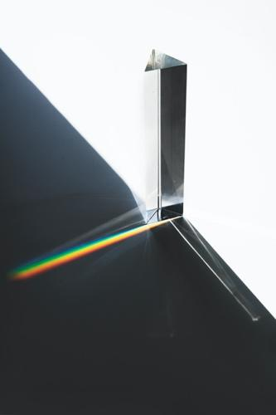
Light Absorption AND SOLAR SpectrA

ENGAGE:
1. What clothing colors stay cooler on bright, sunny days? What role does light absorption and reflection play in this phenomenon?
2. Draw or describe an example of a light spectrum. How do spectroscopes help scientists observe them?
https://www.freepik.com/photos/background

3. How do stars make light? What star properties make stars better suited to support life on an orbiting planet? What can we learn about star properties by looking at the light spectra they emit? It is good to guess or research!
4. Staring at the Sun can cause blindness. How does sunlight cause blindness?

EXPLORE:

Part A: Observe the Light Spectrum of the Sun
***Safety Reminder: DO NOT look directly at the sun by eye or through a spectroscope. Instead, look at the light reflected off of the papers.***
1. Form groups as directed. Gather three pieces of paper, one white and two different colors, and a spectroscope/spectrometer.
2. Place the pieces of paper on a flat surface in direct sunlight.
3. View the light reflected off of the WHITE paper with a spectrometer/spectroscope. Adjust your eye positioning to observe the rainbow-like spectrum. Ask for help if you are not seeing it.
4. Record answers to the following questions:
A) Are all of the colors of the rainbow equally bright in the spectrum?
B) How many thin, black lines can you see in the rainbow spectrum? (HINT: If available, it can help to take a picture of your spectrum to observe the black lines.)
5. Discuss your observations with a neighbor. Did they see any black lines? How many? Did they get a good picture of the spectrum?
6. In the data table provided (next page), draw the spectrum you see reflected off of white paper. Draw in color and mark the location of black lines (MISSING colors) in the spectrum. Label the wavelength or frequency of black lines if your spectroscope has that capability.
7. Now observe the light reflecting off of at least two different colors of paper. Draw the spectrum for light reflecting off of one color in the data table.
8. Feel the different papers in the sun with your hands. RECORD a description of the relative temperatures of the different colors of paper.

Drawings of Spectra for Sunlight Reflected Off of Different Colors of Paper

White Paper

(nm) 700 600 500 400 300

Colored Paper = ______________ (put color of paper in the blank)

(nm) 700 600 500 400 300

Part B: Analyze the Spectrum of the Sun
The figure below shows a detailed spectrum for light from the Sun. During PART A, you might have seen something similar to this when you viewed sunlight reflected off of white paper. The graph below the spectrum quantifies the brightness of different wavelengths of light in the Sun spectrum.
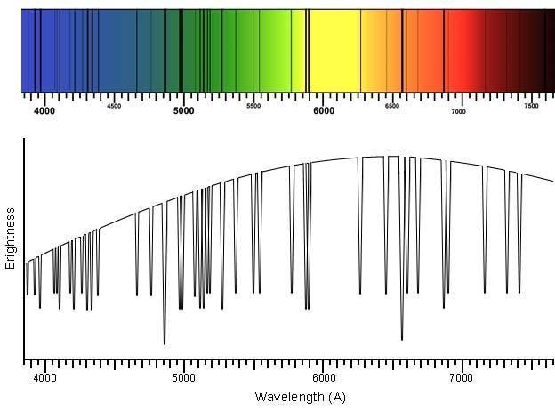
IMAGE CREDIT: https://ia.terc.edu/spectral_solar_spectrum.html

1. According to the brightness graph, what color(s) are the brightest colors in sunlight? What is approximate wavelength (in Angstroms) of the brightest color?

DID YOU KNOW?
Scientists have concluded that star spectra result from a blackbody emission of color at the center of a star minus the colors (black lines) absorbed by specific elements in the star. “Absorbed” means light has been captured by the element.

2. Open this webpage, (https://ia.terc.edu/spectral_catalog.html) to view a spectral catalog of element absorption. As you click on different elements, you can see the wavelengths of light that are absorbed by each element.
3. Do elements tend to absorb many lines of color or just a handful of specific wavelengths?
4. Do each of the elements absorb the same colors or different colors of light?
DID YOU KNOW?

To identify elements that absorb light in the Sun, scientists match black absorption lines for a specific element (measured in experiments on Earth) to black absorption lines observed in the Sun’s spectrum. When an absorption line for an element is also an absorption line in the Sun, scientists conclude that the Sun includes that element as part of its makeup. So, let’s use the catalog to find out if any of these eight elements are absorbing light in the Sun!

5. One-by-one, look at each element in the catalog. Write the element’s symbol next to any absorption lines in the Sun spectrum (above) that match an absorption line for the element in the catalog. It is okay if some elements do not have a match in the Sun’s spectrum.
6. In the table below, summarize how well each element’s absorption lines match absorption lines in the Sun’s spectrum by writing the element’s name or symbol in the table.

DATA TABLE: Comparing Element Absorption Lines to Absorption Lines in the Sun Spectrum
How well do lines match? | Elements from database

ALL element lines are in the Sun’s spectrum

SOME element lines are in the Sun’s spectrum

NO element lines are in the Sun’s spectrum

EXPLAIN:

Part A.
A1. When placed in sunlight, do colored pieces of paper have a higher or lower temperature than white paper?
A2. Compare the color of maximum brightness in the Sun’s spectrum to the color kids use to draw Sun pictures in elementary school.
A3. In one or two sentences, describe differences between the spectrum reflected off white paper and the spectrum reflected off of colored paper. Be specific.
A4. Are the brightest parts of colored paper spectra the opposite or same color as the paper? When they hit the paper, what happens to light colors that appear brightest in the spectra?
A5. What happened to the light that is reduced or missing in the colored paper spectra?
A6. Why do many people prefer to wear white clothing in the heat of the summer?
A7. Scientists explain the difference in reflected spectra for different colors using the term “absorbed”. For example, atoms in red paper absorb different colors than atoms in blue papers. What happens to the light’s energy when it is absorbed by an atom? Good to guess or research.
A8. What changes occur inside of an atom that has absorbed light? Good to guess or research.
A9. Elements emit specific colors when energized (e.g., by flames in a flame test or by electricity in a gas tube). Are the colors an element absorbs the same or different from the colors it emits? Research or explain your hypothesis.

Part B.
B1. Did absorption lines (black lines) for hydrogen match absorption lines in the Sun’s spectrum?
B2. Did absorption lines (black lines) for carbon match absorption lines in the Sun’s spectrum?
B3. Did absorption lines (black lines) for neon match absorption lines in the Sun’s spectrum?
B4. To absorb light in a star, the element must be in that star. Based on your previous three answers, do you conclude that the composition of the Sun includes hydrogen atoms? Carbon atoms? Neon atoms?
B5. Are you surprised by the presence or absence of any of these elements? Explain your answer.
B6. Absorption lines for 67 elements have been matched to absorption lines in the Sun’s spectrum. Why haven’t absorption lines for all 92 of the Earth’s naturally occurring elements been matched to absorption lines in the Sun spectrum? Be creative and hypothesize at least two specific explanations for this.
EXTEND:
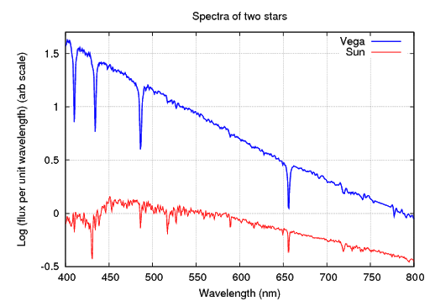
VEGA
SUN
Image Source: http://spiff.rit.edu/classes/phys301/lectures/spec_lines/spec_lines.html

The figure above shows the visible light spectra for two stars: Vega (top line) and the Sun (bottom line). Use this figure to answer the following questions.
1. Compare and contrast the wavelengths of dips (absorption lines) and maximum brightness in these spectra. Be as detailed and specific as possible.
2. Given the pattern of absorption (dips in the spectra shown), are the elements that absorb light in these stars best described as the same, similar, or different? Justify your answer.
3. When observed WITHOUT a spectroscope, do you predict the stars would appear to be the same color a different color? If different, what color is Vega? Justify your answers.
4. Hypothesize. Do you think spectra for other stars would be similar, the same, or different from these two spectra? Explain your choice.
5. Gathering the light to view spectra for distant stars (such as Vega) can be tricky. Propose (guessing is good) at least two reasons why measuring the spectra of Vega and other distant stars is more challenging than measuring the Sun’s spectrum.
6. For each of the reasons you noted in the previous question, provide an experimental strategy you would use to observe spectra from these stars.
7. RESEARCH EXTEND: Scientists have concluded that features of star spectra correlate with the chance that an orbiting planet might support life. What features make a distant star more likely to have a planet that harbors life?
8. QUANTITATIVE EXTEND: Wavelengths are labeled with the unit “Å” (an Angstrom) in figures in this activity.
a) For yellow light with a wavelength of 5750 Å, calculate the wavelength in nanometers (nm) and meters (m). Show your work.
b) What visible light colors (colors in the rainbow) have longer wavelengths than yellow light?
c) What other types of electromagnetic radiation (X-rays, microwave, UV, IR, etc.) have longer wavelengths than yellow light?
9. ENGINEERING EXTEND. How would you modify either spectroscopes and/or phone cameras to capture better photos of Sun spectra (as in part A of this lab)? Draw (or if allowed, build) your design improvements.
10. BIOLOGY EXTEND. Research and explain the role of light absorption:
- In the human eye to allow color vision.
- In plant chloroplasts to collect energy during photosynthesis.

EVALUATE:
1. Write a “two-minute paper” to answer the prompt posed by your teacher.
2. “Tweet up” a great photo or drawing of a solar spectrum.
3. When prompted by your teacher, write a reflection to describe the “muddiest point” of the discussion.
4. Under your teacher’s direction, execute a “gallery walk” to share out answers for EXTEND questions #7-10.

