Playing With Polygons
Read all directions before using scissors. Notice the triangle at the bottom of the page. You will cut out the exterior angles by cutting along the dashed lines. Later, you will need to create your own polygon and cut out its exterior angles—so carefully read and remember the steps below.
 |  | 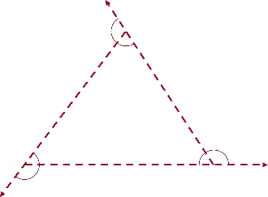 | 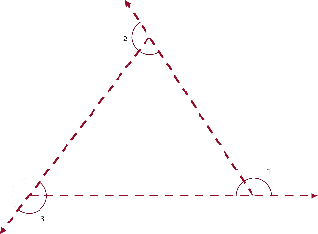
Step 1: Draw a polygon with dashed lines. | Step 2: Take a ruler and draw dashed lines to extend the legs of the polygon. | Step 3: Draw semi-circles that include the interior and exterior angles. Make each semi-circle a different color. | Step 4: Number each exterior angle.
Step 5: Cut out the exterior angles. Step 6: Put their vertices together to form a new shape.
