EKPHRASIS EXAMPLE
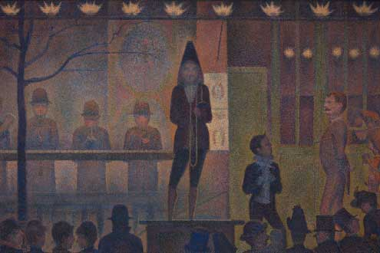
Seurat, Georges. (1887). Circus Sideshow [Painting]. The Met Fifth Avenue, Gallery 825, New York.

Line | Line Starter | What the Subject Does | Sensory Detail | Feeling or Action Evoked by Subject or Viewer | Figurative Language
Line 1 | It seems as if… | the cone-hatted ringleader | bound in deep plum |  | like a jester at court
Line 2 | Makes a… | party of one on his pulpit | To a flat-hatted and round-hatted crowd | suspense, intrigue, anticipation
Line 3 | Ready to… | make the crowd swoon, | with Seurat’s romance of mustards and plums | that romance and entrance | like the real thing—like a circus sideshow
Line 4 | With a… |  |  | long gaze, out of the shadows the image is clear
Line 5 | Finally… | the trumpeter takes a deep breath |  | I watch Seurat’s Circus Sideshow

Draft Example
It seems as if the cone-hatted ringleader, bound in deep plum like a jester at court,
Makes a party of one on his pulpit to a flat-hatted and round-hatted crowd - suspense, intrigue, anticipation.
Ready to make the crowd swoon with Seurat’s romance of mustards and plums that romance and entrance like
the real thing—like a circus sideshow.
With a long gaze, out of the shadows the image is clear.

