EKPHRASIS EXAMPLE
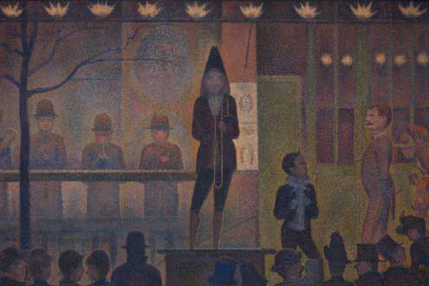
Seurat, Georges. Circus Sideshow. 1887. The Met Fifth Avenue, Gallery 825, New York.
 | Line starter | What the subject(s) does | Sensory detail | Feeling or action evoked by subject or viewer | Figurative language
Line 1 | It seems as if... | the cone-hatted ringleader | bound in deep plum |  | like a jester at court
Line 2 | Makes a... | party of one on his pulpit | to a flat-hatted and round-hatted crowd | suspense, intrigue, anticipation
Line 3 | Ready to... | make the crowd swoon, | with Seurat’s romance of mustards and plums | that romance and entrance | like the real thing- like a circus sideshow
Line 4 | With a... |  |  | long gaze, out of the shadows the image is clear
Line 5 | Finally... | the trumpeter takes a deep breath |  | I watch Seurat’s Circus Sideshow

Draft Example:
It seems as if the cone-hatted ringleader, bound in deep plum like a jester at court,
Makes a party of one on his pulpit to a flat-hatted and round-hatted crowd - suspense, intrigue, anticipation.
Ready to make the crowd swoon with Seurat’s romance of mustards and plums that romance and entrance like
the real thing - like a circus sideshow.
With a long gaze, out of the shadows the image is clear.

