THE DANCE

William Carlos Williams
In Brueghel's great picture, The Kermess,
the dancers go round, they go round and
around, the squeal and the blare and the
tweedle of bagpipes, a bugle and fiddles
tipping their bellies (round as the thick-
sided glasses whose wash they impound)
their hips and their bellies off balance
to turn them. Kicking and rolling
about the Fair Grounds, swinging their butts, those
shanks must be sound to bear up under such
rollicking measures, prance as they dance
in Brueghel's great picture, The Kermess.
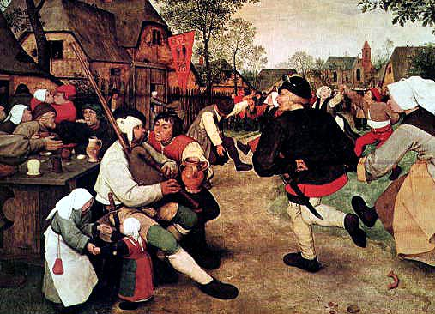
The Kermesse, Pieter Brueghel (1567)

