Home on the Range
Find the domain and range for each of the following.
1. | 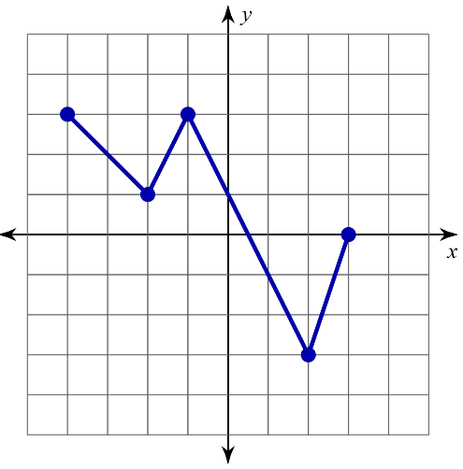 | 2. | 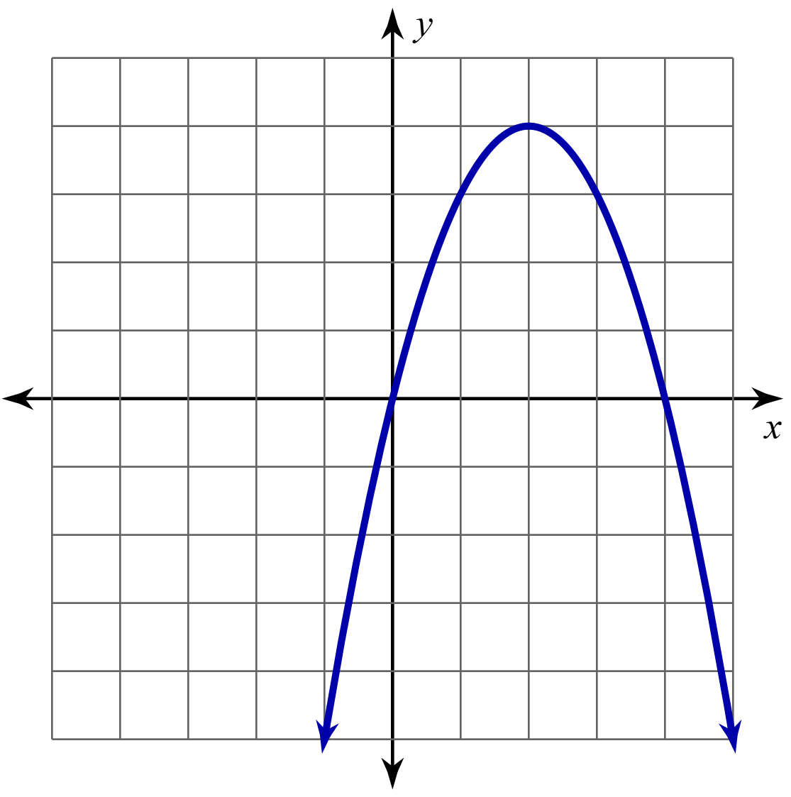
  I Think… | We Think…
  I Think… | We Think…
3. | 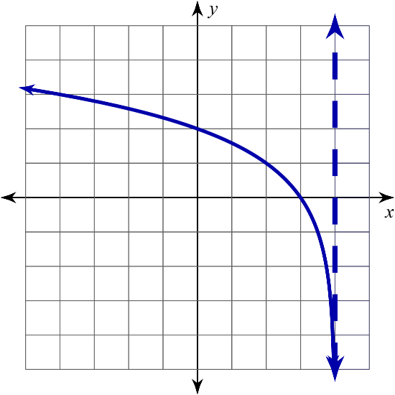 | 4. | 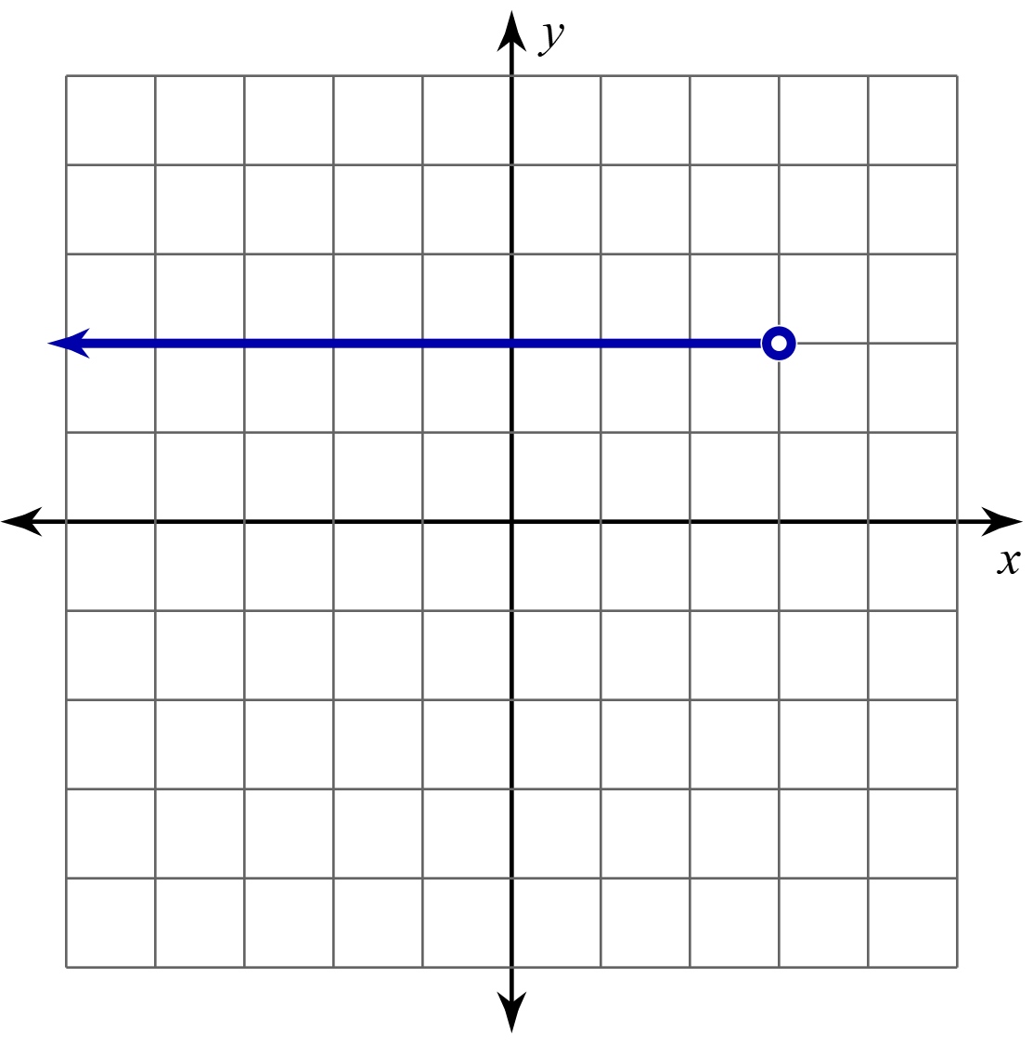
  I Think… | We Think…
  I Think… | We Think…

