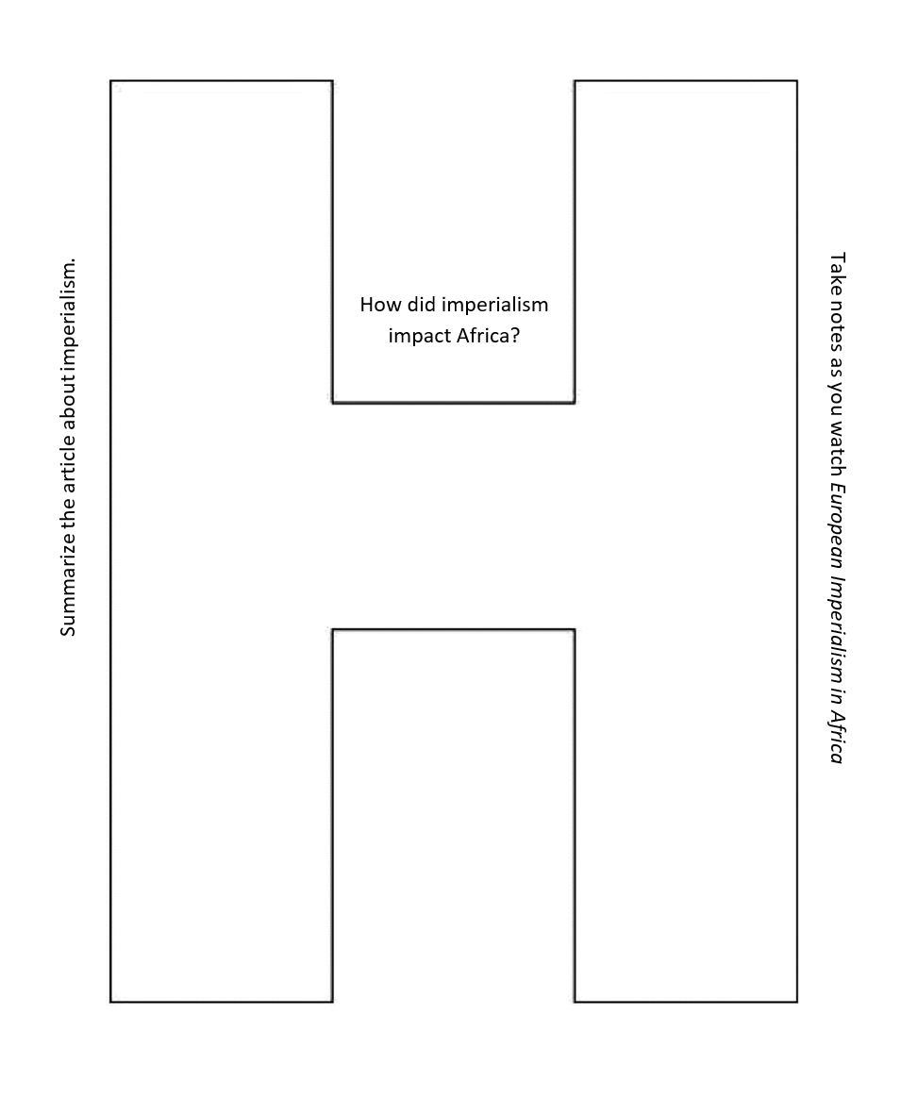
H-chart
How did imperialism affect Africa?
Take notes as you watch the video titled “European Imperialism in Africa.”
Summarize the reading about imperialism in Africa.

