Maps: Africa in 1878 and 1914
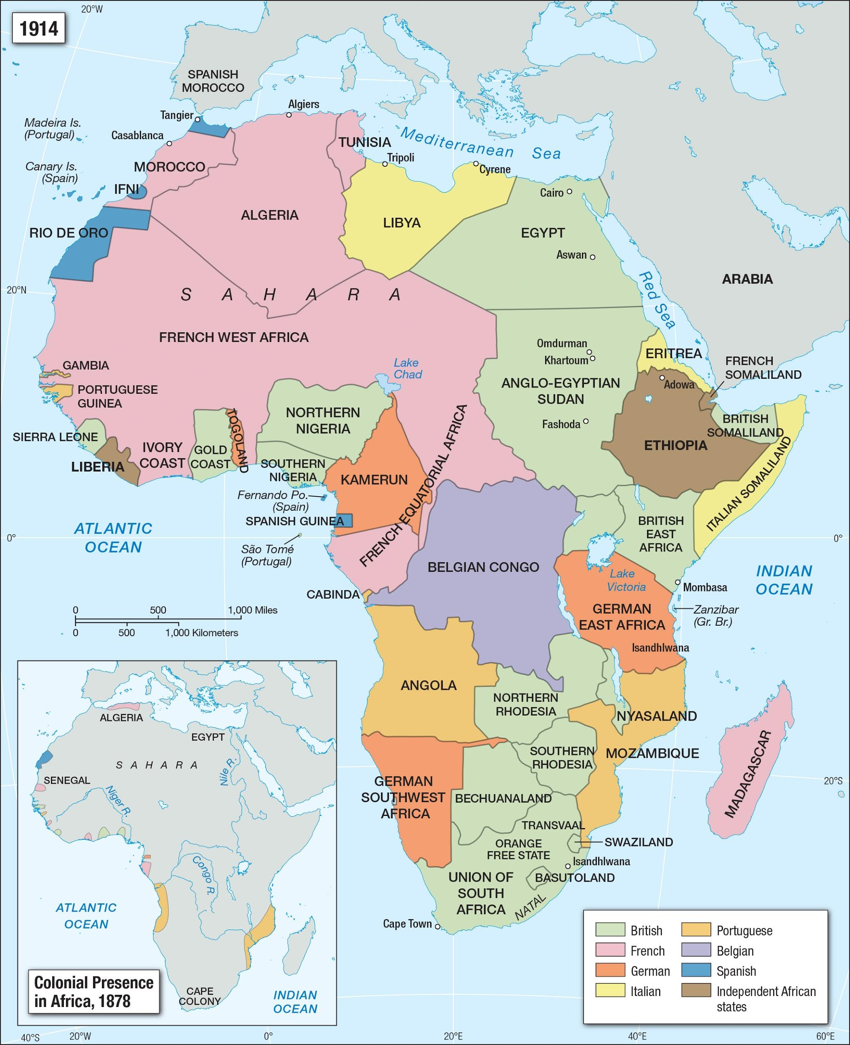
Source: Facing History and Ourselves. (n.d.). Colonial presence in Africa [Map]. Facing History and Ourselves. https://www.facinghistory.org/resource-library/image/colonial-presence-africa

