Political Cartoons
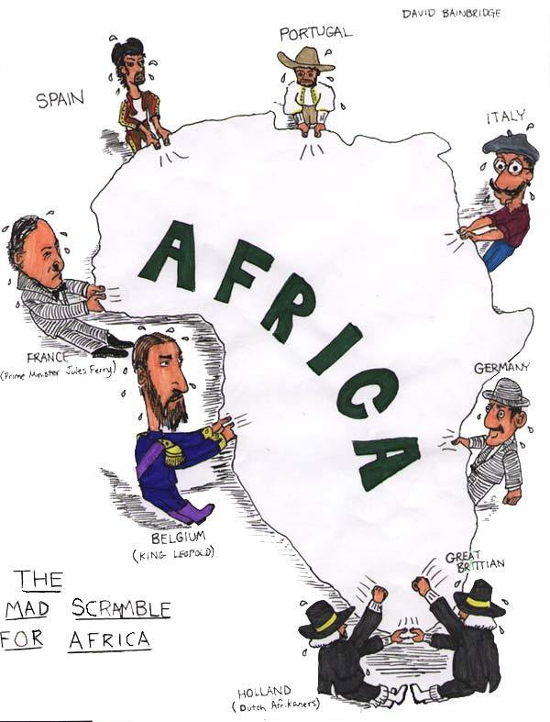

Source: Bainbridge, D. (n.d.). The mad scramble for Africa [Cartoon]. Colormefree. Tumblr. https://colormefree.tumblr.com/post/4681580543/legallypresent-the-mad-scramble-for-africa

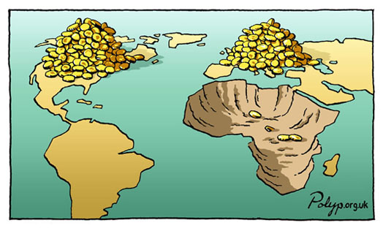
Source: Polyp the cartoonist. (n.d.). Africa, unfair trade, mining minerals, gold [Cartoon]. Polyp. https://polyp.org.uk/cartoons/wealth/polyp_cartoon_africa_unfair_trade_mining_minerals_gold.jpg

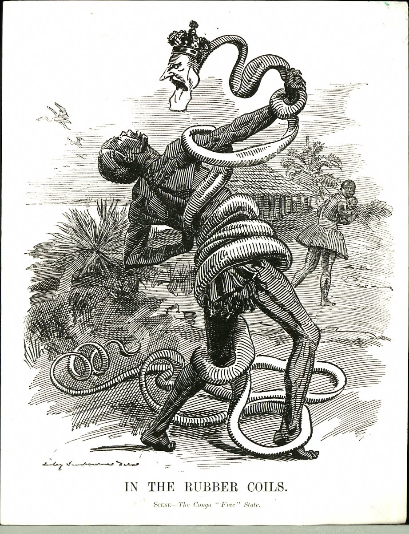

Source: Sambourne, E. L. (1906). In the rubber coils. Scene—The Congo “free” state [Cartoon]. Wikimedia Commons. https://commons.wikimedia.org/wiki/File:Punch_congo_rubber_cartoon.jpg

