CARD SORT
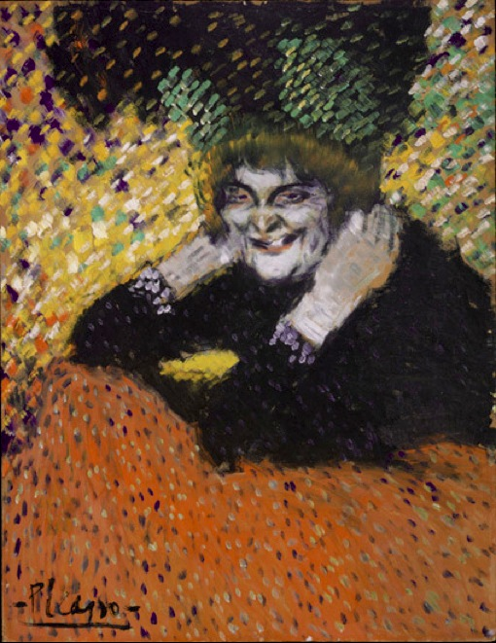 | “Knock, knock,” he said.  “Who’s there?” they asked? | Surely that wasn’t the last cookie, he mused.
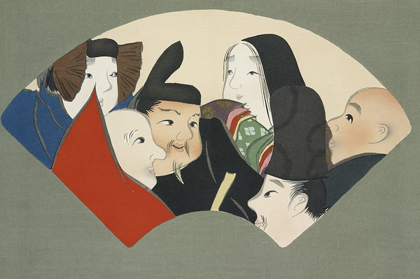 | He rolled his eyes dramatically and mumbled, “Okay, okay I understand.” | I wonder what the big deal is, she pondered.
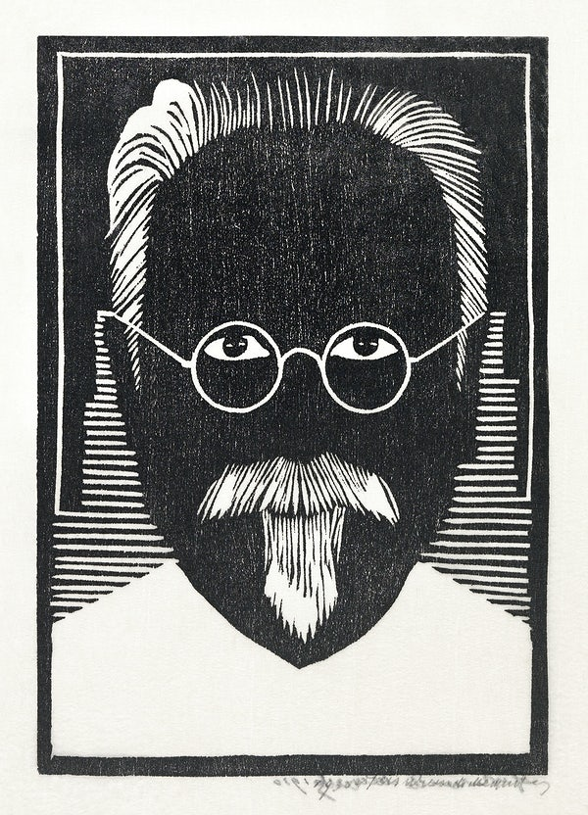 | “Hey!” she whispered, “Are you sleeping?” | This isn’t the last you’ll see of that, he thought to himself.
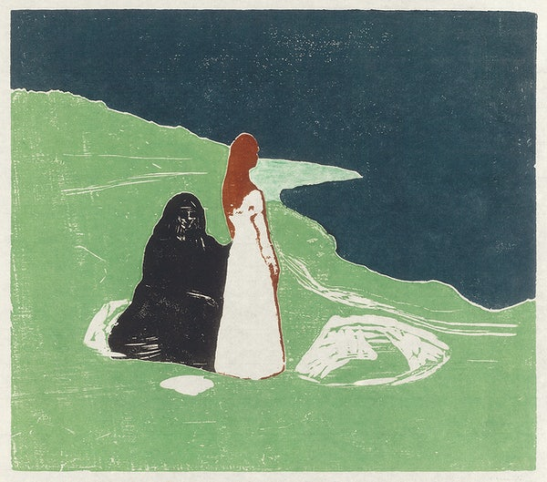 | “Whoa look out!” they cried.  “I see you, I see you,” he said, waving and grinning wildly. | They wondered, where are we going?

