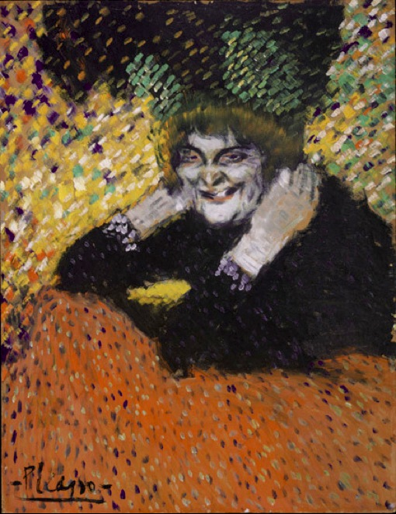
Pablo Picasso, 1901, Old Woman (Woman with Gloves), oil on cardboard, 67 × 52.1 cm, Philadelphia Museum of Art

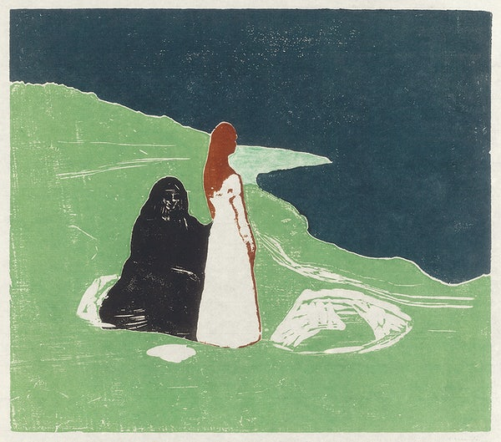
Munch, E. (n.d.). Two Women on the Shore [Digital image]. https://www.rawpixel.com/image/2043765/two-women-the-shore

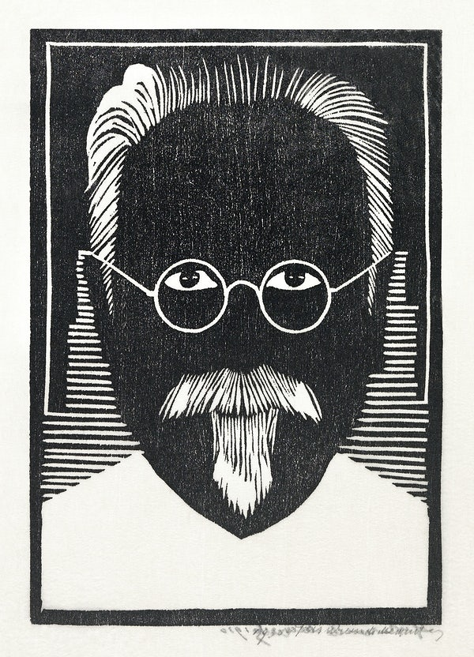
Jessurun de Mesquita, S. (n.d.). Self–portrait with glasses and goatee (Zelfportret met bril en sik) [Digital image]. https://www.rawpixel.com/image/2698105/free-illustration-image-portrait-black-and-white-glasses

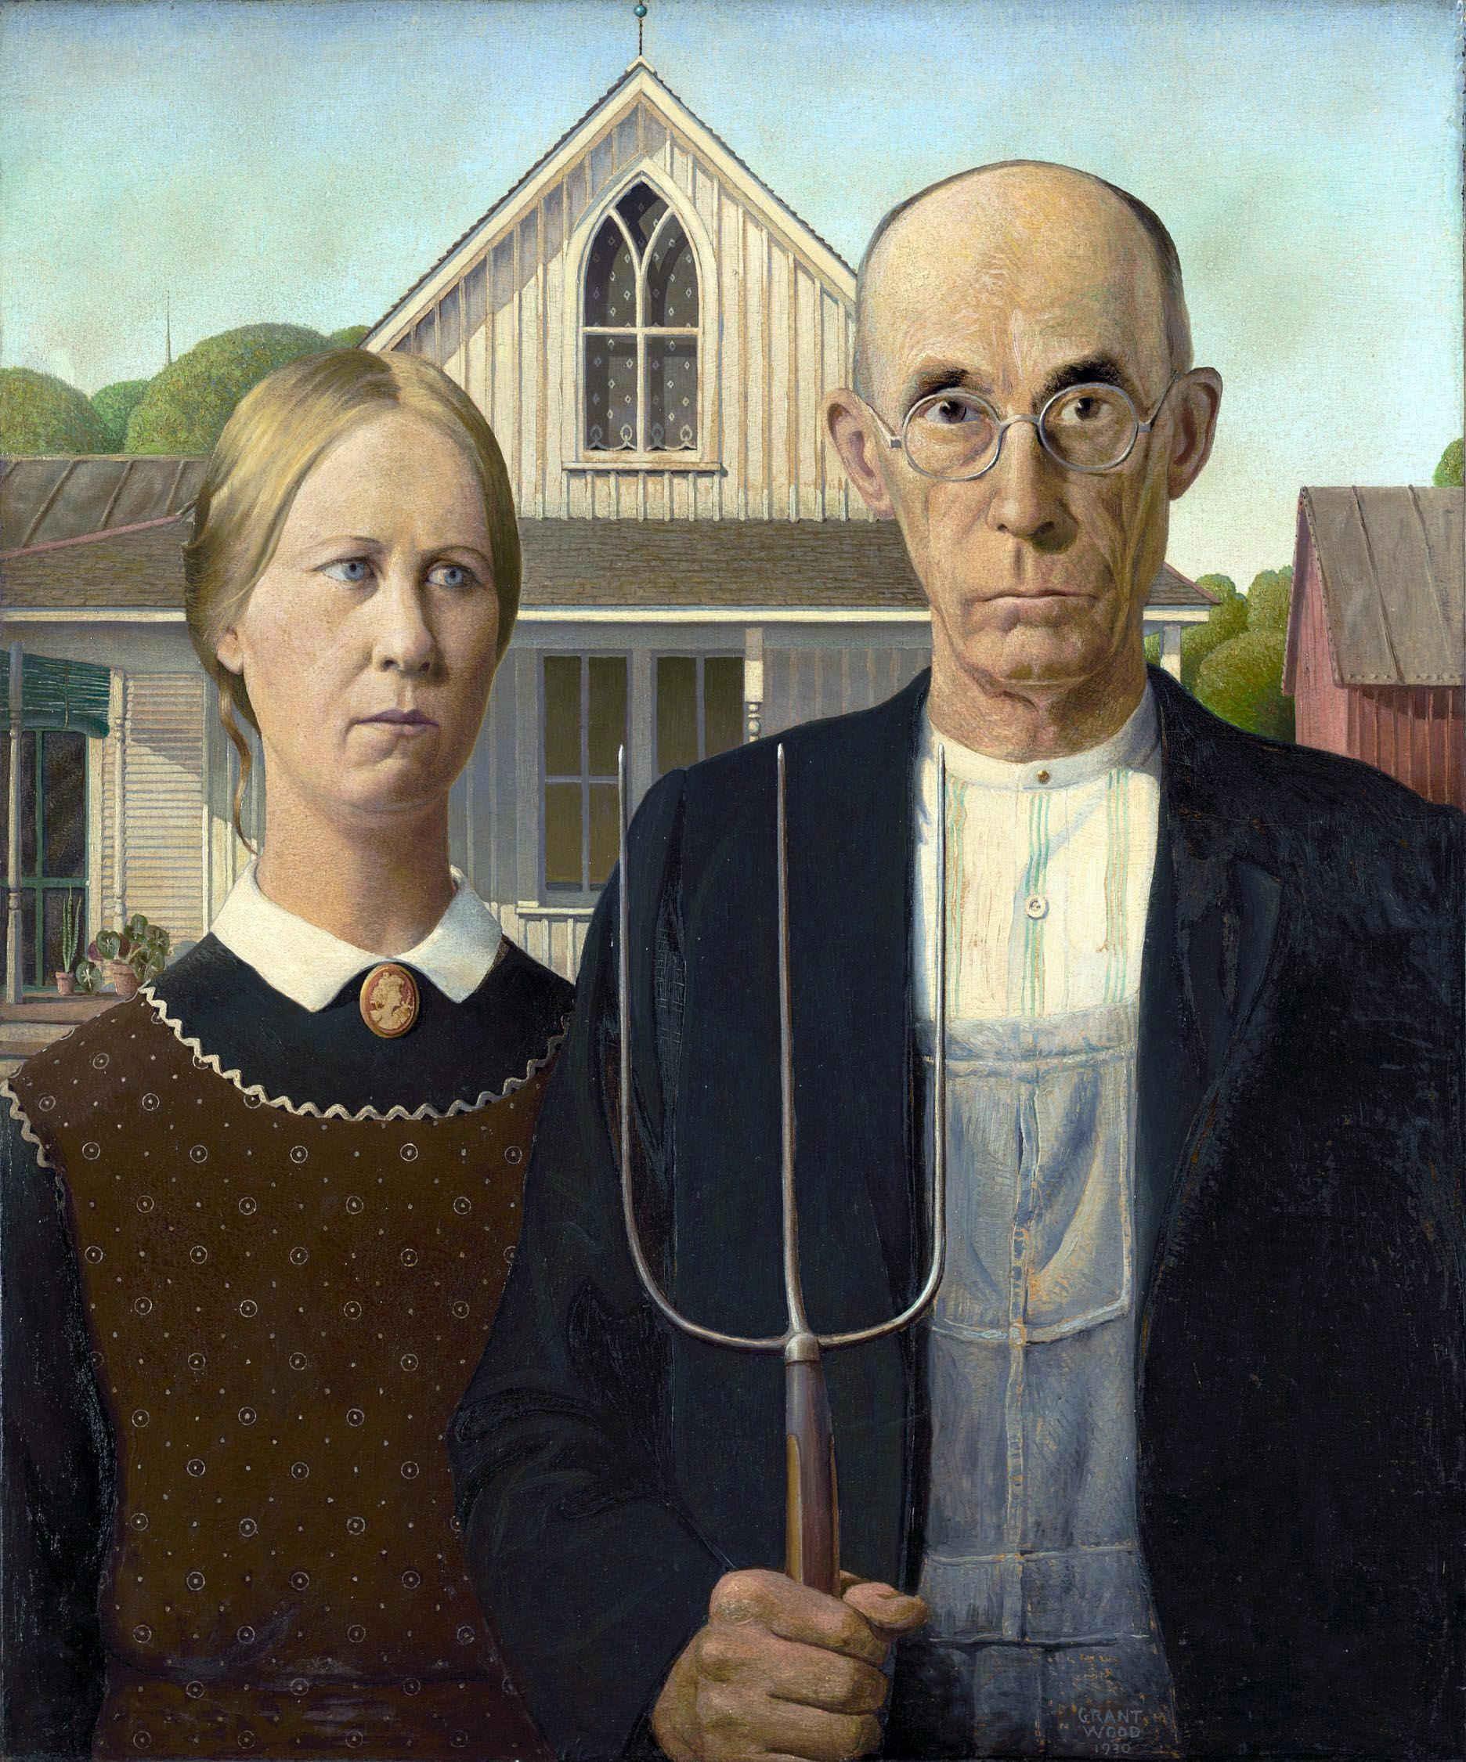
Wood, G. (2012, May 15). American Gothic [Digital image]. https://commons.wikimedia.org/wiki/File:Grant_DeVolson_Wood_-_American_Gothic.jpg

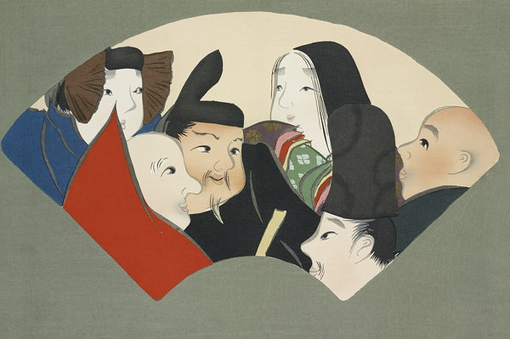
Sekka, K. (n.d.). Rokkasen from Momoyogusa–Flowers of a Hundred Generations [Digital image]. https://www.rawpixel.com/image/2049622/japanese-woodcut-print-kamisaka-sekka
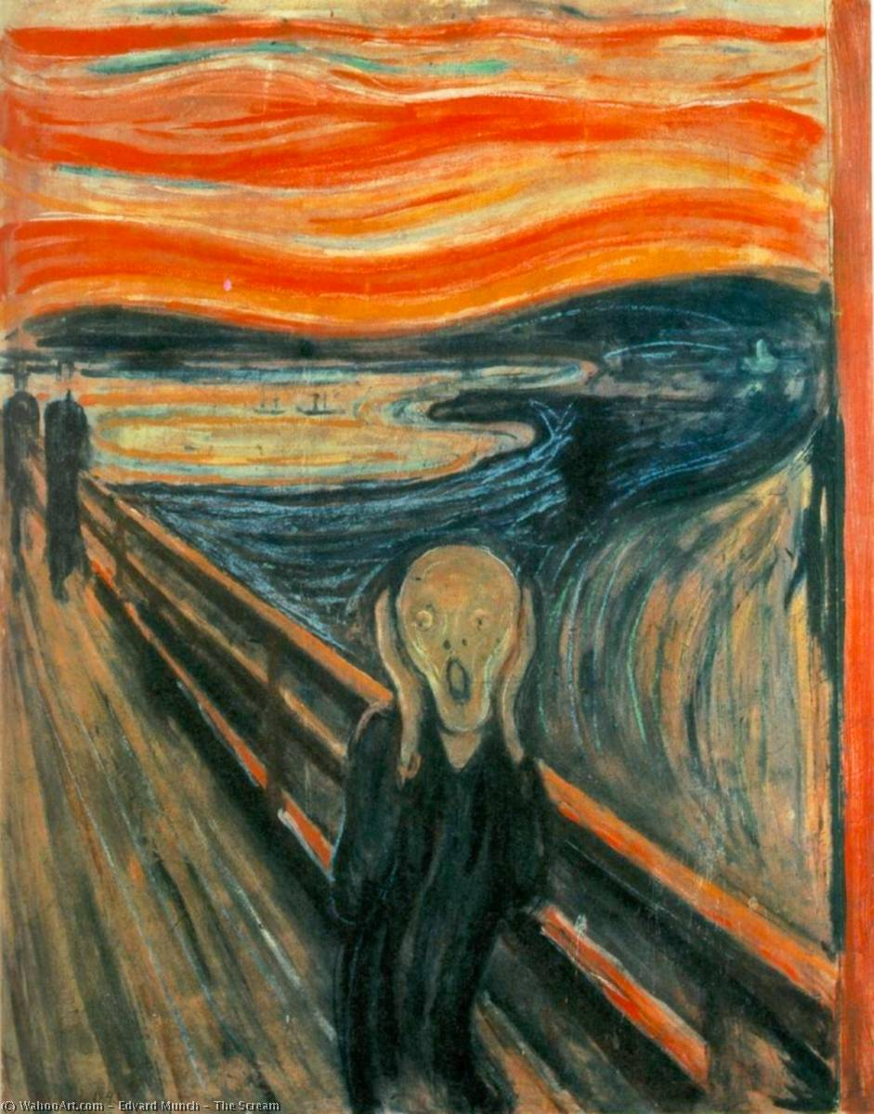
Munch, E. (2019, March 7). The Scream [Digital image]. https://commons.wikimedia.org/wiki/File:Edvard-Munch-The-Scream.jpg

