Presidential Letter Packet
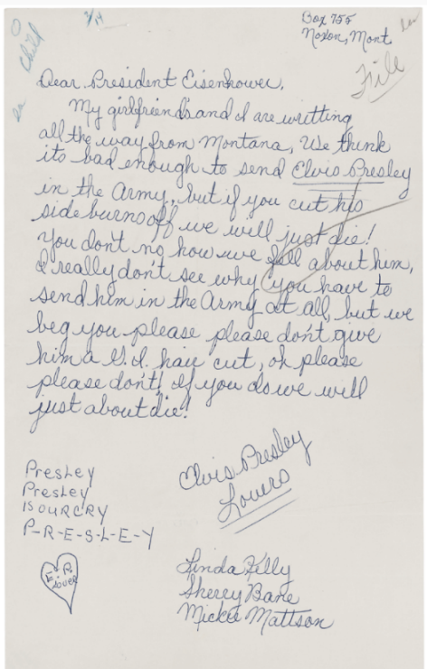
Letter from Linda Kelly, Sherry Bane, and Mickie Mattson to President Dwight D. Eisenhower Regarding Elvis Presley. President (2). Alphabetical Files, 1953-1961. White House Central Files (Eisenhower Administration), 1953-1961. Dwight D. Eisenhower Library (LP-DDE). https://catalog.archives.gov/id/594359

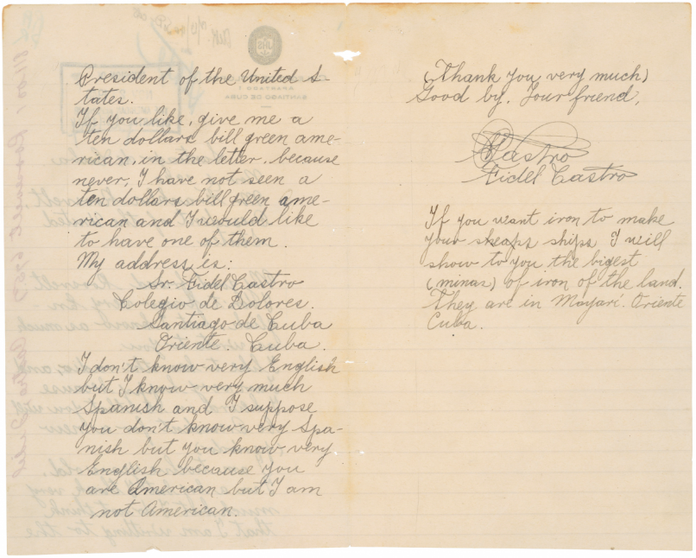
Letter from Fidel Castro to President Franklin D. Roosevelt. 1940 Correspondence, Part 12, 800-800.1. General Records, 1936-1961. Records of the Foreign Service Posts of the Department of State, 1788-ca. 1991. National Archives at College Park. https://catalog.archives.gov/id/302040

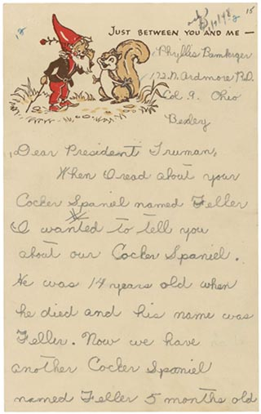
Fried, Ellen. (2004). “Just Between You and Me”: Children’s Letters to Presidents. Prologue Magazine. National Archives. (36) 1. https://www.archives.gov/publications/prologue/2004/spring/childrens-letters.html

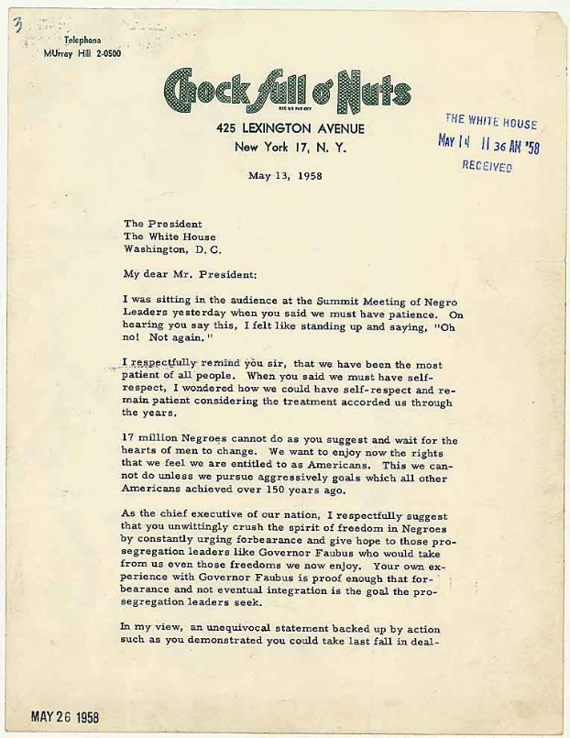
Letter from Jackie Robinson to President Eisenhower of May 13, 1958. Negro Matters - Colored Question (6). Official Files, 1953-1961. White House Central Files (Eisenhower Administration), 1953-1961. Dwight D. Eisenhower Library. https://catalog.archives.gov/id/186627?q=jackie%20robinson#.VgWq9gMY1jM.link
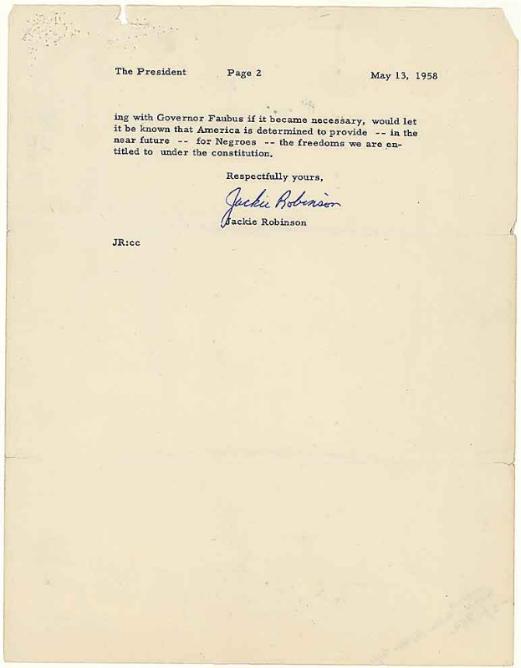
Letter from Jackie Robinson to President Eisenhower of May 13, 1958. Negro Matters - Colored Question (6). Official Files, 1953-1961. White House Central Files (Eisenhower Administration), 1953-1961. Dwight D. Eisenhower Library. https://catalog.archives.gov/id/186627?q=jackie%20robinson#.VgWq9gMY1jM.link

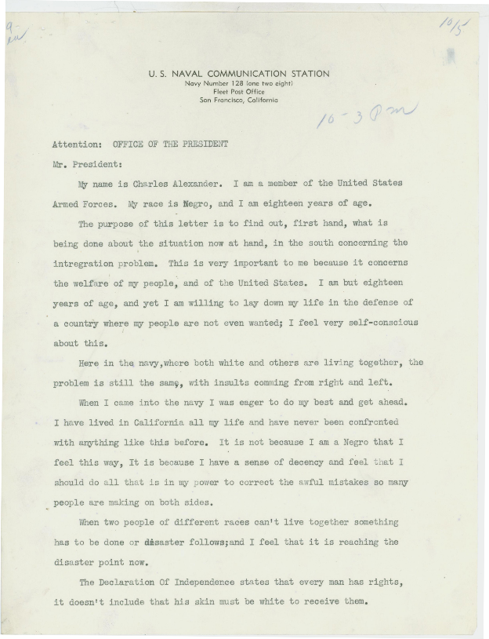
Letter to President Dwight D. Eisenhower from Charles Alexander Regarding Integration. Bulk Mail Files, 1953-1961. White House Central Files (Eisenhower Administration), 1953-1961. Dwight D. Eisenhower Library. https://catalog.archives.gov/id/6092843
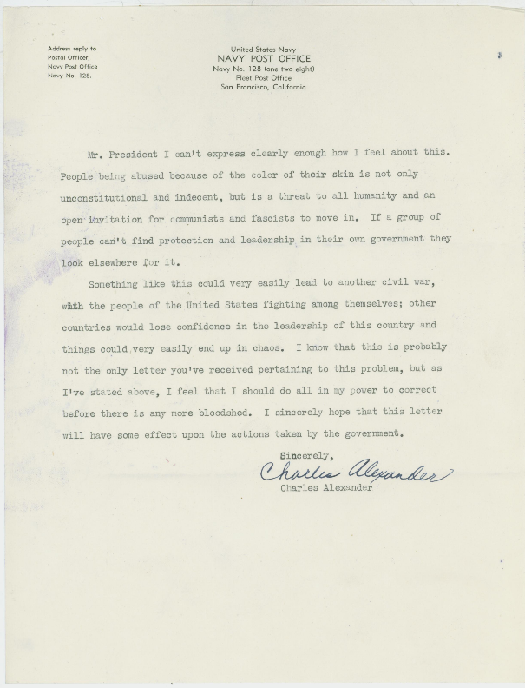
Letter to President Dwight D. Eisenhower from Charles Alexander Regarding Integration. Bulk Mail Files, 1953-1961. White House Central Files (Eisenhower Administration), 1953-1961. Dwight D. Eisenhower Library. https://catalog.archives.gov/id/6092843

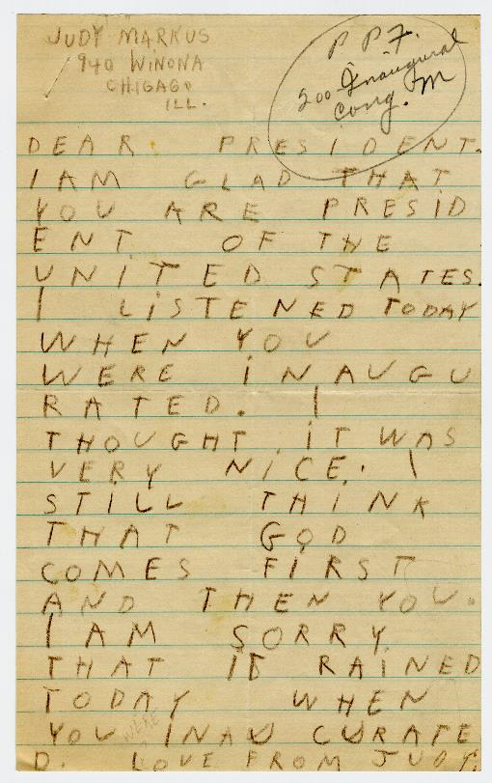
Letter to President Franklin D. Roosevelt from a Child. President's Personal Files, 1933-1945. Papers as President, President's Personal File, 1933-1945. Franklin D. Roosevelt Library. https://catalog.archives.gov/id/6728529

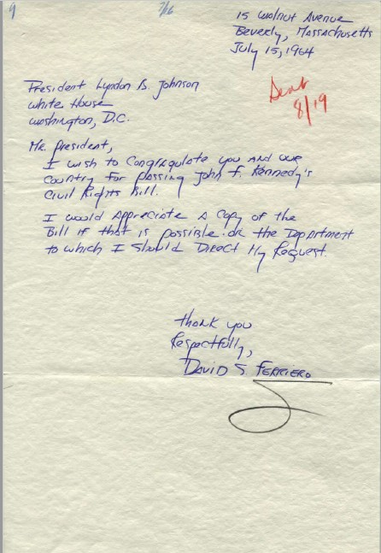
Letter to President Lyndon B. Johnson from David S. Ferriero. White House Name Files, 11/22/1963-1/20/1969. White House Central Files (Johnson Administration), 11/22/1963-1/20/1969. Lyndon Baines Johnson Library. https://catalog.archives.gov/id/18482221

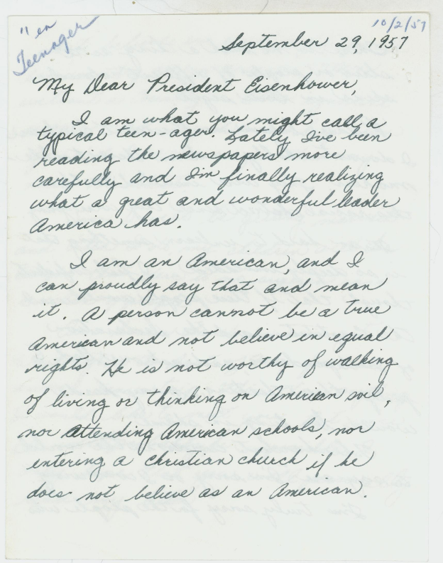
Letter to President Dwight D. Eisenhower from Teenager Dana Anderson Regarding Equal Rights. Bulk Mail Files, 1953-1961. White House Central Files (Eisenhower Administration), 1953-1961. Dwight D. Eisenhower Library. https://catalog.archives.gov/id/6092838
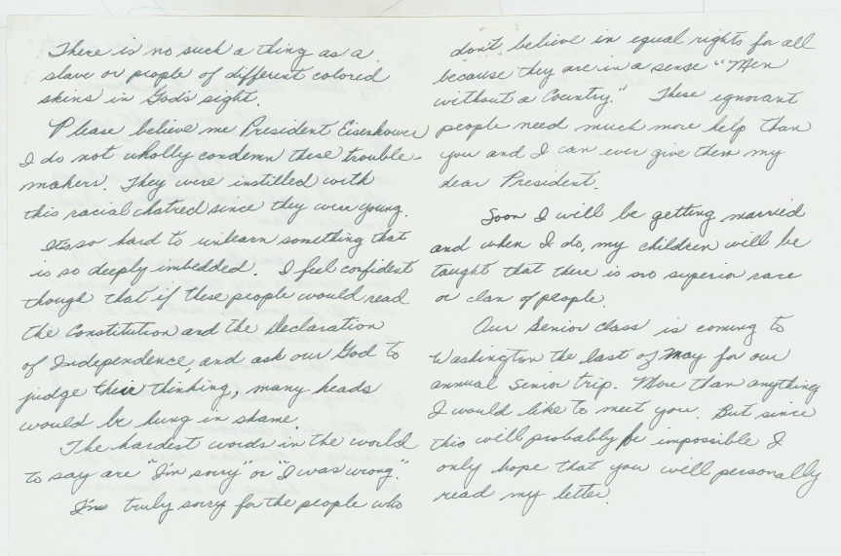
Letter to President Dwight D. Eisenhower from Teenager Dana Anderson Regarding Equal Rights. Bulk Mail Files, 1953-1961. White House Central Files (Eisenhower Administration), 1953-1961. Dwight D. Eisenhower Library. https://catalog.archives.gov/id/6092838
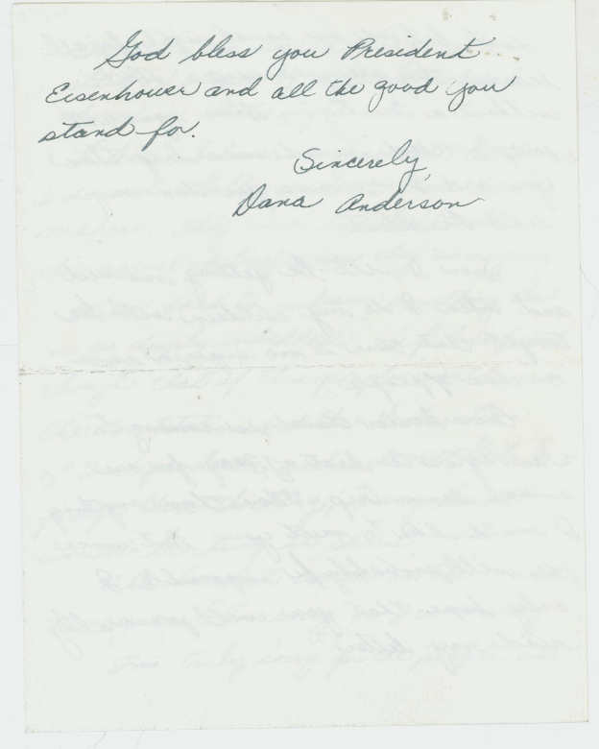
Letter to President Dwight D. Eisenhower from Teenager Dana Anderson Regarding Equal Rights. Bulk Mail Files, 1953-1961. White House Central Files (Eisenhower Administration), 1953-1961. Dwight D. Eisenhower Library. https://catalog.archives.gov/id/6092838

