LEVELS OF ORGANIZATION PROJECT Instructions
With your partner, choose one disease from your speed dating assignment. Create a model/poster to show how the disease affects each level of organization. Be sure to label each level. Write a summary, at least one page in length and typed in Times New Roman or Arial (12-point font, double-spaced), about the disease’s effects on each level—from the cellular level to the organism level—and how these compare with normal functions at each level. You and your partner will present your work to the class, giving a short description of what is occurring at each level. This project is due on MM/DD/YYYY.
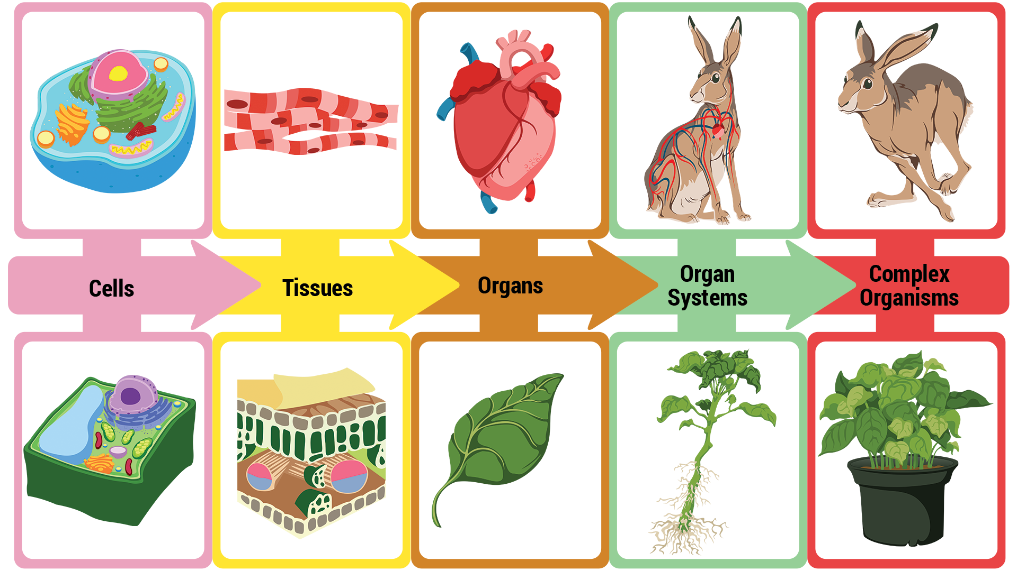
WCW: Terese LaRose

LEVELS OF ORGANIZATION PROJECT Instructions
With your partner, choose one disease from your speed dating assignment. Create a model/poster to show how the disease affects each level of organization. Be sure to label each level. Write a summary, at least one page in length and typed in Times New Roman or Arial (12-point font, double-spaced), about the disease’s effects on each level—from the cellular level to the organism level—and how these compare with normal functions at each level. You and your partner will present your work to the class, giving a short description of what is occurring at each level. This project is due on MM/DD/YYYY.

