Gerty Cori Interactive Answer Key
Answer the following questions that correspond with Gerty Cori Interactive.

Patient-Donor Blood Connection
In the table below, fill in each patient’s phenotype, possible genotype, and potential blood donations they can receive based on their blood type.
Gerty Cory (1896-1957) was an Austro-Hungarian-American biochemist. She was born and raised in Europe.

She went on to study her love of science at medical school (an amazing feat for a woman in 1914) where she met her husband and fellow biochemist, Carl.

Due to the rise of anti-semitism, she and her husband left Europe to the United States where together they studied the process of cellular respiration.

Reactants and Products of Cellular Respiration Card Sort
Match the following reactant/ product with what it is doing during respiration.

__C_ 1. Glucose
__E_ 2. Water
__A_ 3. Oxygen
__B_ 4. Carbon Dioxide
__D_ 5. ATP

- Plants take it in through the leaves. Animals breathe it in through their mouth or nose.
- Released through leaves by plants. Released as gas by animals.
- Plants get it from making their own food. Animals get it through consuming food.
- Used for cellular activity or released as heat.
- Released as other bodily fluids or used by cells.

Cellular Respiration Formula Card Sort
Write the formula for Cellular Respiration
Glucose (C₆H₁₂O₆) + Oxygen(O₂) = Carbon Dioxide + Water (H₂O) + ATP

Levels of Organization

Kingdom Business
Out of the following kingdoms, which of these have organisms that have the ability to do cellular respiration?
Kingdoms-Check the correct one(s)
Animal | Plantae | Protist | Fungi | Bacteria
X | X | X | X | X

Cells
From the different types of specialized cells, which ones do you believe would use the most energy if you were exercising?
Cells (Check the correct one)
Bone Cells (Osteocytes) | Skin Cells | Muscle Cells | Nerve Cells
 |  | X

Organelles
Which organelle within the muscle cell would you find cellular respiration occurring?
Organelles (Check the correct one)
Centrioles | Chloroplast | Nucleus | Mitochondria
 |  |  | X

Why Do We Do It?
You just recalled in cellular respiration, what the reactants (what is being used) and the products (what was produced) are. From what you have learned so far, what is the main purpose for our doing this process? to metabolize food to produce energy to do work

Gerti and Carl Cori’s continued their fascination with how the body does respiration led to discovery of not only how our body uses other chemicals to help us with producing energy, but also how our body can continue doing respiration when one of the needed reactants is in short supply.
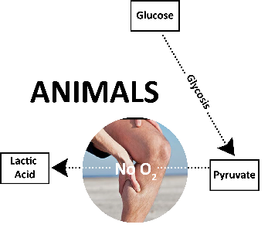
Animals
Glucose → Lactic acid + Energy

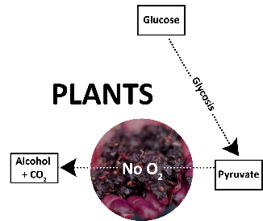
Plants
Glucose → Alcohol + Carbon dioxide + Energy

What reactant do you notice is missing from the equation? Oxygen

Anaerobic Respiration Analysis
Let’s review how respiration and anaerobic respiration may occur with the example of a cheetah. Cheetahs are known as the fastest animal in the world. In seconds, cheetahs can go from being relaxed to a full-on sprint with the potential of reaching up to 70 mph. While this cheetah is chasing its prey, put the following steps in order of what you expect to happen with the process of cellular respiration.
Complete the following matching by connecting the action with what is occurring in respiration:
__B__1. The cheetah is studying its prey.

__A__2. The cheetah takes after its prey.

__C__3. The cheetah has been chasing the
prey for 25 seconds

- Cellular respiration speeds up, more glucose is broken down and oxygen used, and more ATP is being used by the muscle cells.
- Cellular respiration occurring at its normal rate of food breakdown and oxygen levels are great to build up and harvest ATP.
- Cellular respiration cannot keep up, oxygen levels decrease, and anaerobic respiration kicks in.

Although cheetahs are fast, taking into consideration the heat of the environment in which they live and how fast they are running, what do you predict will start to happen to them?
Lactic acid builds, muscles start to become tired, & respiration will slow down.

Cheetahs can only keep up their speed for a very short amount of time before their body starts to slow down. What do you believe is the cause for the decrease?
Not enough glucose and oxygen to sustain the cellular respiration process, so due to the slow down of ATP production there is not enough energy to keep the muscle cells very active for long.

The cheetah has fortunately caught her prey, but she must rest before she eats her meal. After an exhausting day but a great meal, this cheetah is resting. What do you expect the process of cellular respiration to do?
CR will slow down; the body has time to breakdown and store sugars (such as glucose), oxygen levels increase, generating more energy to be used while sleeping but even more when the cheetah becomes active again.

Card Sort Solution

Medical Assistants | Technical/Vocational School | 1-2 years | $29,070 - $48,170
Cardiovascular Technicians | Associate Degree | 2 years | $29,910 - $98,070
Agricultural Technicians | Bachelor’s degree | 4 years | $29,010 - $62,200
Nurse Anesthetists | Master’s degree | 6 years | $131,840 - $208,000+
Cardiologists | Doctorate Degree | 8 years | $165,610 - $208,000+

