Gerty Cori Interactive QUESTIONNAIRE
Answer the following questions that correspond with Gerty Cori Interactive.

Patient-Donor Blood Connection
In the table below, fill in each patient’s phenotype, possible genotype, and potential blood donations they can receive based on their blood type.
Gerty Cory (1896-1957) was an Austro-Hungarian-American_____________. She was born and raised in Europe.

She went on to study her love of science at _____________ school (an amazing feat for a woman in 1914) where she met her husband and fellow biochemist, _____________.

Due to the rise of anti-semitism, she and her husband left Europe to the United States where together they studied the process of _____________.

Reactants and Products of Cellular Respiration Card Sort
Match the following reactant/product with what it is doing during respiration.

_____1. Glucose
_____2. Carbon Dioxide
_____3. Oxygen
_____4. ATP
_____5. Water

- Plants take it in through the leaves. Animals breathe it in through their mouth or nose.
- This is released through leaves by plants. It is released as gas by animals.
- Plants get it from making their own food. Animals get it through consuming food.
- This is used for cellular activity or released as heat.
- This is released as other bodily fluids or used by cells.
Cellular Respiration Formula Card Sort
Write the formula for Cellular Respiration

_____________ + _____________ = _____________ + _____________ + _____________

Levels of Organization

Kingdom Business
Out of the following kingdoms, which of these have organisms that have the ability to do cellular respiration?
Kingdoms-Check the correct one(s)
Animal | Plantae | Protist | Fungi | Bacteria

Cells
If you were exercising, out of the different types of specialized cells, which ones do you believe would use the most energy?
Cells (Check the correct one)
Bone Cells (Osteocytes) | Skin Cells | Muscle Cells | Nerve Cells

Organelles
Within the cell that you chose, which organelle would you find cellular respiration occurring?
Organelles (Check the correct one)
Centrioles | Chloroplast | Nucleus | Mitochondria

Why Do We Do It?
You just recalled in cellular respiration what the reactants (what is being used) and the products (what was produced) are. From what you have learned so far, what is the main purpose for us to do this process?

Gerti and Carl Cori’s fascination with how the body does respiration led to discovery of how our body not only uses other chemicals to help us with producing energy, but also shows how our body can continue doing respiration when one of the needed reactants are in short supply.

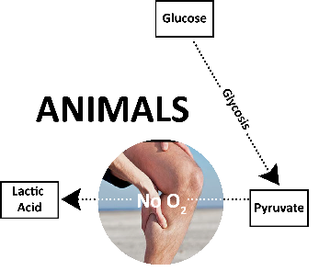
Animals
Glucose → Lactic acid + Energy

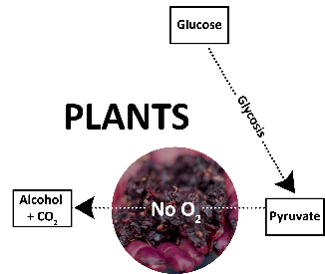
Plants
Glucose → Alcohol + Carbon dioxide + Energy

What reactant do you notice is missing from the equation? _______________

Anaerobic Respiration Analysis
Let’s review how respiration and anaerobic respiration may occur with the example of a cheetah. Cheetahs are known as the fastest animal in the world. In seconds, cheetahs can go from being relaxed to a full-on sprint with the potential of reaching up to 70 mph. While the cheetah is chasing its prey, put the following steps in order of what you expect to happen with the process of cellular respiration.
Complete the following matching by connecting the action with what is occurring in respiration:
_____1. The cheetah studies its prey.

_____2. The cheetah takes after its prey.

_____3. The cheetah has been chasing its
prey for 25 seconds

- Cellular respiration speeds up, more glucose is broken down and oxygen used, and more ATP is being used by the muscle cells.
- Cellular respiration is occurring at its normal rate of food breakdown and oxygen levels are great to build up and harvest ATP.
- Cellular respiration cannot keep up, oxygen levels decrease, and anaerobic respiration kicks in.

Although cheetahs are fast, taking into consideration the heat of the environment in which they live and how fast they are running, what do you predict will start to happen to them?

Cheetahs can only keep up their speed for a very short amount of time before their body starts to slow down. What do you believe is the cause for the decrease?

The cheetah has fortunately caught her prey but must rest before she eats their meal. After an exhausting day but a great meal, this cheetah is resting, what do you expect the process of cellular respiration to do?

