Parallel Processing
Look at each of the following images. Which lines are parallel? Are any of the lines parallel?
Image 1  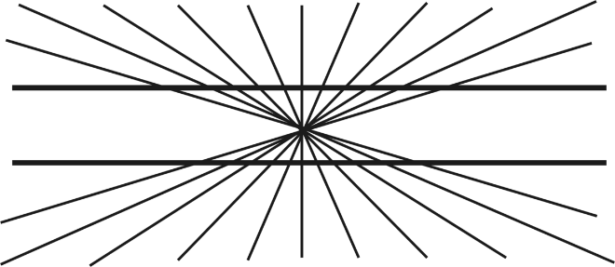 | Image 2

Image 3
