Picture Captions
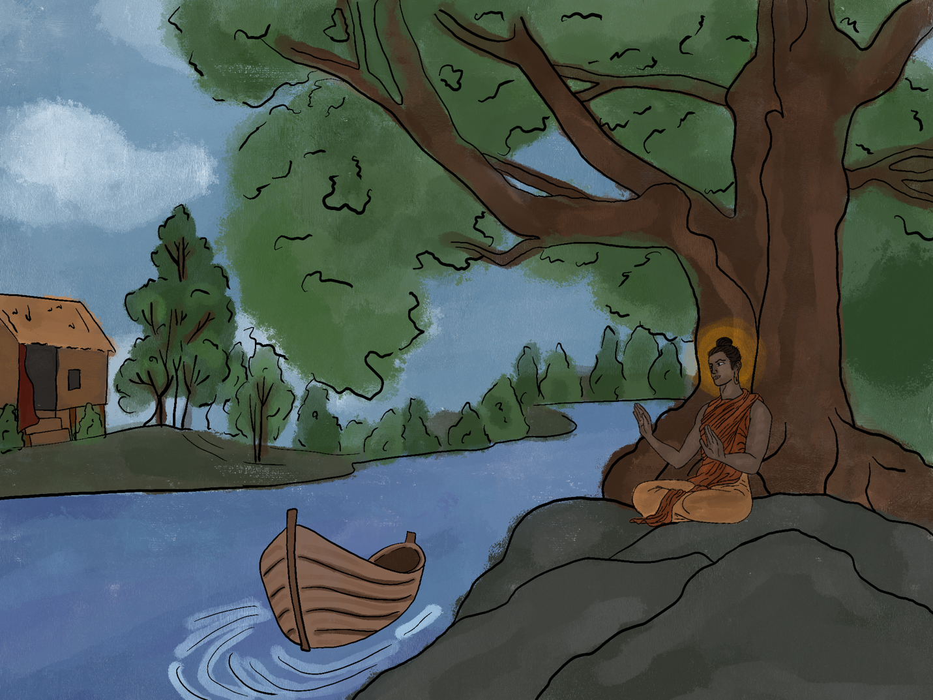

Siddhartha grew up in his house. He grew up near a riverbank with boats. He grew up near the Sal-wood forest. He spent time by a fig tree. Siddhartha was a handsome son of a Brahman. Siddhartha grew up with his friend Govinda. Govinda was also the son of a Brahman. The Brahman’s were the highest Hindu caste.

Siddhartha grew up in his house, and he grew up near a riverbank with boats. He grew up near the Sal-wood forest, and he spent time by a fig tree. Siddhartha was a handsome son of a Brahman, and he grew up with his friend Govinda. Govinda was also the son of a Brahman, and the Brahman’s were the highest Hindu caste.

Siddhartha grew up in his house, which was near a riverbank with boats. He grew up near the Sal-wood forest, yet also spent time by a fig tree. Siddhartha was a handsome son of a Brahman, much like his friend Govinda. Govinda was also the son of a Brahman, which were the highest Hindu caste.

While Siddhartha grew up in his house, which was near a riverbank with boats, he was also near the Sal-wood forest spending time by a fig tree. Being the handsome son of a Brahman, much like his friend Govinda, Siddhartha belonged to the highest Hindu caste.

Which caption has the most effective description for a reader? Why? Explain below:

