STEAL

1. Use the template to provide examples of quotes next to each STEAL category.
2. Draw what you believe your character to look like or draw images and symbols to represent your character in the template.

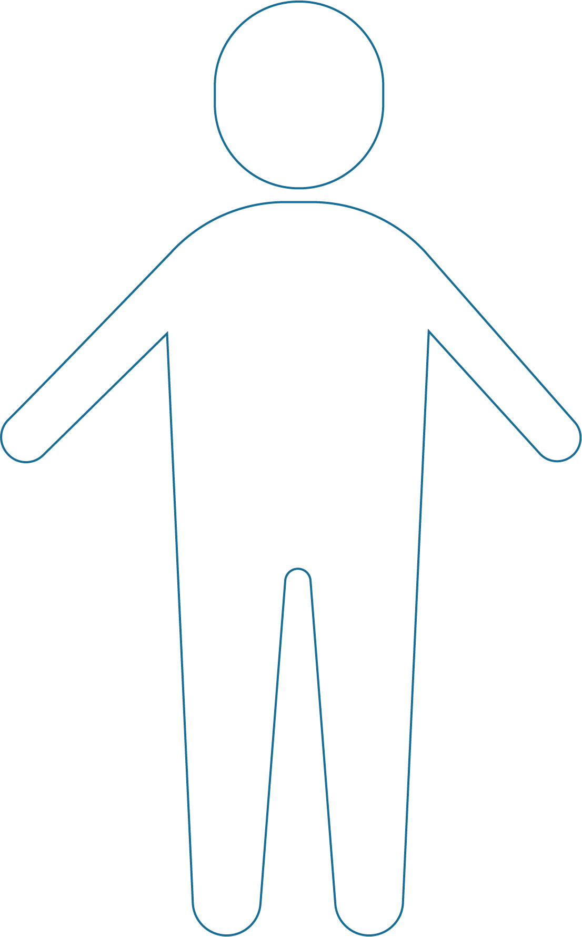

**Speech:**

**Thoughts:**

**Effects on others:**

**Actions:**

**Looks:**

3. Thinking about the quote you provided, respond to the prompt below.

|  |  |
| --- | --- |
| **What insight does the text give us into the character?** | |
| Speech |  |
| **Thoughts** |  |
| **Effects on others** |  |
| **Actions** |  |
| **Looks** |  |