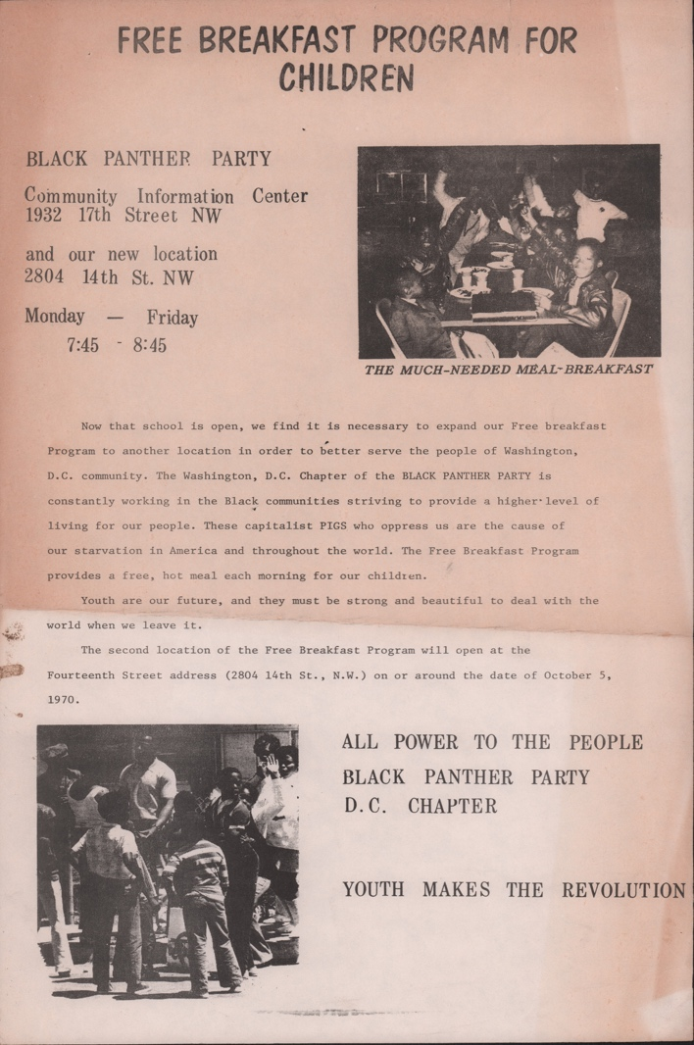
PANTHER PROGRAMS PICTURE SET

Picture Set 1

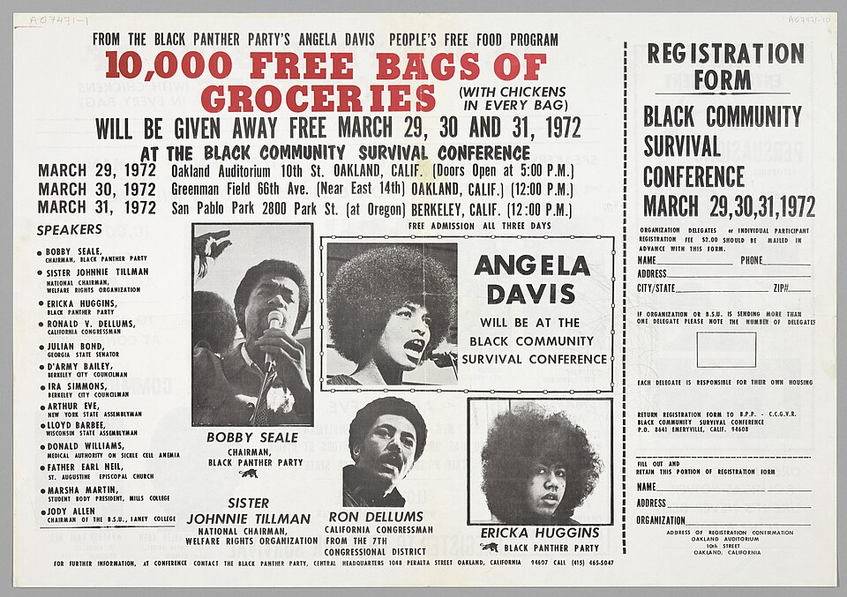
Picture A: People’s Free Food Program

Picture B: Black Panthers Breakfast Program

Source:
Wikimedia Commons contributors. (n.d.). Flier for the Black Community Survival Conference [Poster]. Wikimedia Commons. https://commons.wikimedia.org/wiki/File:Flier_for_the_Black_Community_Survival_Conference.jpg

Wikimedia Commons contributors. (n.d.). Black Panther Party Free Breakfast [Photograph]. Wikimedia Commons. https://commons.wikimedia.org/wiki/File:Black_Panther_Party_Free_Breakfast.jpg

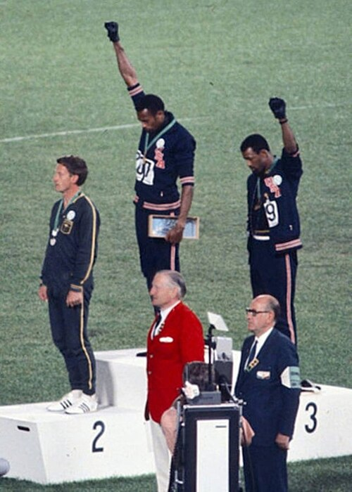
PANTHER PROGRAMS PICTURE SET

Picture Set 2
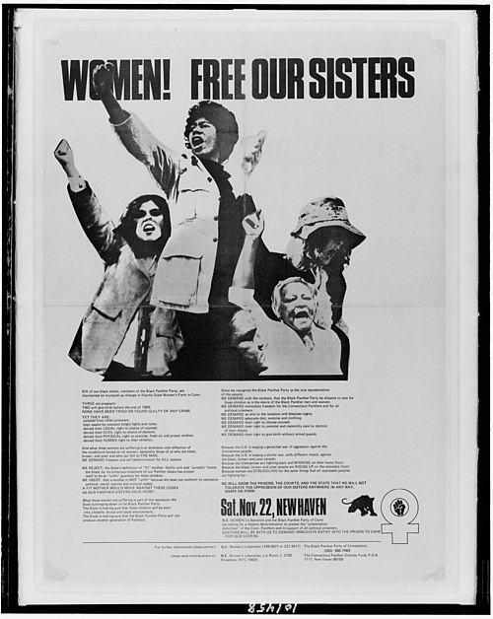
Picture B: Smith (center) and Carlos protested
racial discrimination
Picture A: People’s Free Food Program

Source:
Wikimedia Commons contributors. (n.d.). Women! Free our sisters LCCN2015648047 [Poster]. Wikimedia Commons. https://commons.wikimedia.org/wiki/File:Women!_Free_our_sisters_LCCN2015648047.jpg

Cozzi, A. (1968). John Carlos, Tommie Smith, Peter Norman 1968cr [Photograph]. Wikimedia Commons. https://commons.wikimedia.org/wiki/File:John_Carlos,_Tommie_Smith,_Peter_Norman_1968cr.jpg

PANTHER PROGRAMS PICTURE SET

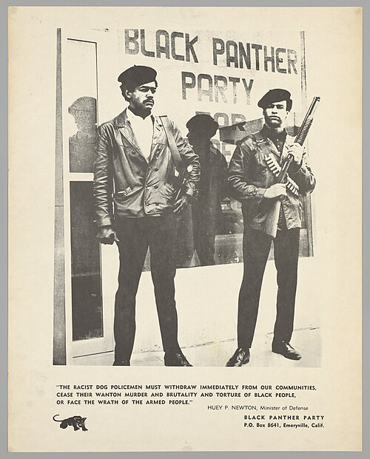
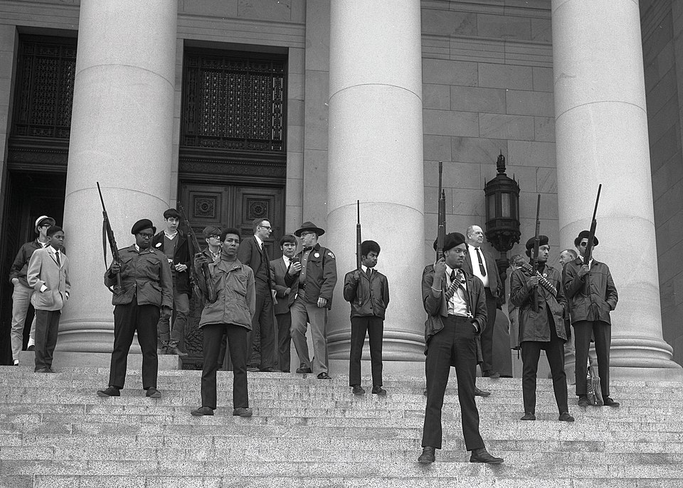
Picture Set 3

Picture A:
Black Panther Party on the steps of the Washington State Capitol

Picture B: Huey P. Newton & Bobby Seale
Huey P. Newton & Bobby Seale
Huey P. Newton & Bobby Seale

Source:
Wikimedia Commons contributors. (n.d.). Black Panther demonstration [Photograph]. Wikimedia Commons. https://commons.wikimedia.org/wiki/File:Black_Panther_demonstration.jpg
National Museum of African American History and Culture. (n.d.). Black Panther Party poster: “Free Em All” [Poster]. Wikimedia Commons. https://commons.wikimedia.org/wiki/File:NMAAHC-2012_46_20_1001.jpg

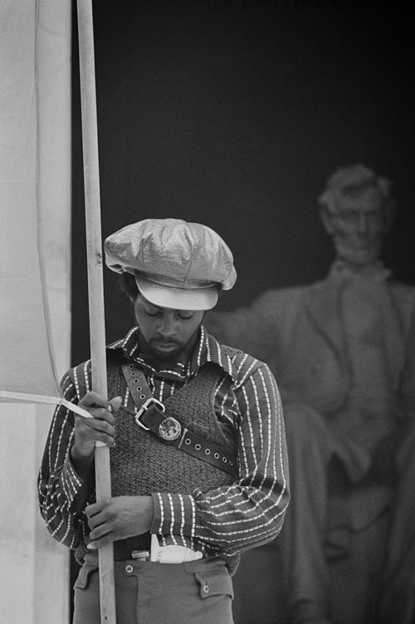
PANTHER PROGRAMS PICTURE SET

Picture Set 4
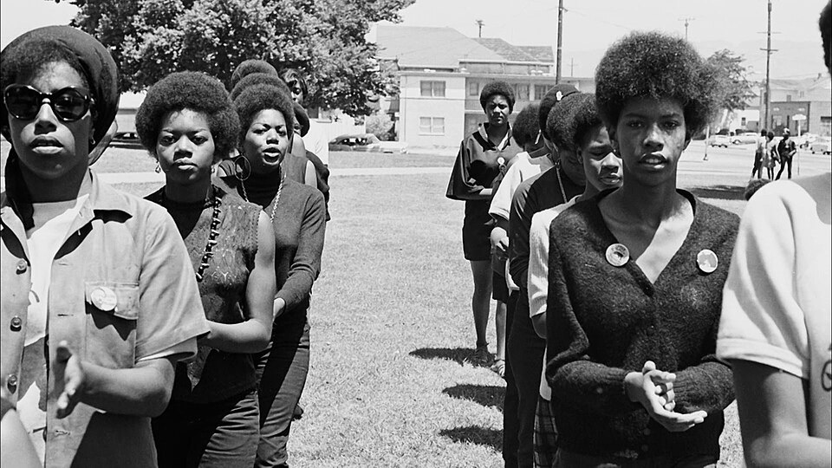

Picture B:
Black Panther convention at Lincoln Memorial
Picture A: Women in the Black Panther Party

Source:
Wikimedia Commons contributors. (n.d.). Black Panther women at a demonstration [Photograph]. Wikimedia Commons. https://commons.wikimedia.org/wiki/File:Black.Panthers.Women.jpg
Wikimedia Commons contributors. (n.d.). Black Panther convention2 [Photograph]. Wikimedia Commons. https://commons.wikimedia.org/wiki/File:Black_Panther_convention2.jpg

