PANTHER PROGRAMS PICTURE SETS
Picture Set 1
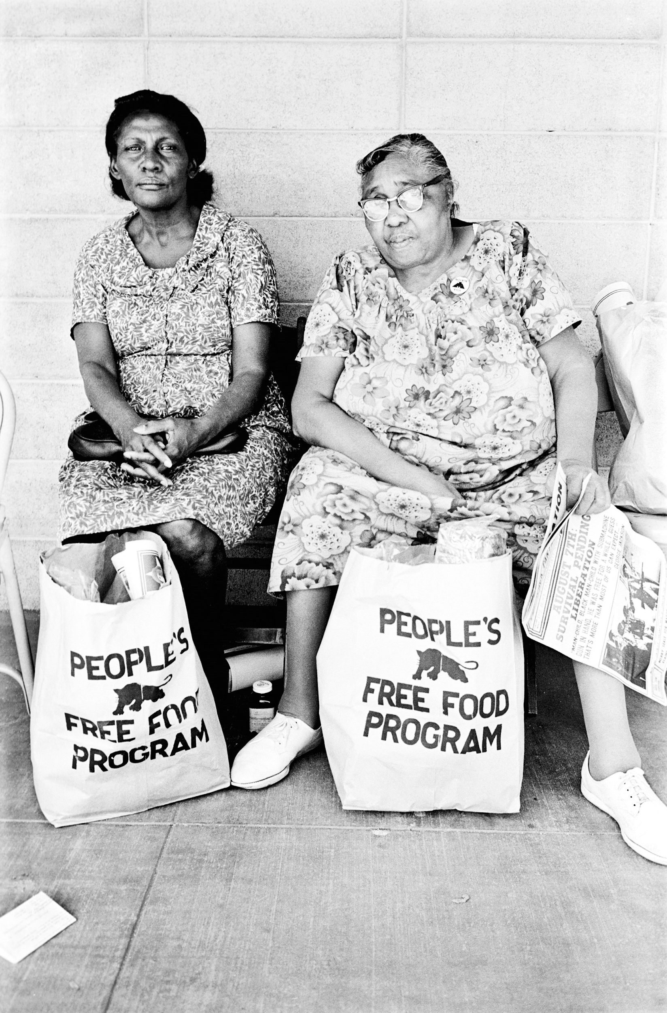
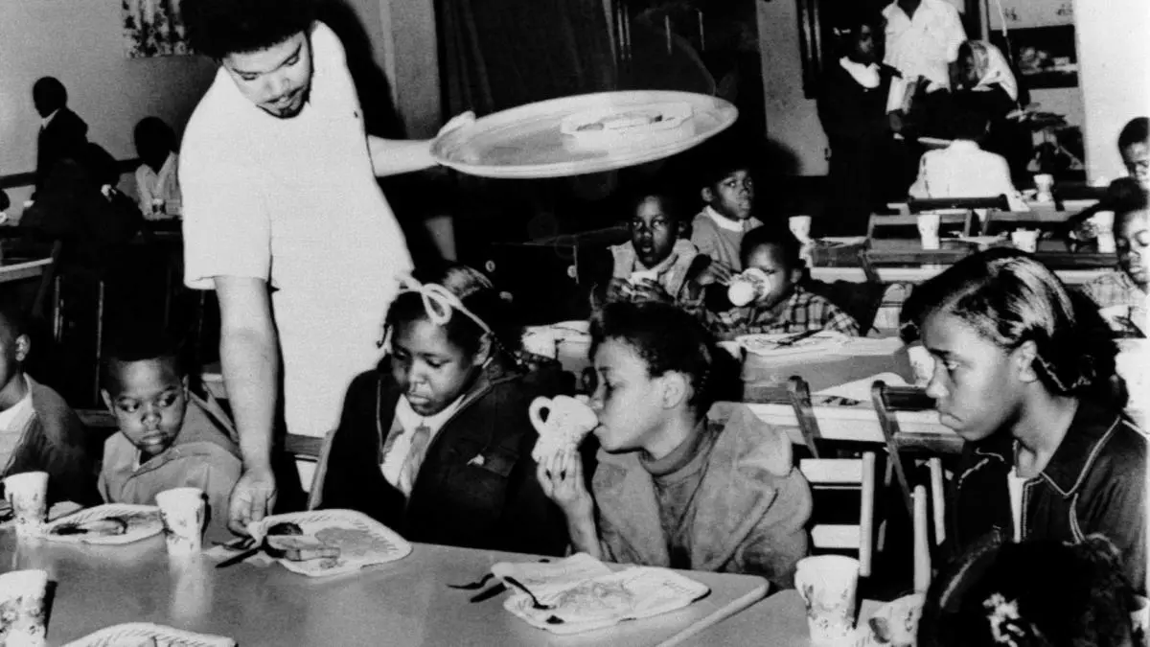
James, S. (2016, October 19). People’s Free Food Program [Photograph found in Steven Kasher Gallery, Palo Alto]. Retrieved February 26, 2021, https://www.anothermag.com/fashion-beauty/9194/retracing-the-creative-legacy-of-the-black-panthers | William P. S. (1969, April 16). Bill Whitfield, member of the Black Panther chapter in Kansas City, serving free breakfast to children before they go to school. [Photograph]. Associated Press. https://www.history.com/news/free-school-breakfast-black-panther-party
What do you observe about the image on the left? What do you observe happening in the image on the right? What issue do you believe is addressed in both images?

Picture Set 2
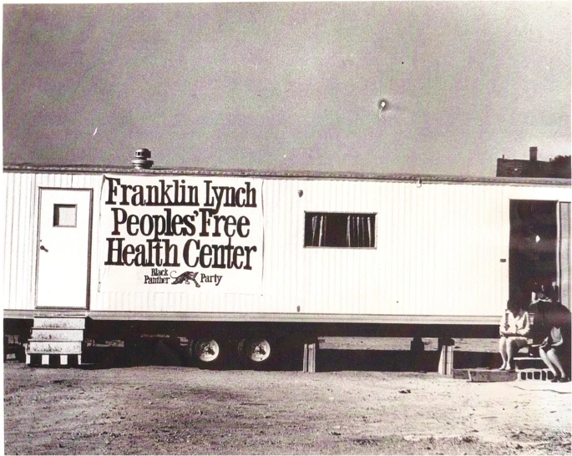
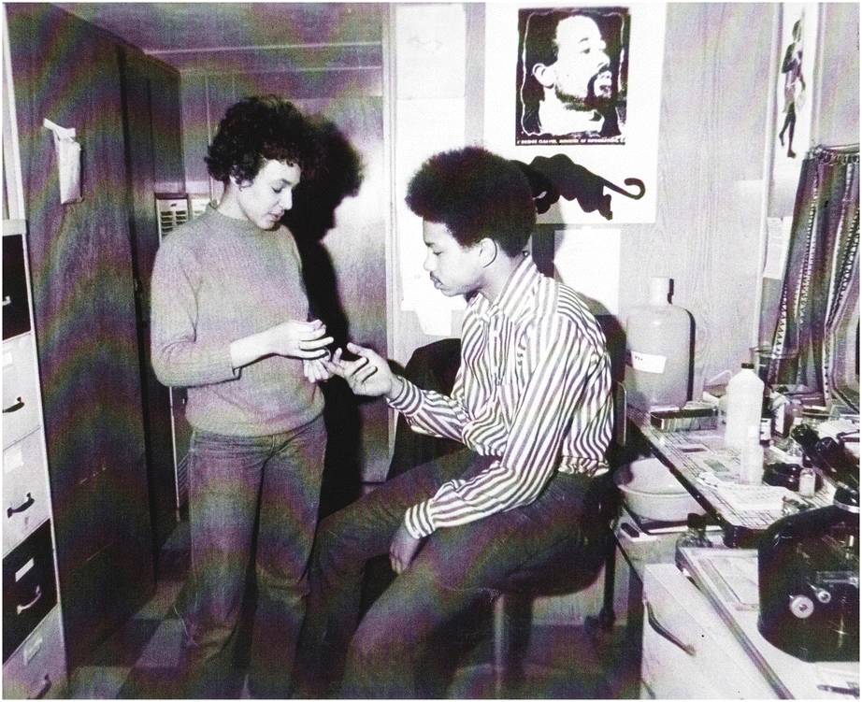

Bassett, M.T. (2019). No Justice, No Health: The Black Panther Party’s Fight for Health in Boston and Beyond. J Afr Am St 23, 352–363. https://doi.org/10.1007/s12111-019-09450-w

What do you observe happening in the image on the left? What do you notice about the image on the right? What issue do you believe is addressed in both images?

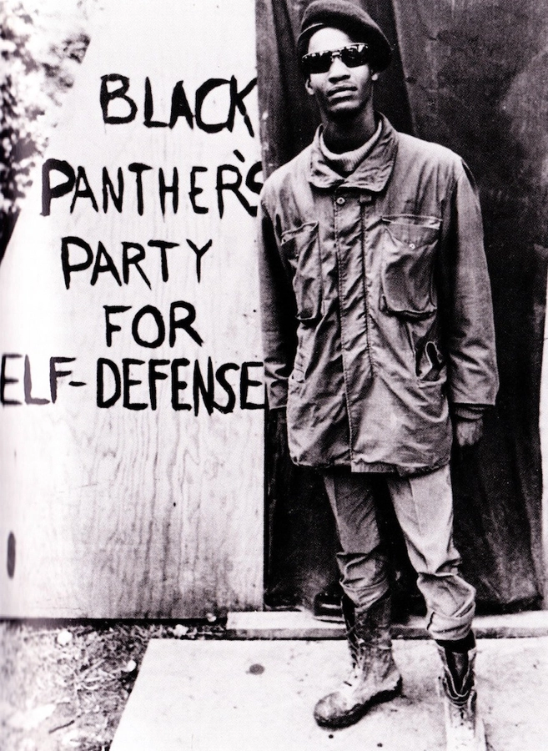
Picture Set 3
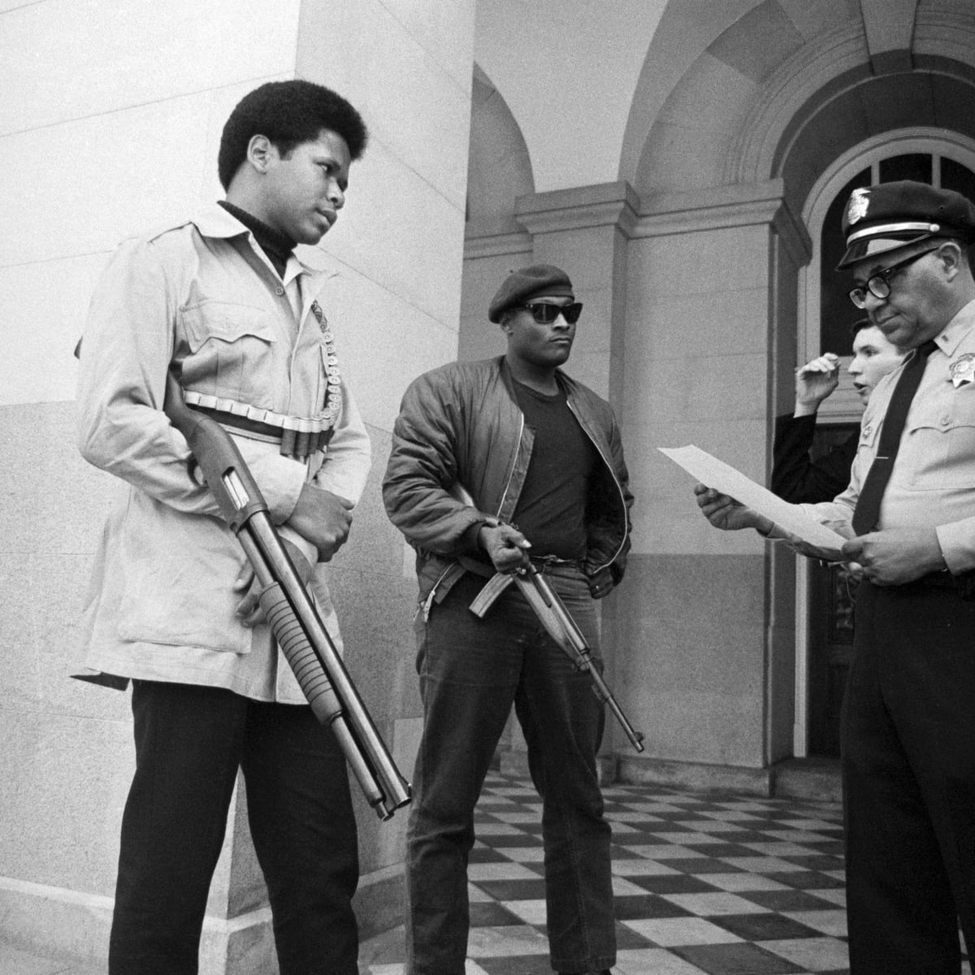

Morgan, T. (2018, August 30). The NRA supported gun control when the Black Panthers had the weapons. History.com. https://www.history.com/news/black-panthers-gun-control-nra-support-mulford-act |  | Chiles, N. (2015, March 26). 8 Black Panther Party programs that were more empowering than federal government programs. Atlanta Black Star. https://atlantablackstar.com/2015/03/26/8-black-panther-party-programs-that-were-more-empowering-than-federal-government-programs/2/

What stands out to you in the image on the left? What do you notice about the image on the right? What issue do you believe is addressed in both of these images?

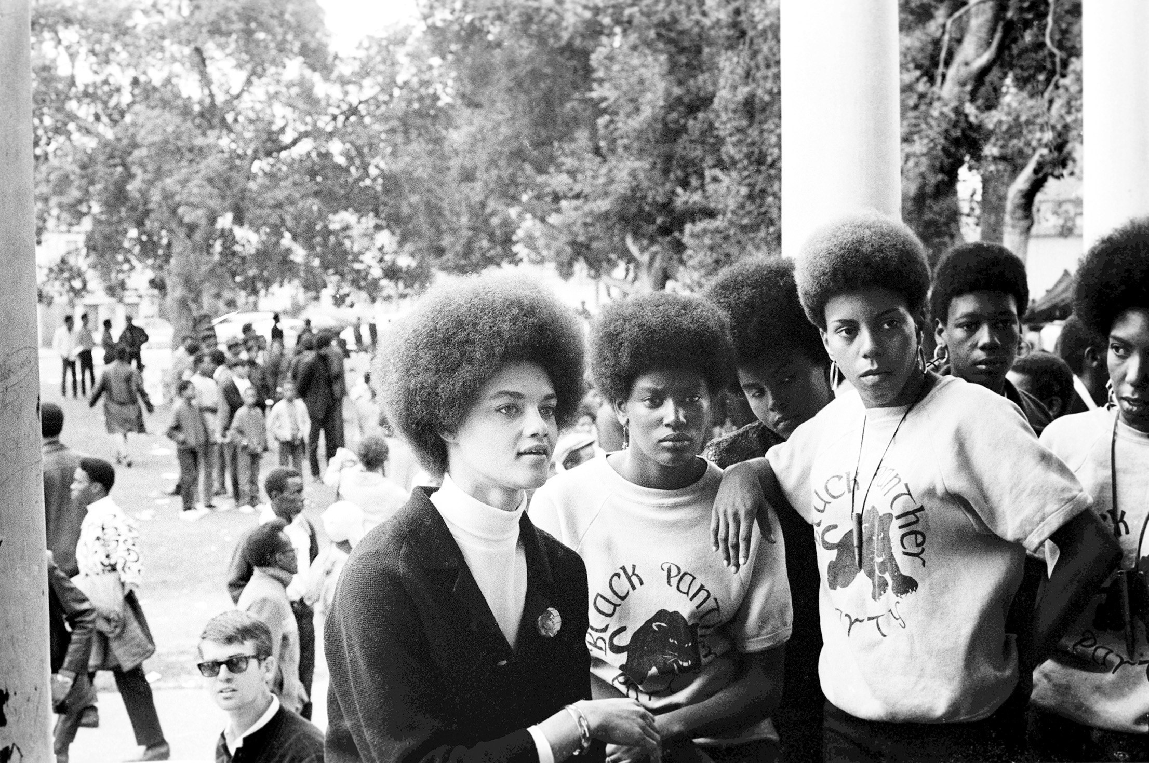
Picture Set 4
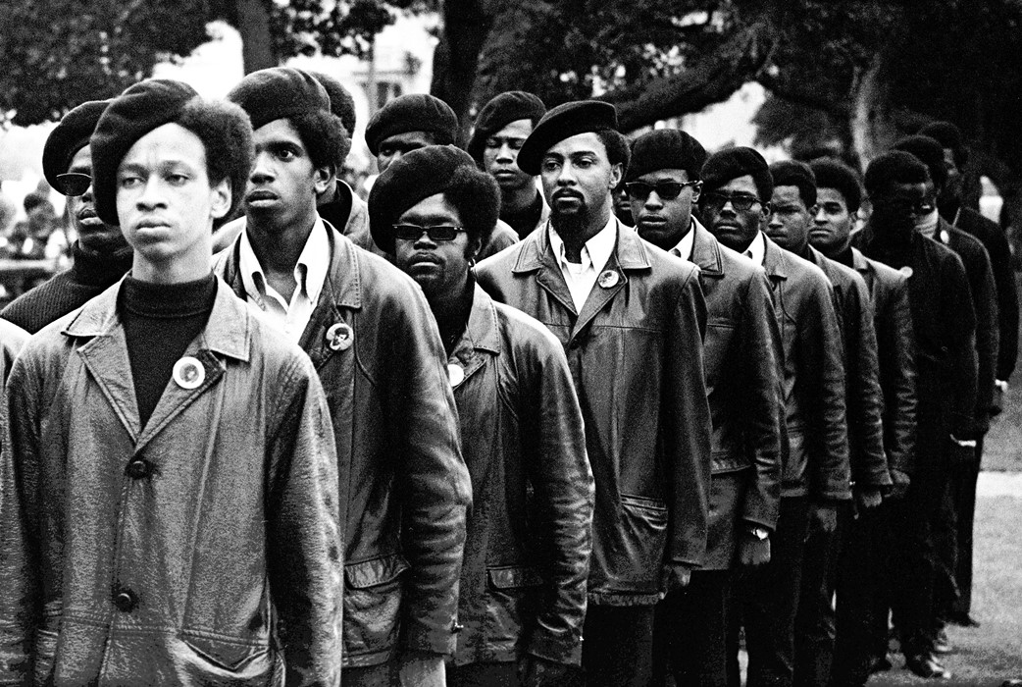

James, S. (2016, October 19). Panthers line up at a Free Huey rally [Photograph found in Steven Kasher Gallery, Oakland]. https://www.anothermag.com/fashion-beauty/9194/retracing-the-creative-legacy-of-the-black-panthers | James, S. (2016, October 19). Kathleen Cleaver at a Free Huey rally [Photograph found in Steven Kasher Gallery, Oakland]. https://www.anothermag.com/fashion-beauty/9194/retracing-the-creative-legacy-of-the-black-panthers

What are some things that stand out to you in both of these images? What do you notice about clothing or hairstyles? Do these images seem different from others you have seen from this time period?

