Station 1
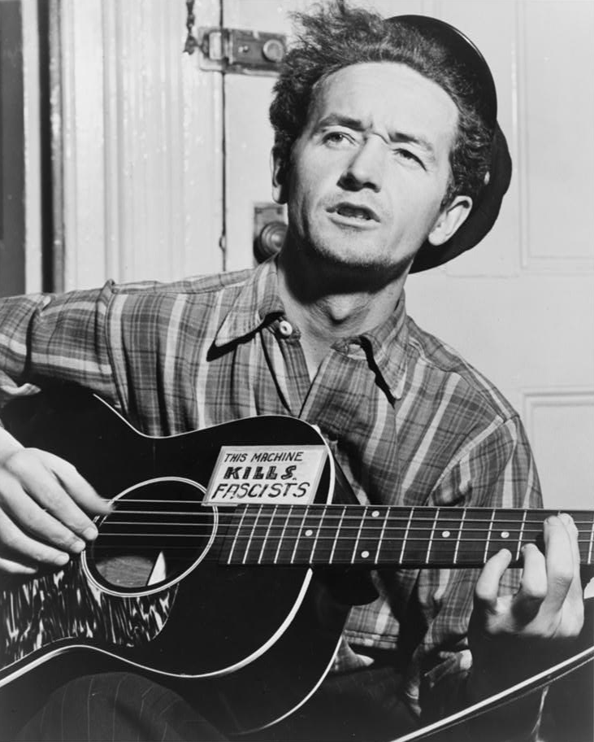
“Wherever little children are hungry and cry, wherever people ain’t free. Wherever men are fightin’ for their rights, that’s where I’m a-gonna be.”
—Woody Guthrie, 1940

Sources
Aumuller, A. (1943). Woody Guthrie, half-length portrait, facing slightly left, holding guitar [Photograph]. Library of Congress. https://www.loc.gov/item/95503348/
Woody Guthrie Publications, Inc. (n.d). Tom Joad. Lyrics. Retrieved March 11, 2021, from https://www.woodyguthrie.org/Lyrics/Tom_Joad.htm

Station 2
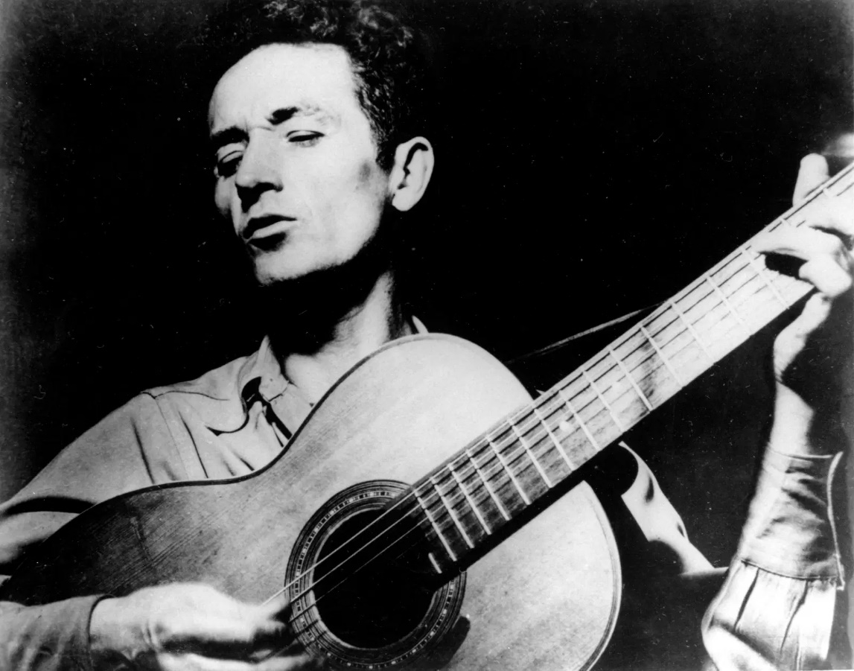
“There's several ways of saying what's on your mind. And in states and countries where it ain't any too healthy to talk too loud, speak your mind, or even vote like you want to, folks have found other ways of getting the word around. One of the mainest ways is by singing…. If the fight gets hot, the songs get hotter. If the going gets tough, the songs get tougher.”
—Woody Guthrie, 1942

Sources
Folkways Records. (1965). Woody Guthrie, half-length portrait, facing left, singing and playing guitar [Photograph]. Library of Congress. https://www.loc.gov/item/98505476/
Guthrie, W. (1990). Pastures of plenty: A self-portrait (D. Marsh & H. Leventhal, Eds.). HarperCollins.

Station 3
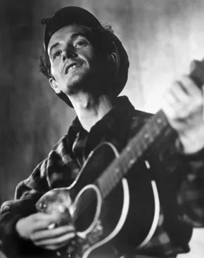
“A folk song is what’s wrong and how to fix it or it could be whose hungry and where their mouth is or whose out of work and where the job is.”
—Woody Guthrie, 1940

Sources
Hall, S. (2016, July 12). Woody Guthrie on Elections, Politics, and the Power of Folksong [Blog post]. Library of Congress. https://blogs.loc.gov/folklife/2016/07/woody-guthrie-on-elections-politics-and-the-power-of-folksong/
Library of Congress. (1943) Woody Guthrie, half-length portrait, facing front, playing guitar [Photograph]. https://www.loc.gov/item/98505517/

station 4
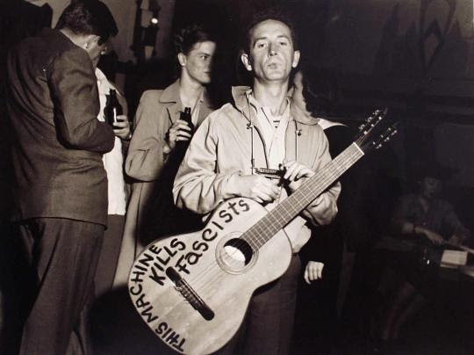
Woody began writing “This Machine Kills Fascists” on
his guitar in 1941 after seeing the message inscribed
on WWII weaponry.

Source
Balog, L. (1941). Woodie Guthrie, 1941 [Photograph]. The Museum of Fine Arts, Houston. https://emuseum.mfah.org/objects/50216/woodie-guthrie;jsessionid=466DF8BD335E1E47965D0A72A5BE9762.

