Nothing But Net

Team Scores
Equations | 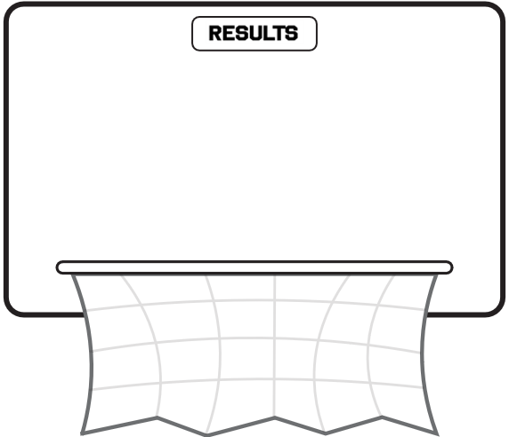
Variables

Overall Shooting from the Field
Equations
Variables

Team Baskets
Equations
Variables

