Make a farm
- Roll the dice to find how many of each animal to put in your farm.
- Place the animals on the farm mat where you think they would live.
- Take a picture of your farm and upload it to Seesaw.
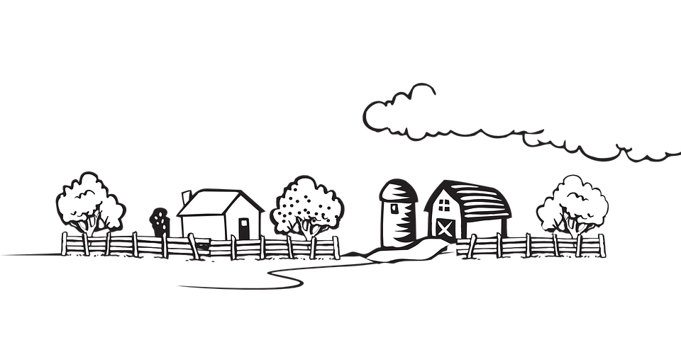
Source: Clickr Free Vector Images. (April 2012). Landscape. Pixabay. https://pixabay.com/vectors/landscape-rural-village-area-trees-33145/

