Name: __________________________________________

What Products do these farm animals give us?
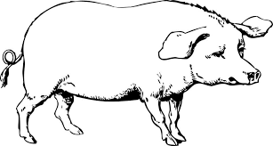
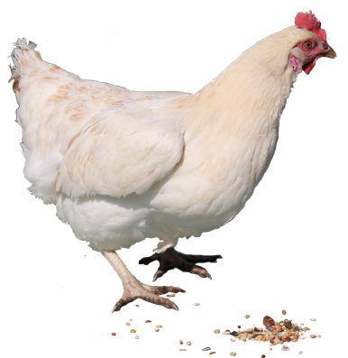
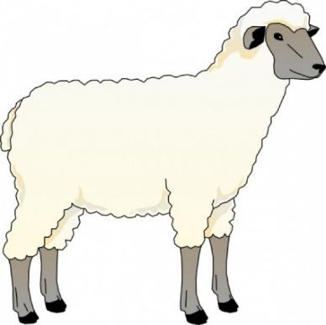
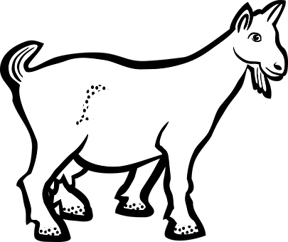
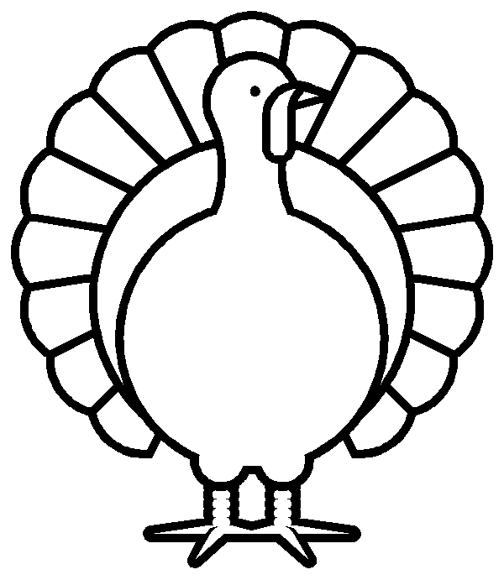
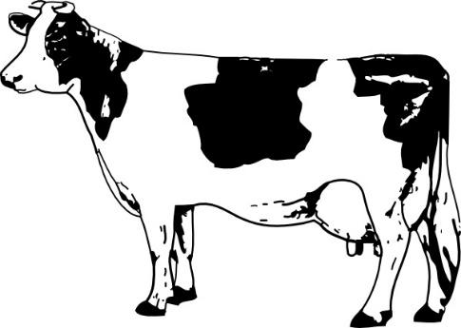
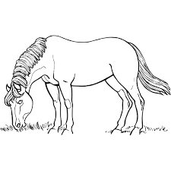
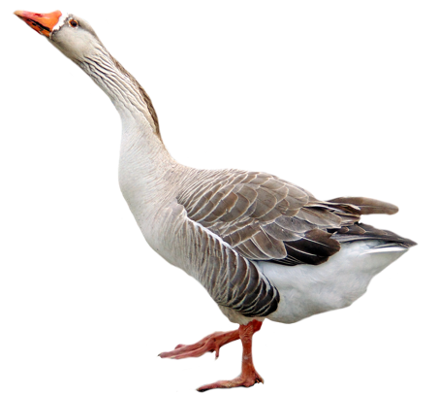

Fried Chicken | Feather Pillow  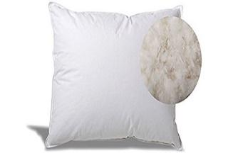 | Goat Cheese  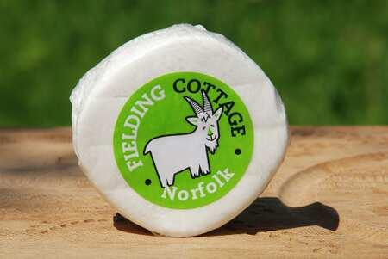 | Wool for Clothes  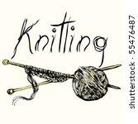
Ham  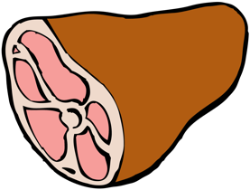 | Hen Egg  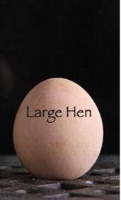 | Riding for Fun  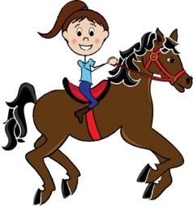 | Cheeseburgers  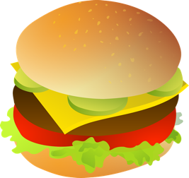
Goat Milk  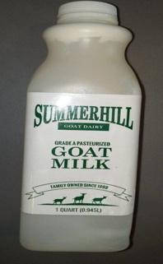 | Goose Egg  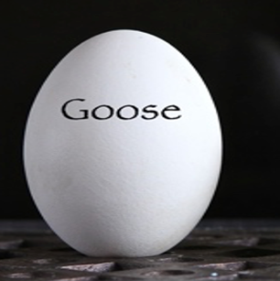 | Roast Turkey  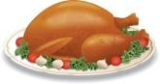 | Feathers  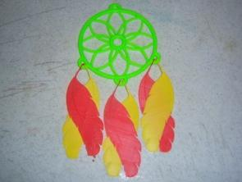
Milk  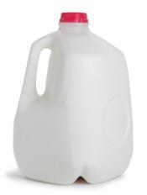 | Paintbrushes  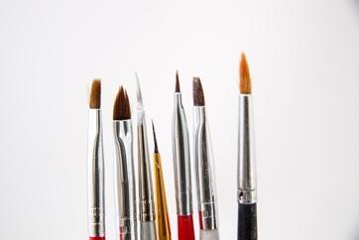 | Bacon | Lamb Chops  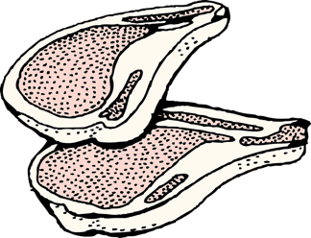

Sources
N.a. (Dec. 2014). Bacon [image]. Pixabay. https://cdn.pixabay.com/photo/2014/12/21/23/25/bacon-575334_640.png
N.a. (July 2017). Brush [image]. Pxhere. https://get.pxhere.com/photo/brush-tool-color-artist-paint-colors-creativity-tools-to-draw-1272848.jpg
N.a. (April 2012). Cheeseburger [image]. Pixabay. https://cdn.pixabay.com/photo/2012/04/14/15/37/cheeseburger-34315_960_720.png
N.a. (n.d.). Chicken [image]. PNGall. http://www.pngall.com/wp-content/uploads/2016/03/Chicken-PNG-2.png
N.a. (n.d.). Clothing [image]. PNGall. http://www.pngall.com/wp-content/uploads/2018/04/Clothing-PNG-File.png
N.a. (Nov. 2016). Cow clip art [image]. All Free Download. https://images.all-free-download.com/images/graphiclarge/cow_clip_art_6170.jpg
N.a. (n.d.). Eggs [image]. Blogspot. https://3.bp.blogspot.com/-ZY1NayIVnso/V0n-JVotcwI/AAAAAAAAIN4/JU_6VWEZE7c0tmi3qQwY5Dxz82oSP0JKwCLcB/s1600/Blog%2B2%2BIMG_8522a.jpg
N.a. (n.d). Feather [image]. Thingiverse. https://cdn.thingiverse.com/renders/3d/15/6b/a5/e0/100_7023_preview_featured.jpg
N.a. (February 2021). Grade A pasteurized goat milk [image]. Open Food Facts. https://world.openfoodfacts.org/product/0602066100023/grade-a-pasteurized-goat-milk
N.a. (31 Mar. 2016). Goat [image]. Pixabay. https://cdn.pixabay.com/photo/2016/03/31/20/46/goat-1296007__340.png
N.a. (n.d.). Horse eating grass [image]. Free SVG. https://freesvg.org/horse-eating-grass
N.a (Oct. 2014). Horse riding [image]. Clipartpanda.com. http://images.clipartpanda.com/english-horse-riding-clipart-girl_child_riding_a_horse_0515-0911-0912-3129_SMU.jpg
N.a. (April 2012.). Lamb [image]. Pixabay. https://cdn.pixabay.com/photo/2012/04/13/11/27/lamb-31970_640.png
N.a. (n.d.). Milk jug [image]. Blogspot. http://1.bp.blogspot.com/-6AFkpzLp2ok/T_xuGefPOkI/AAAAAAAAB9s/DkiZrONZKJA/s1600/milk-jug.jpg
N.a. (n.d.). Pig [image]. Clipartix. https://clipartix.com/wp-content/uploads/2017/07/Pig-clipart-cute.png
N.a. (n.d.). Sheep [image]. Clipartix. https://clipartix.com/wp-content/uploads/2016/04/Free-sheep-clip-art-pictures.jpg
N.a. (n.d.). Turkey [image]. Clip Art Library. http://clipart-library.com/clipart/8iE6oAg4T.htm
N.a. (24 Sept. 2010). Turkey drumstick [image]. Dailyclipart. https://www.dailyclipart.net/wp-content/uploads/medium/Turkey_Drumstick.jpg
N.a. (n.d.). Whole ham [image]. Openclipart. https://openclipart.org/image/2400px/svg_to_png/1023/johnny-automatic-whole-ham.png

