where do animals live and what do they eat?

The information on each of the below cards can help your students with their farm research. If your students are not reading yet, have them match the cards by looking for key words and pictures.

Instructions: Cut each set into three pieces. If you want the sets to be self-checking, you can color code the sets or mark the cards on the blank side. Laminate for extended use.

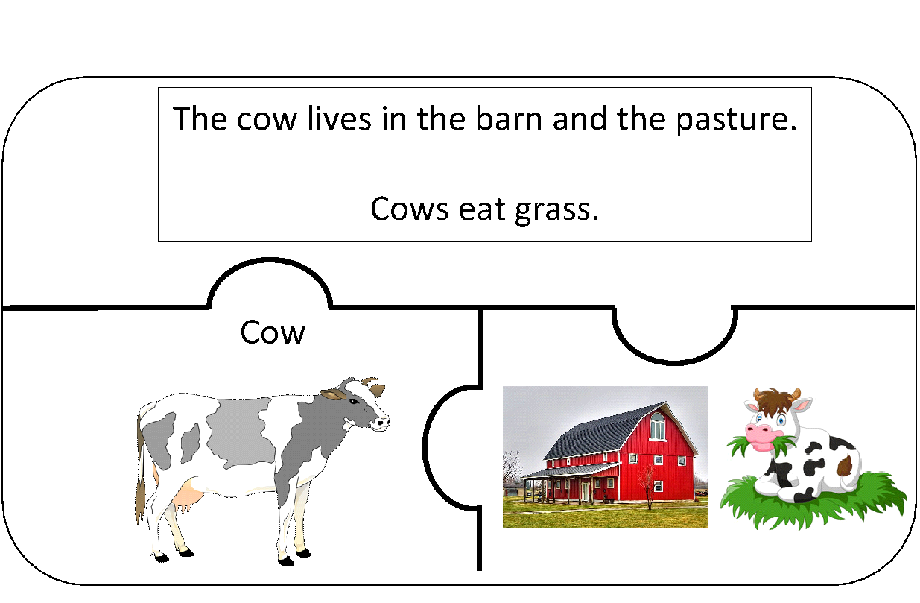

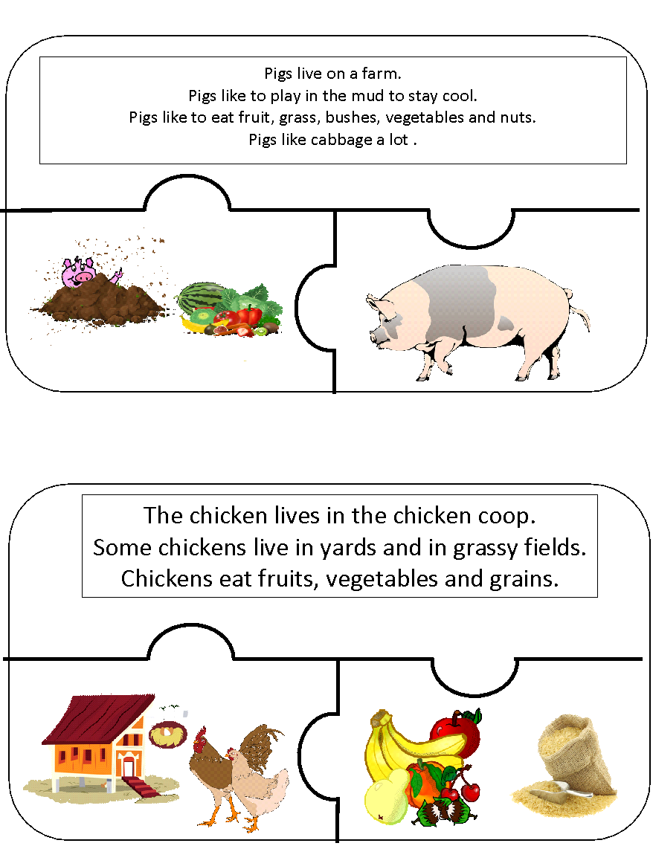
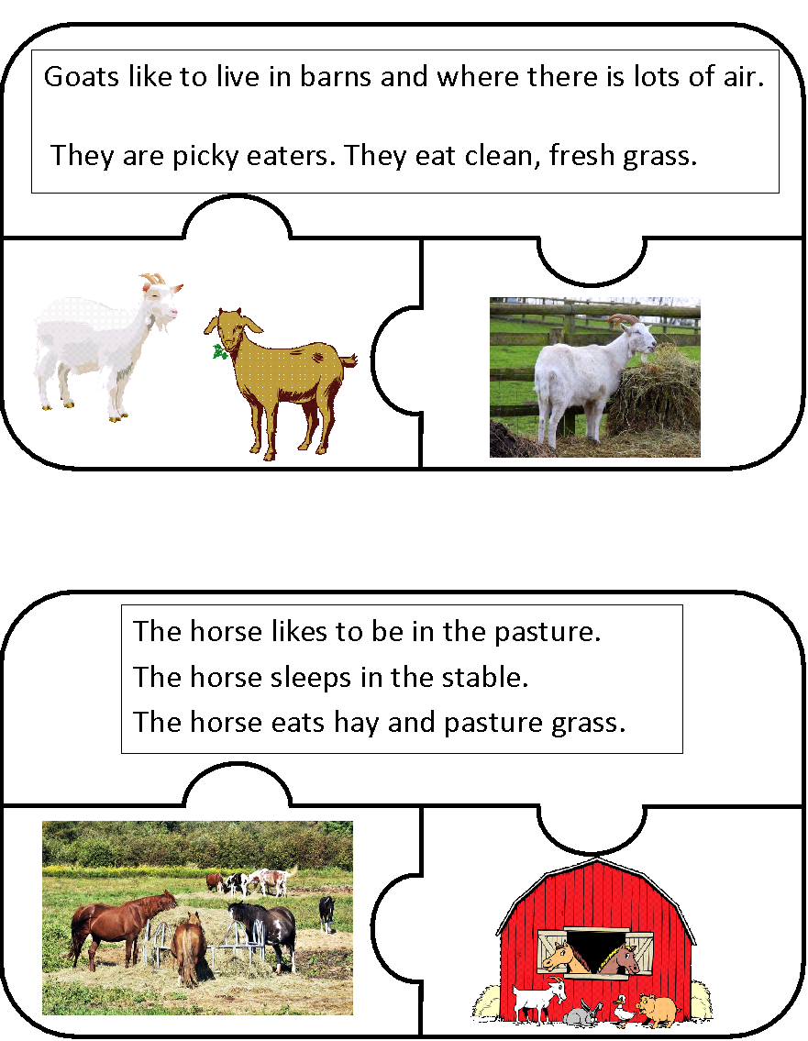

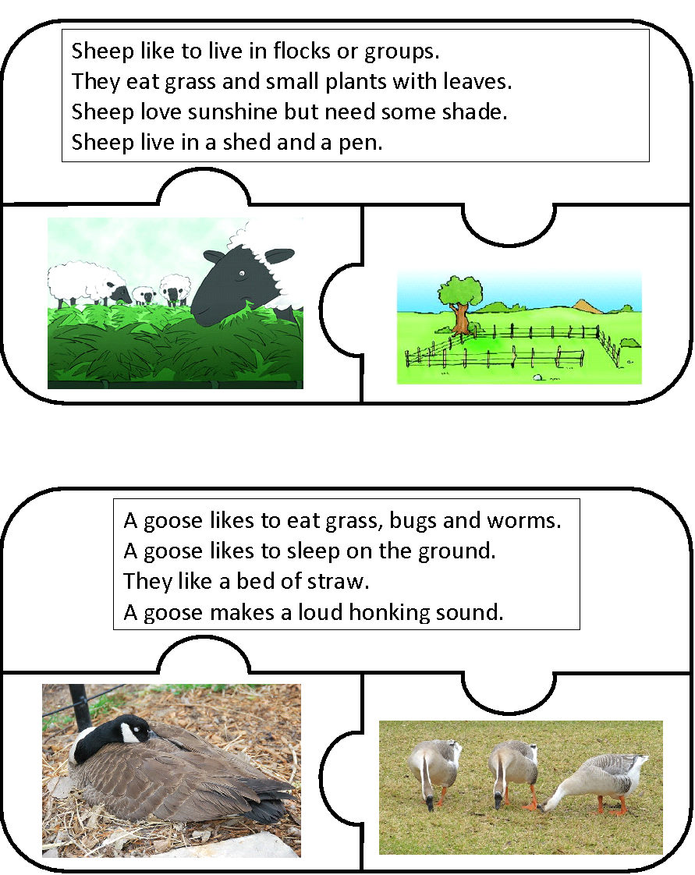

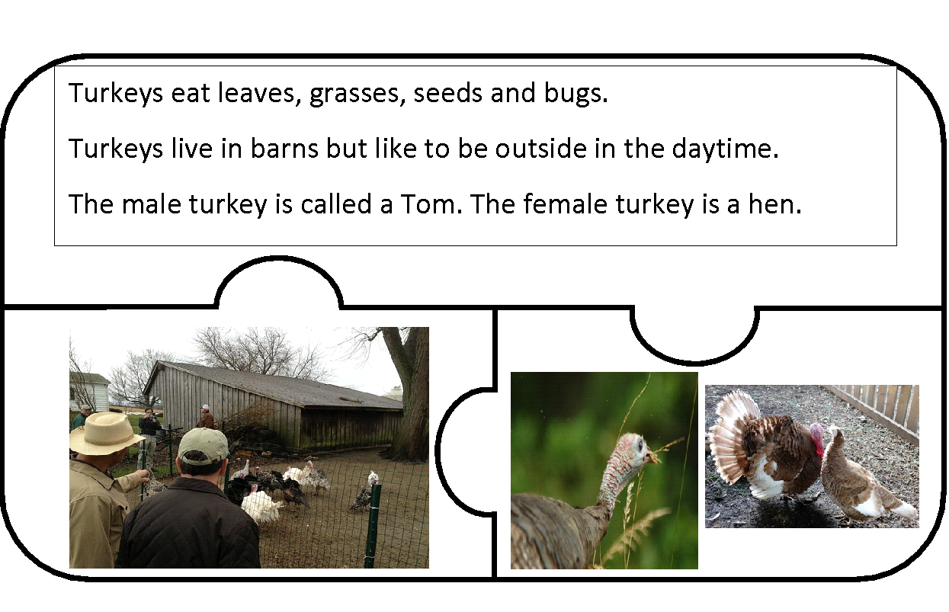
Sources:
A. Drauglis. (n.a.). Turkey. Flickr. https://live.staticflickr.com/3419/3746940920_f4dfe9086d.jpg
N.a. (n.d.). Animals. Pixabay. https://cdn.pixabay.com/photo/2012/04/30/09/58/animals-44571_960_720.png
N.a. (n.d.). Applejack's chicken coop. Wixmp. https://images-wixmp-ed30a86b8c4ca887773594c2.wixmp.com/intermediary/f/f7734375-eee6-49f7-ab92-f5fec3b5c0f1/d7vrp5l-2d981d50-71a3-4399-a1d6-0ab8f489b8de.png/v1/fill/w_287,h_200,strp/mlp_resource__applejack_s_chicken_coop_by_lahirien_d7vrp5l-200h.p
N.a. (n.d.). Barn. Pixabay. https://pixabay.com/photos/barn-rustic-barns-ohio-digital-art-2683249/
N.a. (n.d.). Goat. Geograph.org.uk. https://s0.geograph.org.uk/geophotos/02/23/59/2235987_71729157.jpg
N.a. (n.d.). Goat PNG. PNG Img. http://pngimg.com/uploads/goat/goat_PNG13149.png
N.a. (n.d.). Goat vector. Pixabay. https://cdn.pixabay.com/photo/2016/06/14/15/02/vector-1456762_640.png
N.a. (n.d.). Goose. Flickr. https://farm3.staticflickr.com/2159/2476380393_0304cc025d_z.jpg
N.a. (n.d.). Goose. Public Domain Pictures. https://www.publicdomainpictures.net/pictures/10000/nahled/1066-12453739216Xco.jpg
N.a. (n.d.). Healthy. Open Clip Art. https://openclipart.org/image/2400px/svg_to_png/148765/healthy.png
N.a. (n.d.). Horses eating hay. Schools Do. https://news.schoolsdo.org/wp-content/uploads/2015/04/horses_eating_hay.jpg
N.a. (n.a.). Pig in dirt. Good Free Photos. https://www.goodfreephotos.com/albums/vector-images/pig-in-dirt-vector-clipart.png
N.a. (n.d.). Pig. Pixabay. https://pixabay.com/static/uploads/photo/2012/05/07/12/50/pig-48368_960_720.png
N.a. (n.d.). Rice. PNG All. http://www.pngall.com/wp-content/uploads/2018/04/Rice-PNG-HD.png
N.a. (n.d.). Sheep. Flickr. https://live.staticflickr.com/6203/6152714069_0a6a3da34d_n.jpg
N.a. (n.d.). Terreno. Blogspot. https://3.bp.blogspot.com/-O4SQg-lnDcA/V7t39JKjBkI/AAAAAAAACI4/nWGDsehUu98WLzoAcV3P1W2tC10pNB6KgCLcB/s1600/Terreno.jpg
N.a. (n.d.). Turkey. Flickr. https://live.staticflickr.com/65535/40797185203_00eb747e85_b.jpg
N.a. (n.d.). Vegetables. Public Domain Files. http://res.publicdomainfiles.com/pdf_view/2/13494157219168.jpg

