Writing Equations

Extend
Use the graph below to write the equation of the circle in standard form. Be sure to show your work and your thinking.
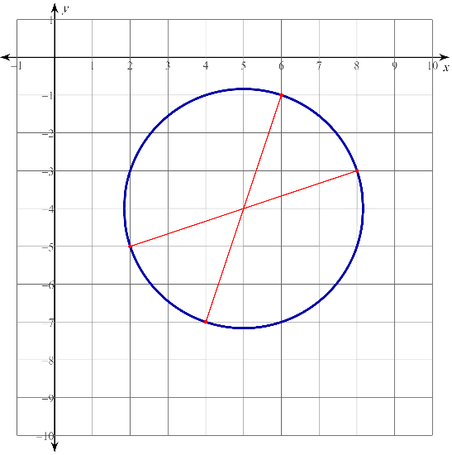

Use the graph below to write the equation of the circle in standard form. Be sure to show your work and your thinking.
