CARBON MONOXIDE ENVIRONMENTAL FACTORS

General
Carbon monoxide (CO) is an invisible, odorless, tasteless, poisonous gas in the air we breathe that results from farm-based fires, oxidation of methane, plant growth and decay, and other natural processes. Man-made sources of this deadly gas are responsible for the high amounts often found in cities. Carbon monoxide is produced when carbon in fuels is not completely burned.
Air in cities contains 100 times as much carbon monoxide as any other pollutant. The collection of other pollutants in the air may be more dangerous, but carbon monoxide is the most abundant pollutant. Motor vehicles produce the greatest amount of carbon monoxide in cities. Carbon monoxide is also released by factories and in-home activities. Since motor vehicles are the major source of carbon monoxide, daily concentration peaks occur in morning and evening rush hours when city traffic is heaviest.

Effects
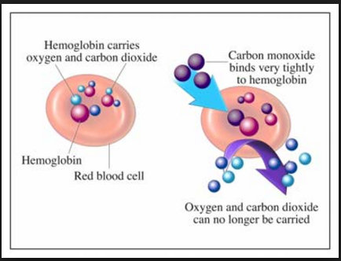
Carbon monoxide affects the central nervous system by taking oxygen away from the body. When this gas is breathed in, it enters the bloodstream and binds to the part of blood that carries oxygen through the body. This part of the blood binds more easily with carbon monoxide than with oxygen, preventing the blood from doing its job. This poisonous gas weakens the heart, decreasing the amount of blood being pumped to the muscles and organs. The health threat is most serious for people suffering from heart disease who are unable to make up for the decrease in oxygen. People with anemia (a blood disorder that causes weakness) or lung diseases, unborn babies, pregnant women, and even healthy children are likely to be harmed by carbon monoxide. Healthy adults are affected also, but only at higher levels of exposure. High levels of the gas can result in visual problems, reduced work ability, reduced manual skills, poor learning ability, and difficulty doing complex tasks. Smaller amounts of carbon monoxide can affect mental function, vision, and alertness.
American Council of Science and Health. (2016, January 27). Here’s why carbon monoxide is so dangerous [Infographic]. Retrieved from https://www.acsh.org/news/2016/01/27/why-carbon-monoxide-is-so-dangerous

Standards
The Environmental Protection Agency (EPA) has developed two national air quality standards for carbon monoxide: 35 parts per million (ppm) averaged over a 1-hour period and 9 ppm averaged over an 8-hour period. For an area to meet those standards, these numbers may be exceeded only once in a year. If an area goes above those numbers twice in any year, it is in violation of that standard.
Oklahoma Department of Environmental Quality. (2020, April). Carbon Monoxide [Fact sheet]. Retrieved from https://www.deq.ok.gov/wp-content/uploads/deqmainresources/CarbonMonoxide_04-2020.pdf

