LEAD IN THE AIR ENVIRONMENTAL FACTORS
General
Elemental lead is found in ores with other metals. Ore is metal that is found in nature. Lead is heavy and appears as bluish gray. After lead is introduced into the environment, it will be around forever as there is currently no way to permanently destroy lead or remove the harmful parts of it. Lead is also found in the air as vapors, very fine particles, and organic halogens such as lead bromide and lead chloride. Lead is also found in the production of batteries and ammunition, as well as in nonferrous smelting factories. Smelting is the extraction of a metal from its ore by heating and melting. Smelting factories turn raw ore into finished metal. Lead was banned from being added to gasoline in 1985 because it was found that 81 percent of lead in the air came from vehicles. Great strides have been made to reduce lead emissions and improve the air quality. However, centuries of using lead in mining, smelting, and manufacturing has resulted in contamination to the environment. Lead can be found in many places that result in human exposure such as food, water, soil, paint, and hundreds of other materials.

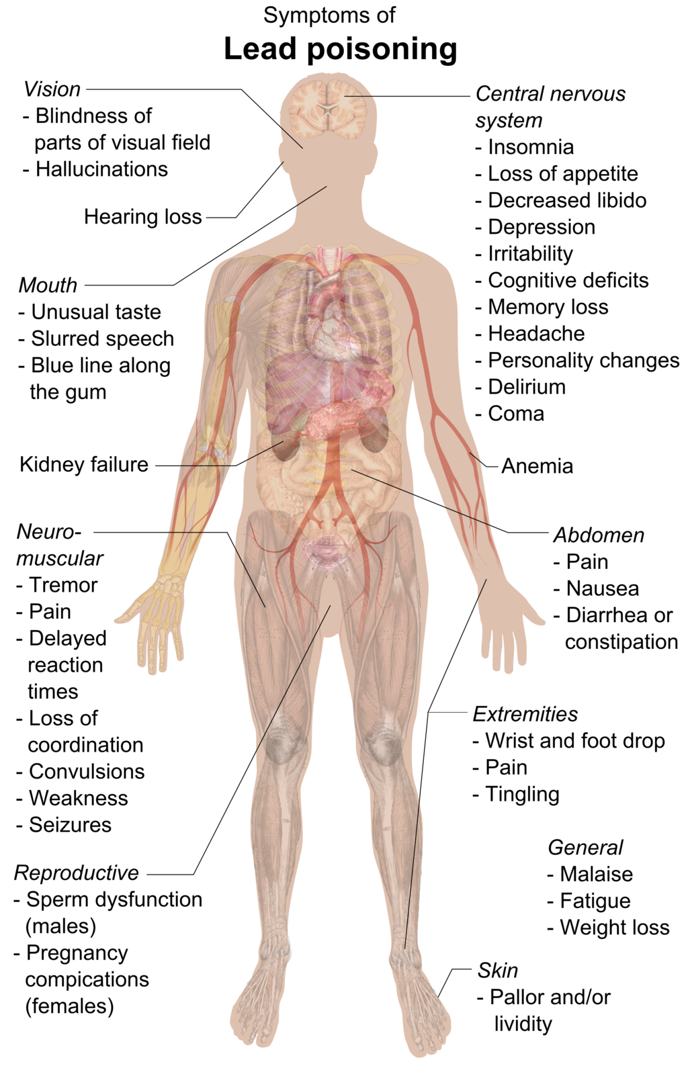

Effects
People generally come into contact with lead by inhaling or ingesting it. Three main ways people are exposed to lead today are lead-based paint, drinking water, and soil in dust in urban settings. Lead in the air is easily deposited into the lungs and can also enter the bloodstream. Lead can accumulate in blood, bone, and soft tissue within the body. If people ingest lead, ten to fifteen percent is absorbed into the body; children and pregnant women absorb higher percentages.

Symptoms of low-level lead poisoning include headaches, abdominal pain, and irritability. Exposure to lead can damage the central nervous system and slow rates of growth in children and fetuses. High levels of lead poisoning can result in permanent deficiency in both physical growth and intelligence. Repeated exposure to lead in both children and adults can cause anemia, which is characterized by low iron levels in the blood, kidney disease, problems with reproduction, and damage to the nervous system.

Standards
For lead, primary and secondary National Ambient Air Quality Standards (NAAQS) are measured as total suspended particles (TSP) collected on a filter. Lead has identical primary and secondary standards of 0.15 micrograms per cubic meter (µg/m3) measured on a 3-month rolling average. The Environmental Protection Agency may require monitoring of lead near areas such as open and recently closed industrial areas, airports that have piston-engine aircrafts that emit lead, and other sources of re-entrained lead dust.
Haggstrom, M. (2015, June 7). Symptoms of lead poisoning (raster). [Image]. https://commons.wikimedia.org/wiki/File:Symptoms_of_lead_poisoning_(raster).png#file
Oklahoma Department of Environmental Quality. (2020, April). Lead in air. [Fact Sheet]. https://www.deq.ok.gov/documents/?deqattkeyword=&deqdivisons=all&documenttags%5B%5D=fact-sheets

