OZONE ENVIRONMENTAL FACTORS
General
Ozone (O3) is a colorless, odorless, highly reactive form of oxygen. High concentrations of the gas can be blue, unstable, and have a strong odor. Unlike other pollutants, ozone is not given off by specific sources. It is formed from sunlight through chemical reactions of oxygen with nitrogen oxides (NO_{X}) and dangerous, volatile organic compounds (VOCs). Some of the more common sources of these compounds include gasoline vapors, chemical solvents, and cleaning fluids.
Ozone is formed in two locations of our atmosphere, sub-stratospheric and stratospheric.
Sub-stratospheric ozone (also known as smog) is formed at ground level. Stratospheric ozone is produced at high altitudes and provides a protective layer around the earth by absorbing most of the sun’s harmful ultraviolet rays. These two should not be confused. Ground level ozone is a pollutant, while stratospheric ozone is a necessary part of the atmosphere. Basically, ozone is good up high—bad nearby.
Ground level ozone is produced naturally from sources in very low amounts. Even though ozone is produced daily, high ozone levels usually happen from May to August when there is more sunlight. Typical conditions needed for high ozone amounts include:
- Weekdays when traffic and industrial activity is high;
- Times between 11 a.m. and 5 p.m. when the sun is high;
- Winds light or calm;
- Little or no cloud cover present.
Ground level ozone happens mostly in busy cities; however, both ozone and the ozone-forming VOCs and NO_{X} can travel long distances under certain weather conditions.
Effects
Ozone affects both public health and public well-being. Ozone can cause health problems because it can damage lung tissue, reduce lung function, and sensitize the lungs to other irritants. It also irritates the mucous membranes of the nose and throat, causing coughing and infection of the lungs. An estimated 90 percent of inhaled ozone is never exhaled. Its effects are worse in people with long lasting lung disease, asthma or diseases of the heart and circulatory system, and can affect these individuals at lower amounts.
Ozone damage can result from long exposure to low amounts or from exposure to higher amounts for a shorter period of time. Short-term exposure to ozone in the range of 0.15 to 0.25 parts per million (ppm) may harm functions of the lung and may cause breathing problems and related signs of sickness in sensitive people. Long-term exposure to ozone at low concentrations has been found to reduce lung activity in normal, healthy people as well, especially during exercise. This decrease in lung activity can result in chest pain, coughing, sneezing, nausea, headache, and lung-related blockage. Results from animal studies show that repeated exposures to high levels of ozone for several months or more can create permanent damage in the lungs.
Ground level ozone affects plants more than humans. It interferes with the production and storage of starches in plants, resulting in leaf injury or smaller growth and yield of plants. Some plants such as soybeans, alfalfa, oats, corn, beans, clover, shrubs and deciduous trees are especially sensitive to ozone and show damage at low amounts. Ozone can also damage nylon and other man-made materials, as well as rubber, metal, and paint.
Standards
The national 8-hour primary and secondary air quality standard for ozone is 0.070 ppm. These standards are met when the average of the annual fourth-highest daily maximum 8-hour average ozone concentration is less than or equal to 0.070 ppm using the most recent 3 years of collected data at any one ozone monitoring site.
The primary standards are designed to protect public health, including the health of sensitive people such as asthmatics, children, and the elderly. The secondary standards are designed to protect public well-being, including protection against decreased visibility, damage to animals, crops, vegetation, and buildings.
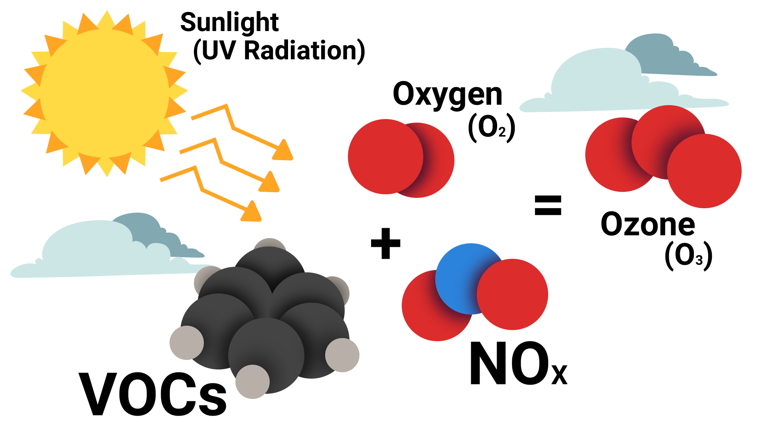
Oklahoma Department of Environmental Quality. (2020, April). Ozone [Fact sheet]. Retrieved from https://www.deq.ok.gov/wp-content/uploads/deqmainresources/Ozone_04-2020.pdf

