PARTICULATE MATTER ENVIRONMENTAL FACTORS
General
Anything made up of tiny solid particles or liquid droplets and found in the atmosphere is called particulate matter (PM). Particulate matter can be made of many different things depending on where it comes from. All around the world, natural sources make up most of the particulate matter.
Natural Forms of Particulate Matter (PM) | Man-Made Sources of Particulate Matter (PM)
- Pollen and spores  - Sea salt  - Dust from dry areas  - Dust from volcanoes  - Products from wildfires | - Motor vehicles  - Utility and industrial boilers  - Dust from roads  - Agricultural, construction, and mining activities  - Prescribed fires and other forms of open burning  - Gasses accidentally released from factory operations
Particulate matter makes its way into the air through combustion, burning, construction, mining, metal smelting (pulling various elements out of metal), metal processing and grinding. Particulate matter can also form in the atmosphere through condensation.
Particulates can range in size from less than 0.1 micrometer (µm) to 50 micrometers (µm) in diameter. A single strand of human hair ranges from 50 to 70 micrometers (µm) in diameter. Particles larger than 50 micrometers (µm) will settle out of the air. Particles larger than 10 micrometers (µm) but smaller than 50 micrometers (µm) are usually dust blown around.
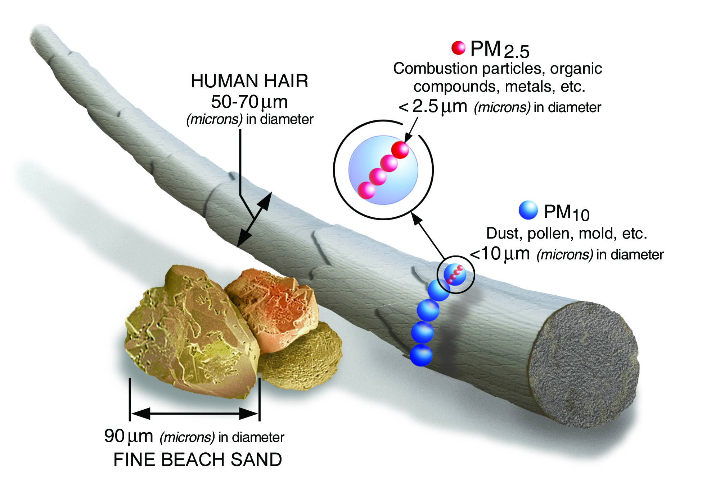
United States Environmental Protection Agency. (n.d.). Size Comparisons for PM Particles [Digital image]. Retrieved April 16, 2021, from https://www.epa.gov/pm-pollution/particulate-matter-pm-basics#PM
Particulate matter that is 10 micrometers (µm) and smaller presents a health risk because they are small enough to enter the respiratory system through breathing. They also can become lodged in the tiny sacs of the lungs. When particulate matter is 2.5 micrometers (µm) in diameter and smaller, it causes the sky to look hazy in cities and rural areas. The tiny particles in the air scatter the light, which creates a haze that blocks the clearness of what we see.
The distance particulate matter can travel in the air will depend on the size, shape, and density of the particles. Weather conditions will also impact how far it can travel. Particles larger than 10 micrometers (µm) in diameter settle fairly quickly. Their effect is felt mostly near their source. Particulate matter that is less than 2.5 micrometers (µm) can remain in the atmosphere for days or even weeks.
Effects
Particulate matter can have a significant impact on a person’s health. Those with chronic lung and heart disease, people with asthma, the elderly and children are all at greater risk than the average individual from the effects of particulate matter. Some of these include the following:
- Difficulty breathing and respiratory symptoms;
- Aggravation of existing respiratory and heart diseases;
- Alterations in the body’s defense systems against foreign materials;
- Damage to lung tissue;
- Cancer;
- Premature death.
The extent of the effects depends on the size, amount, and make-up of the particulate matter as well as the concentration and composition of any gases combining with the particulate matter. Particles less than 6 micrometers (µm) in diameter can penetrate the bronchial passages. Particles smaller than 1 micrometer (µm) can be deposited in the lungs. Lung tissue becomes damaged, and changes may occur in the immune system. The graphic below illustrates the effects air pollution can have on human body systems.
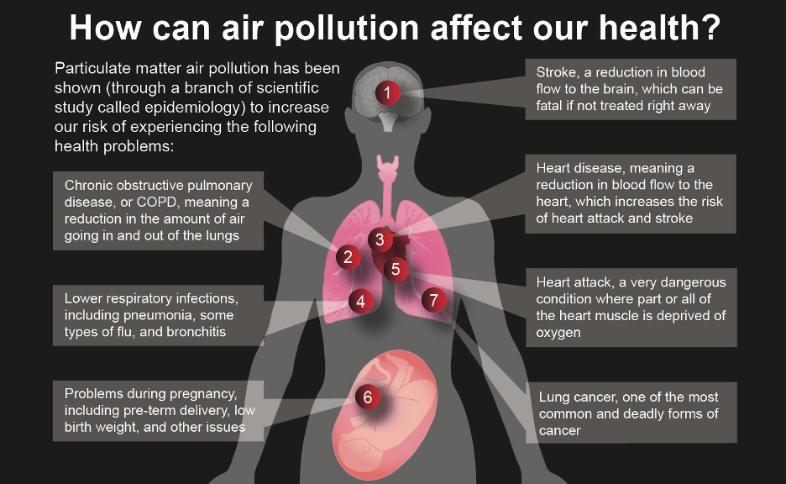
NASA/JPL-Caltech. (2020, October 21). [Particulate matter air pollution is associated with numerous adverse health effects]. Retrieved April 16, 2021, from https://climate.nasa.gov/news/3027/getting-to-the-heart-of-the-particulate-matter/

Standards
There are three National Ambient Air Quality Standards for PM-2.5:
- A primary standard of an annual arithmetic mean of 12 micrograms per cubic meter (µg/m3 );
- A secondary standard of 15 µg/m3 (annual arithmetic mean);
- A 24-hour average not to exceed 35 µg/m3 .
For PM-10, the primary and secondary standard is a 24-hour average of 150 µg/m3. Attainment of the standards is based on an average of three calendar years of data. Thus, the 24-hour PM-2.5 standards are attained when the three-year expected number of excesses per year at each monitoring site is less than or equal to one. The annual standard is attained when the three-year expected annual arithmetic mean is less than or equal to the standard.

Oklahoma Department of Environmental Quality. (2020, April). Particulate matter. [Fact sheet]. Retrieved from https://www.deq.ok.gov/wp-content/uploads/deqmainresources/ParticulateMatter_04-2020.pdf

