Zip Code Breakdown
The following photos are aerial maps of two different zip codes located in the Oklahoma City area. Observe and record exactly what you see in each photo. Make an inference about the evidence you have observed. Then, record what you do not know or would like to know about the photo. Finally, tell how you could find the information you want to know more about.

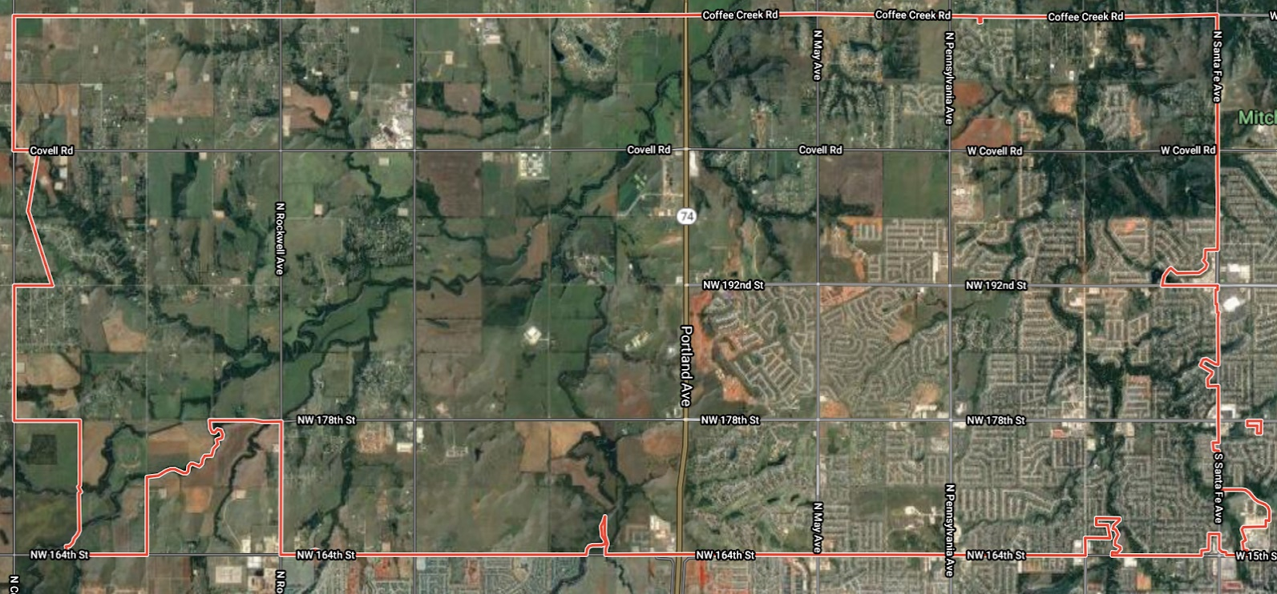
Zip Code 73012
Observations  What do you see? (people, places, objects, etc.) List your observations. | Inferences and Interpretations  Using the evidence you have observed and what you know to be true, make an inference about this photo. | What Do You Not Know?  What do you not know about the photo? Or what would you like to know more about? | How Will You Find It?  Where could you find the information you want to know more about?

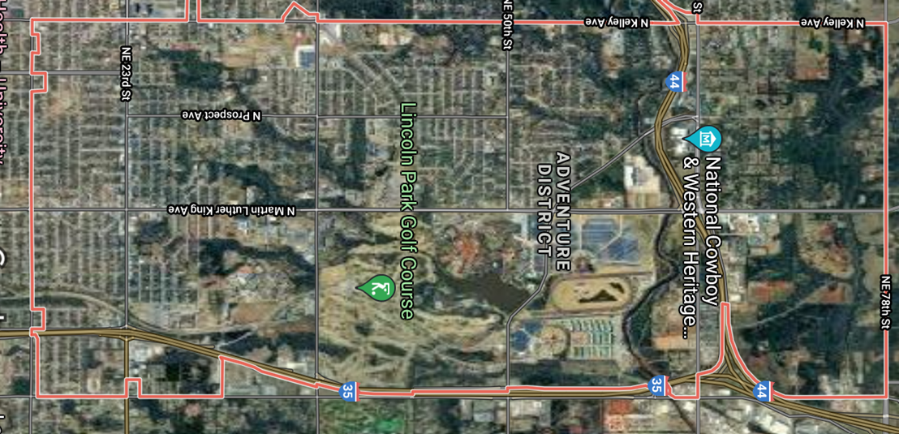
Zip Code 73111
Observations  What do you see? (people, places, objects, etc.) List your observations. | Inferences and Interpretations  Using the evidence you have observed and what you know to be true, make an inference about this photo. | What Do You Not Know?  What do you not know about the photo? Or what would you like to know more about? | How Will You Find It?  Where could you find the information you want to know more about?

