You’re Stressing Me Out! Lab Instructions
Introduction
We often look at rocks as hard, unmovable solids. However, rocks exist in various forms all over the earth. The different rock forms are produced over time by different stresses that change the shape of the rock. It is important to recognize these stresses because they play a huge role in the natural disasters we see across the world. By learning about the minerals that are right under our feet, we might find a way to better build and preserve buildings and even save our lives.
Geotechnical engineers study the Earth’s crust and the rocks that take shape there. They identify those rocks and predict whether they could potentially break. With today’s technology, geotechnical engineers can predict the next volcanic eruption, earthquake, or rockslide. They can also help other engineers develop parking garages and strong foundations for bridges and skyscrapers by providing knowledge about how the rocks below them break.
When pressure is put on rocks that causes them to break, we refer to this as “stress.” Today, we are going to explore what happens to rocks under different types of stress. Each of you will demonstrate one of three types of stress, tensional, compressional, or shear, to learn more about the effect it has on rocks.
 | Tensional Stress | Compressional Stress | Shear Stress
Examples | Figure 1  Mid-Atlantic Ridge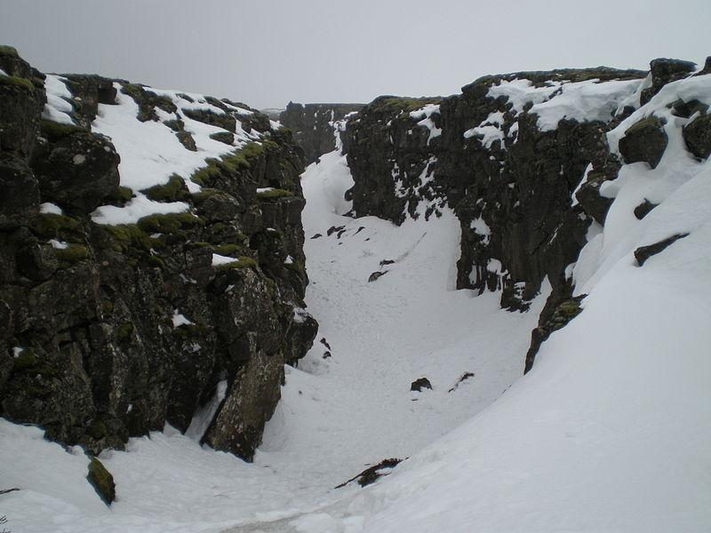  (Mangwanani, 2008) | Figure 2  Mt. Kenya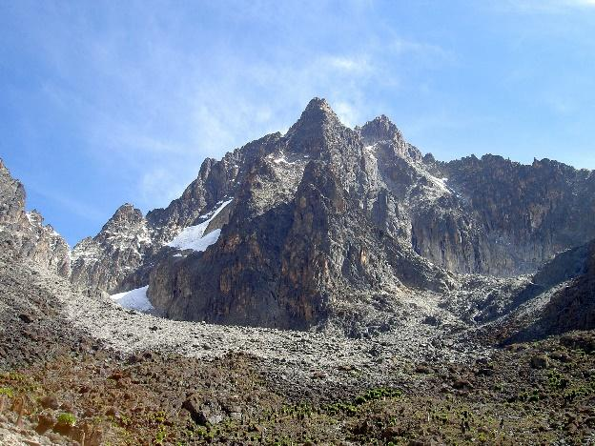  (Chris 73, 2007) | Figure 3  San Andreas Fault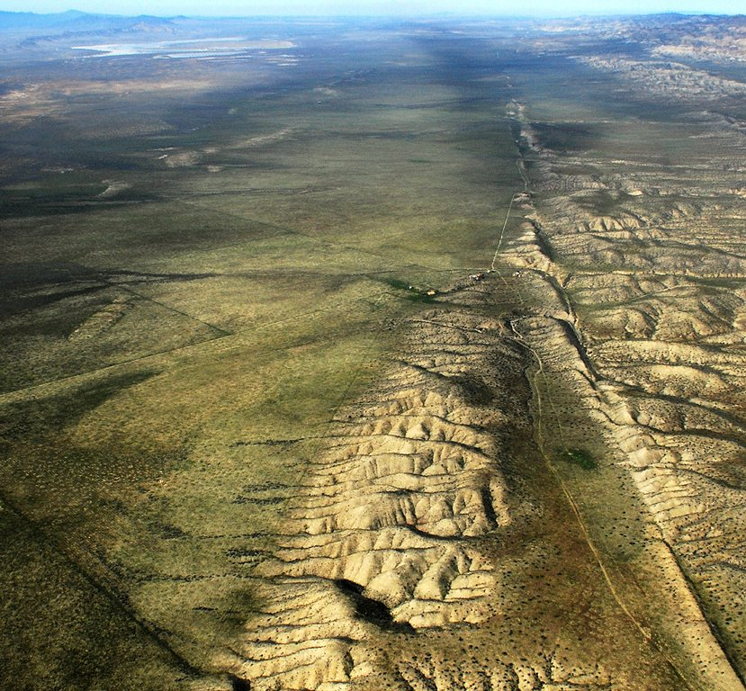  (Wiley, 2009)
Our hands might not be strong enough to break rocks, but we can simulate a rock with a bar of soap.

Supplies
- Lab instructions
- Lab handout
- Bar of soap

Procedure
- Get into groups of three.
- Make sure each group member receives a bar of soap.
- Assign each group member a number, 1-3. Each person will have a chance to show one of the three types of stressors.
- Tensional stress can cause rocks to become separated or become longer, like in the Mid-Atlantic Ridge (Figure 1). Group Member 1, without twisting or bending the bar of soap, place your hands on each side of the soap and pull to demonstrate tensional stress.
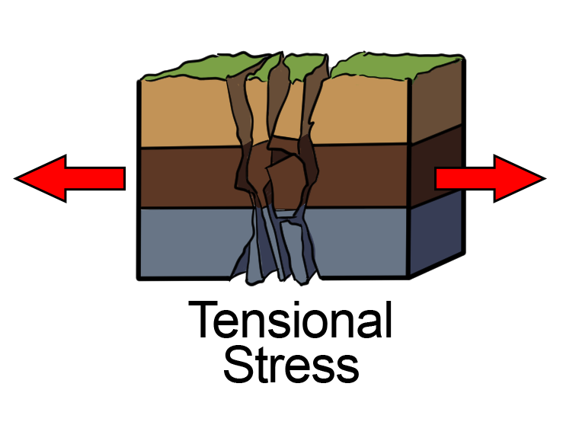
- All group members, record your observations of tensional stress.
- Compressional stress can force rock together and make it shorter, like in Mt. Kenya (Figure 2). Group Member 2, by putting pressure on both sides of your soap, demonstrate compressional stress.
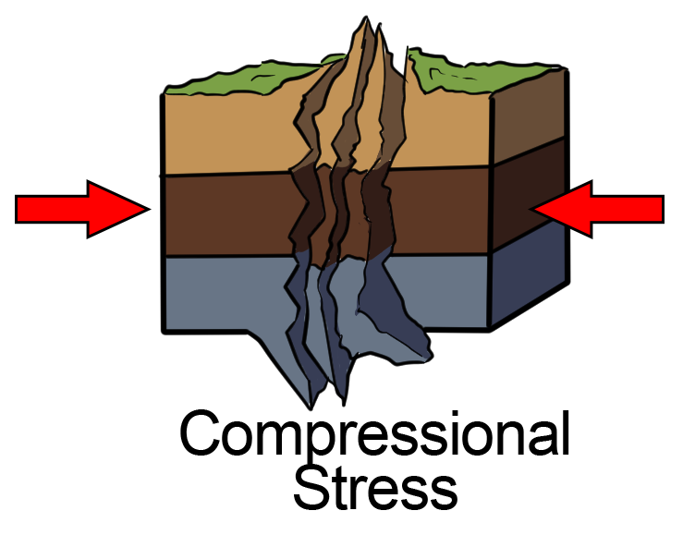
- All group members, record your observations of compressional stress.
- Shear stress can break rocks by moving them in opposite directions, like we see in the San Andreas Fault (Figure 3). Group Member 3, hold each side of the soap and move your hands in opposite directions to demonstrate shear stress.
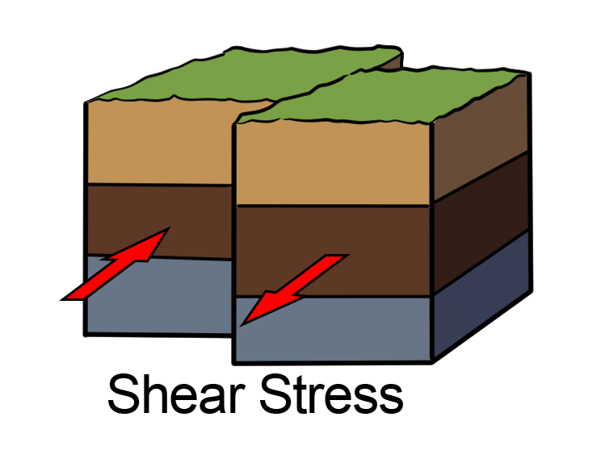
- All group members, record your observations of shear stress.
- Weathering from things like water, wind, plants, and acid rain also has an effect on breaking down rocks. Use your remaining soap pieces to demonstrate what could happen to rocks due to weathering.

Sources
Chris73. (2007). Batian Nelion, also Point Slade in the foreground Mt. Kenya [Photograph]. Wikimedia Commons. https://commons.wikimedia.org/wiki/File:Batian_Nelion_and_pt_Slade_in_the_foreground_Mt_Kenya.JPG
Mangwanani. (2008). Fissure along the Mid Atlantic Ridge in Þingvellir National Park, Iceland [Photograph]. Wikimedia Commons. https://commons.wikimedia.org/wiki/File:Mid_Atlantic_Ridge.jpg
TeachEngineering. (2021, January 23). Soapy stress. https://www.teachengineering.org/activities/view/cub_rock_lesson01_activity1
Wiley, J. (2009). Aerial photo of San Andreas Fault looking northwest onto the Carrizo Plain with Soda Lake visible at the upper left [Photograph]. Wikimedia Commons. https://commons.wikimedia.org/wiki/File:Aerial-SanAndreas-CarrizoPlain.jpg

