Honeycomb Harvest

PERPENDICULAR LINES
PARALLEL LINES

VERTICAL LINES
HORIZONTAL LINES

$$x=2$$
$$-3x+y=4$$
$$6y=18x-12$$

Lines that meet or intersect at a right angle, or 90 degrees.

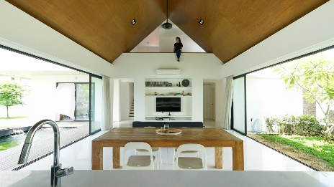
Lines in the same plane that are at an equal distance from each other and never meet.

$$y+3x=7$$
$$12y-4x=-6$$
$$y=-5$$

Königsberg Castle courtyard [Image]. (ca. 1890-1900). Wikimedia Commons. https://commons.wikimedia.org/wiki/File:K%C3%B6nigsberg_Castle_courtyard.jpg
Griffiths, A., & Chua, C. (2017, December 3). Gabled blocks overlook a koi pond at Fabian Tan's Knikno House in Malaysia [Image]. Dezeen. www.dezeen.com/2017/12/03/fabian-tan-kniko-house-gabled-blockwork-koi-pond-petaling-jaya-malaysia/

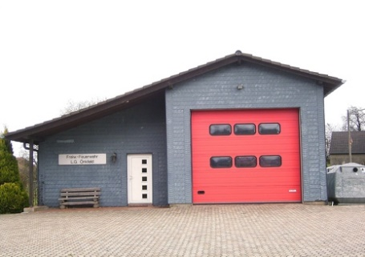
Lines that do not have y-intercepts.

Lines that have a slope of zero.

Vincentz, F. (2007, October 19). Fire stations: Radevormwald Önkfeld [Image]. Wikimedia Commons. https://commons.wikimedia.org/wiki/Radevormwald#/media/File:Radevormwald_%C3%96nkfeld_02.jpg
Khamdamov, A. (2009, December 10). Watching 1 World Trade Center construction [Image]. LiveJournal. https://ganievich.livejournal.com/107983.html#cutid1

