Skate Park
Scissortail Skate Park: 3 dollars to enter and 1 dollar for every hour you stay
Silverstone Skate Park: 5 dollars to enter and 50 cents for every hour you stay
Graph | Equations
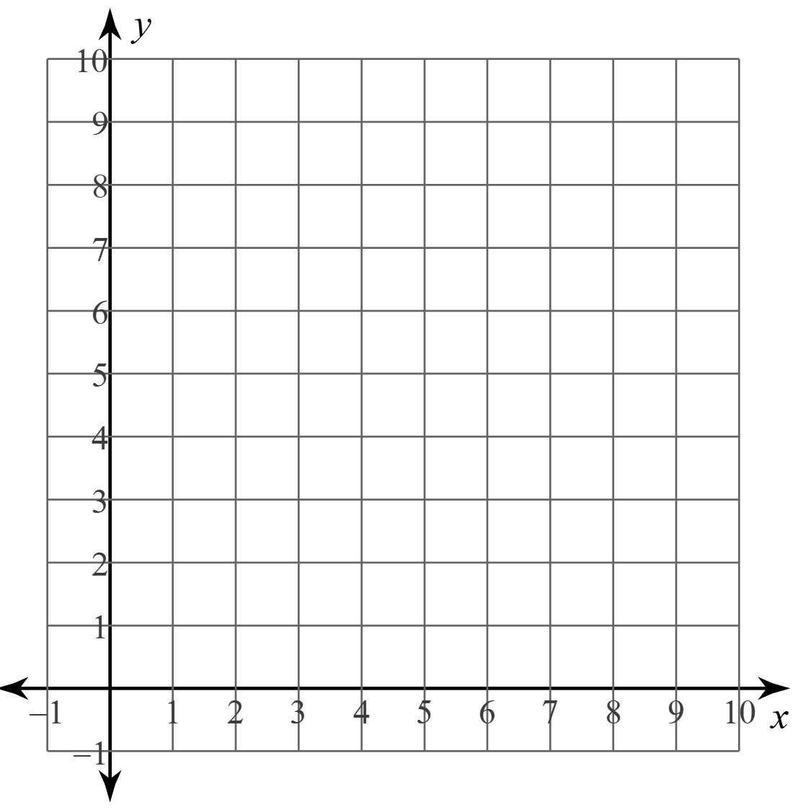

Which skate park will you and your friend attend? Explain your reasoning.

