EVALUATING PROOFS
Look through each of the problems. Identify the information given and what else can be interred/determined from the given information.

1) If PQ $≅$ QS and QS $≅$ ST then PQ = ST.
What is given? | How does the given help you solve more information? | What other information can you ‘see?’
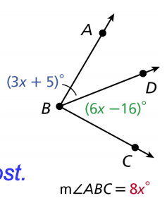
2)
What is given? | How does the given help you solve more information? | What other information can you ‘see?’

3) What is the temperature in degrees Fahrenheit F when it is 15°C? Solve the equation
F = $\frac{9}{5}$ C + 32 for F and justify each step.
What is given? | How does the given help you solve more information? | What other information can you ‘see?’

4) Prove that A (-2, -2), B (5, -1), C (1, 2) is an isosceles right triangle.
What is given? | How does the given help you solve more information? | What other information can you ‘see?’

