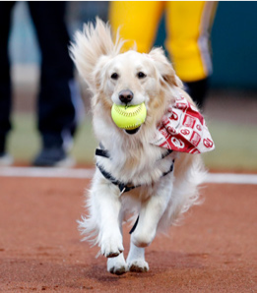
Busy Izzy

We are Kelsey and Addy, and we have a dog named Izzy. Sometimes Izzy gets us into a tiny bit of trouble, but one time she got us into BIG trouble!
We were walking to baseball practice, and Izzy decided to follow us there. Since Izzy is a kind dog and all the kids know her, the coach said she could stay.
The team was so busy throwing, catching, and batting the ball that we didn’t notice how the time had flown by. It was already time to go home!
When we started collecting the gear, we noticed all the batting helmets were missing—and so was my brand-new baseball cap! We looked around but couldn’t spot a thing. We also couldn’t find Izzy. Kelsey and I had a bad feeling. We ran home as fast as we could.
Yep, there was Izzy! Safe and sound in her doghouse. But our caps and helmets were still missing.
Maverick, our neighbor, called out to us from the front yard. “Hey, have you seen my bicycle helmet? It’s missing!”
We went around front and told him no.
Just then, Izzy came racing around the corner of the house with a police officer’s hat in her mouth. She made another loop around the house, and this time she had a hardhat. We yelled at Izzy, “DROP THAT HAT!”
She went right into her doghouse and would not move. So, we got a doggie treat and talked her into coming out. Maverick went into the doghouse and found helmets, caps, and ten more hats.
What were we going to do now?

